ELearning App  
Documentation

|  |  |  |  |
| --- | --- | --- | --- |
| Revision Summary | | | |
| Author | Date | Version | Comments |
| Dean Biele | 5/1/2012 | 1.0 | First Release. |
|  |  |  |  |
|  |  |  |  |
|  |  |  |  |

Table of Contents

Contents

Using this document 4

Building a Course 5

Using Templates 7

Learning Objectives 14

Course Lessons 15

Creating a Final Assessment 16

Suggested Project Workflow 17

Using Audio, Video & Text 19

Admin Template UI 21

Template Types 22

Course Introduction 22

Administrative Text 24

Lesson Overview 26

Lesson Objective 29

Image Half Circle 32

Image Top 35

Image Bottom 38

Image Left 41

Image Right 44

Image Full Screen 47

Video 50

Click to Learn 52

Reflective 55

Resource Links 58

Quiz Introduction 61

Quiz: Multiple Choice 64

Quiz: Multiple Choice Image 68

Quiz: True False 72

Quiz: Fill in the Blank 76

Quiz: Explore 81

Quiz: Drag & Drop 86

Quiz: Drag & Drop Paragraph 90

Quiz: Rank & Order 95

Quiz: Rank & Order Image 99

Lesson Summary 104

Lesson Complete 108

Final Assessment Introduction 112

Final Assessment Submit 116

Final Assessment Results 119

Course Conclusion 121

Customizable 123

Customizable Question 126

Q & A 130

# Using this document

This document provides information on the output of the ELearning APP. Please use this as a “Living Document”.

# Building a Course

Course Structure At-A-Glance

A course is made up of lessons. Each lesson is built as a stand-alone entity.

**Content Lessons**

A Content Lesson typically includes:

* Course Introduction page
* Lesson Overview page
* Learning Objectives page
* Content pages (generally, text with graphics and audio). Use a variety of page layouts and include Practice Questions to keep the user engaged and interested in the experience.
* Quiz Introduction
* Quiz question pages
* Lesson Conclusion page

**Quizzes**

Many course designers like to include quizzes at the end of each lesson to reinforce the learning process. A Quiz is unscored–the user is “tested” on key concepts learned in the lesson. Quiz questions can be built in Review Mode, so that if a learner gets a question wrong, they must go back to a designated page in the course to review the relevant content. Quizzes follow a test to 100% model.

Quizzes are built using Quiz templates and include the following question types:

* Multiple Choice
* True/False
* Fill-in-the-Blank
* Drag & Drop
* Explore
* Rank/Order
* Interactive Simulation
* Custom Questions

In the United Template structure, Quizzes will be viewed by a learner only if the lesson is not yet completed. Once the user achieves a status of Lesson Complete, the Quiz will no longer be available. This means, if they go back through a lesson in review mode, they will no longer see the Quiz questions.

**Final Assessment**

At the end of some courses it may be appropriate to include a Final Assessment. The Final Assessment is scored: the results are stored in the Learning Management System.

Template Specifics

United Templates include the following page template types:

* 00_Course Introduction
* 01_Administrative Text
* 03_Lesson Overview
* 04_Lesson Objective
* 05_Image Half Circle
* 06_Image Top
* 07_Image Bottom
* 08_Image Left
* 09_Image Right
* 10_Image Full Screen
* 11_Video
* 12_Click To Learn
* 13_Reflective
* 14_Resource Links
* 20_Quiz: Introduction
* 21_Quiz: Multiple Choice
* 21_Quiz: Multiple Choice Image
* 22_Quiz: True-False
* 23_Quiz: Fill in the Blank
* 24_Quiz: Explore
* 25_Quiz: Drag & Drop
* 25_Quiz: Drag & Drop Paragraph
* 26_Quiz: Rank & Order
* 26_Quiz: Rank & Order Image
* 27_Lesson Summary
* 28_Lesson Complete
* 30_Final Assessment Introduction
* 31_Final Assessment Submit
* 32_Final Assessment Results
* 33_Course Conclusion
* 40_Customizable
* 41_Customizable Question

# Using Templates

About Templates  
InVision Learning Templates let you easily create content in Flash.

Template UI is organized in Tabs. Each Tab provides a workspace for editing and manipulating specific information, such as text and audio content, graphics, or closed captioning. The Tabs will vary based on the template type in which you are working.

As you create pages, go through each Tab and complete as much of the information as possible. You can always go back later and add additional content.

For example, on a first pass at course creation, you may have draft text and images, but no audio files. (It is a general best practice to record audio only when the text has been finalized). Once the audio files have been created, you can then go back into the templates, add the audio files, time the text bullets to the audio, and insert and time the closed captioning text.

This page will provide specifics on using Flash and navigating in Templates.

Visit the build a course page when you're ready to construct a course.

Getting Started

This section will cover the basic steps and information that you will need to know to work with Flash in order to create a course.

Installing Templates in Flash Professional

The following files will be necessary:

* Adobe Flash Profession CS4 or greater: [Adobe Website](http://www.adobe.com/)
* Adobe Extension Manager 2.0 or greater: [Download the Extension Manager](http://www.adobe.com/exchange/em_download/)
* Instructions:
* Verify that Flash CS 4 or greater and Adobe Extension Manager are installed
* Download the latest version of the United.mxp file to the computer on which you will be working.
* Open the Flash Extension Manager. From the Start Menu > All Programs > Adobe > Adobe Extension Manager.
* Select File, Install New.
* Browse to find the United.mxp file and install it. Alternatively, you can update installed templates by clicking the update button.
* Open Adobe Flash
* Now create a new template. In Flash, select File > New
* Select the Templates Tab and choose United WBT > United Template > OK
* Create a new folder somewhere on the machine.
* Save the newly created template to that file.

Saving Media Files

Saving Images and Audio files:

* All graphics files (.jpg) must be placed in the Media folder for the specific course in which they will appear.
* All audio files (.mp3) must be placed in the Media folder for the appropriate course.

Opening & Saving New Flash Templates  
  
To open and save a new template file:

1. Open Flash.
2. Create a new file: Select File > New.
3. Select United WBT from the Categories column.
4. Choose United Templates from the Template column.
5. Click OK.
6. Save the .fla file – Select File > Save As …
7. Name your course: e.g., module51

Naming Conventions – generally it’s a good idea to name your .fla file with the course name. (Avoid spaces in filenames, but it’s ok to use underscores).

If you are using Flash 8 or greater, you must save the Flash File in the Flash MX 2004 format.

1. Save your course to the appropriate folder
2. You can now begin using Learning Templates to create content.

Now that you have saved a new .fla file, you are ready to create course content using the Learning Templates. Flash will be open, with a blank Template.fla before you.

General Flash Terminology  
This section will provide you with some definitions of common Flash terminology.

.fla

Flash Authoring file. This is the working version of the lesson you are working on. When you choose “publish” the .fla it is compiled into a .swf.

.swf

Also called a “swif”. A .swf is a shockwave flash file that is imbedded within an HTML page. This is the only way to view flash files in a browser.

.mp3

Audio file format used by Templates.

.flv

Flash video format. Used instead of QuickTime or AVIs.

.mp4

Flash video format. Used instead of QuickTime or AVIs.

.jpg

Graphic image file type used by the Templates.

.png

Graphic image file type used by the Templates.

Keyframe

A keyframe is a frame in which you define a change in an animation or include frame actions to modify a document. In the Learning Templates, a keyframe represents a page of content within a course.

Frame

A frame is a continuation of the previous keyframe.

Movie Clip

A collection of frames and keyframes within a library. The Flash Library organizes the media assets. This includes movie clips, buttons, graphics, video and audio. In the Template environment, the Library houses the Templates themselves.

Layers

Allow you to organize frames and keyframes on the stage. In the Template environment, we use a Content Layer and a Navigation Layer only.

Stage

The Flash work area.

Flash Timeline  
At the top of the Flash window, you see the Flash timeline:

Within the Template Timeline, there are two layers: Content and Navigation. The Content layer is dark gray, indicating it is currently selected. Always be sure that the Content layer is selected when you are creating content. In the Content layer, there are 6 blank keyframes already created for you. A keyframe is the equivalent of a course screen or page. ¬ A blank keyframe is indicated by an empty circle: ¬ A keyframe with content is indicated by a filled-in circle: ¬ A frame is indicated by the rectangle. A frame is a continuation of a keyframe and should never appear in the Content Layer.

Flash Library  
On the right side of the screen, you see the Flash Library.

*Note: if the Library does not appear, type Ctrl + L.*

United Templates include the following page template types:

Flash Stage  
In the center of the screen, you see the “Stage” area. This is the area where you will drag and launch your Learning Templates.

Flash Property Inspector  
The Properties Inspector typically appears in the bottom area of the screen, although it can be minimized or moved.

Creating Course Content  
The following sections describe the technical basics for creating a course using Flash Templates. Also read the sections on building a course to learn about rules for course structure and to learn the specifics of each page layout (Template) type.

Creating a Content Page

You are now ready to create your first page in this new lesson:

1. Click on the first blank keyframe in the Content Layer Timeline.
2. Open the Content or Quiz Templates folder in the Templates Library.
3. Select the desired Template and drag it onto the stage in the Content Layer.
4. Select the Template by clicking on it in the Content Stage
5. Make sure the Properties Inspector is open.
6. Click the Launch Component Inspector button.

*The Template working window will appear.*

1. You can now enter content into the Template.
2. As you work in the Template window, you can enter new content, preview your work, edit content, and save updates.

*Note: saving within the Template window saves the content into Flash, but you will also need to save the Flash .fla file.*

1. When you are finished with the lesson page, close the Template window by clicking X in the upper right corner.
2. Create a second content page by clicking in the second blank keyframe and repeating the process.

Creating New Blank Key Frame

Once you run out of blank keyframes in the Timeline, you will need to create a new keyframe.

To create a new blank keyframe:

1. Select the first blank cell at the end of your Content Layer Timeline by clicking on it.
2. Right mouse click in this blank cell.

*A menu appears.*

1. Select Insert Blank Keyframe.

*A blank keyframe has been created*

*You now need to extend the Timeline in the Navigation Layer.*

1. Right mouse click on the cell in the Navigation Layer that is directly below the blank keyframe you just created.
2. Select Insert Blank Frame.

*Note: in the Navigation Timeline, you are creating a blank frame as opposed to a blank keyframe. A frame is an extension of the previous keyframe (in this case, the course Navigation Bar).*

Saving Your Work

As you work within a template, you should periodically save your work using the Template’s save button.

Doing a Template Save will save your content into the Flash file, but it does not save the entire .fla.

You will need to save the .fla file in Flash using File, Save from the Flash toolbar.

Previewing Your Work

As you work within a template, you can Preview your work.

Template Preview allows you to view the content layout for the page on which you are currently working. Essentially, it compiles all of the information that you have put into the various Tabs and lays them out for you in one page layout.

In Template Preview mode, navigation and interactivity do not work.

To see a fully functioning page, you need to publish the .swf file in Flash.

Publishing & Saving

A lesson must be published in order to create the .swf file that will be viewable from the browser.

To publish your newly created page(s) (publish the .swf file and save the .fla):

1. From the Flash menu, select File, Publish [Shift + F12].

*The .swf file for your lesson appears. You can now view all of the lesson pages that you have created so far and interact with a fully working navigation bar.*

*You may want to periodically publish the .swf when creating pages to see how all of the pages flow together.*

1. Save the entire lesson in Flash. From the Flash toolbar, select File, Save.

*This saves the .fla file and all of the content templates.*

If you are using Flash 8 or greater, you must save the Flash File in the Flash MX 2004 format.

Editing an Existing Lesson  
This section will describe how to make updates to existing lessons.

It is easy to make changes to a lesson screen using the Flash Templates.

To open and edit a screen in Flash:

1. Be sure the Content Layer is selected.
2. Click on the keyframe that you want to edit to select it.
3. Now click on the Template within the Stage area to select that.
4. Click on the Launch Component Inspector button in the Properties window.
5. The Template will open and you can edit your content.

Duplicating Screen  
  
For various reasons, you may find it useful to make a copy of a screen and add the copy to the Timeline. For example, if you are using almost the exact same content but just need to change a few words.

First you will need to create a blank keyframe in the desired location on the Timeline. Then you can copy an existing keyframe (the screen that you want to copy) into the blank keyframe that you just created.

To insert a blank keyframe within a Timeline:

1. Click on the keyframe next to where you want to insert your new one.
2. From the Flash menu, choose Insert > Timeline > Frame.

A new frame will be inserted to the right.

Remember, the Content Layer should never have a frame in it, so you now need to insert a blank keyframe over this frame.

1. Right click on the Frame that you just created and choose Insert Blank Keyframe.

A blank keyframe has now been created.

You can now copy an existing keyframe into this blank keyframe:

1. Select the keyframe in the Content Layer that you want to duplicate by clicking on it.
2. Now click on the Template within the Stage area to select it.
3. Right mouse click on the Template in the Stage and choose Copy.
4. Click on the blank keyframe (the one that you just created) where you want to paste the content.
5. Click on the Template within the Stage area to select it.
6. Right mouse click and choose Paste in Place.

Template Toolbar  
The Template Toolbar appears at the top of Template window in Flash and is standard across all Template types.

[](http://continentaltemplatewiki.invisionlearning.com/wiki/index.php?title=Image:Template_Toolbar.jpg)

The Template Toolbar includes the following buttons:

Package

The package button takes the published contents of a course (content.swf, content.xml, index,html, stub.swf, and media folder) and creates a zip folder. This makes distributing the course a one-step process.   
  
Help

Open the help window.  
Admin

Open the admin window.  
Preview

The preview button publishes the course with the current templates content. Use this feature to view the template as it would be seen in the final course.

Publish

The publish command creates the content.xml and publishes the course. This is similar to Flash > File > Publish.

Save

The save button saves the changes as persistent data to the current template. This is not the same as Flash > File > Save.

Exit

Closes the Template UI window.

# Learning Objectives

Before you begin writing course content, be sure to create meaningful and realistic behavioral learning objectives.

Learning objectives are specific and testable and might be written so as to finish the sentence:

*At the end of this lesson, you will be able to:*

* List the five main properties of metal.
* Identify the three most common types of sheet steel products.
* Identify the 4 key elements of steel structure/chemistry.

Learning objectives should be developed for an entire course and for individual lessons.

Quiz questions can be written to test the mastery of these objectives and content can be reviewed to ensure that the learning objectives are achieved.

# Course Lessons

Course content is organized into lessons. A series of frames in the main timeline make up the content in a lesson. All course frames must be organized in a lesson. In a published course, lessons titles are viewable by clicking the Menu button.

There are two types of lesson: non-assessment and assessment.

Non-Assessment  
Standard or non-assessment lessons can be structured any way the developer chooses. There is no restriction to the content of the lesson.   
Best practices would be to structure the lesson with a Lesson Overview, Lesson Objectives, content or quiz pages, Lesson Summary, Lesson Complete.

Assessment  
Assessment lessons must contain a Final Assessment Intro, Quiz Questions, Final Assessment Submit, Final Assessment Results, and Course Conclusion. Only one assessment is allowed per course. Final Assessment templates can only be used in an Assessment lesson.

Lessons are created by using the Course Lesson window in the Template UI.   
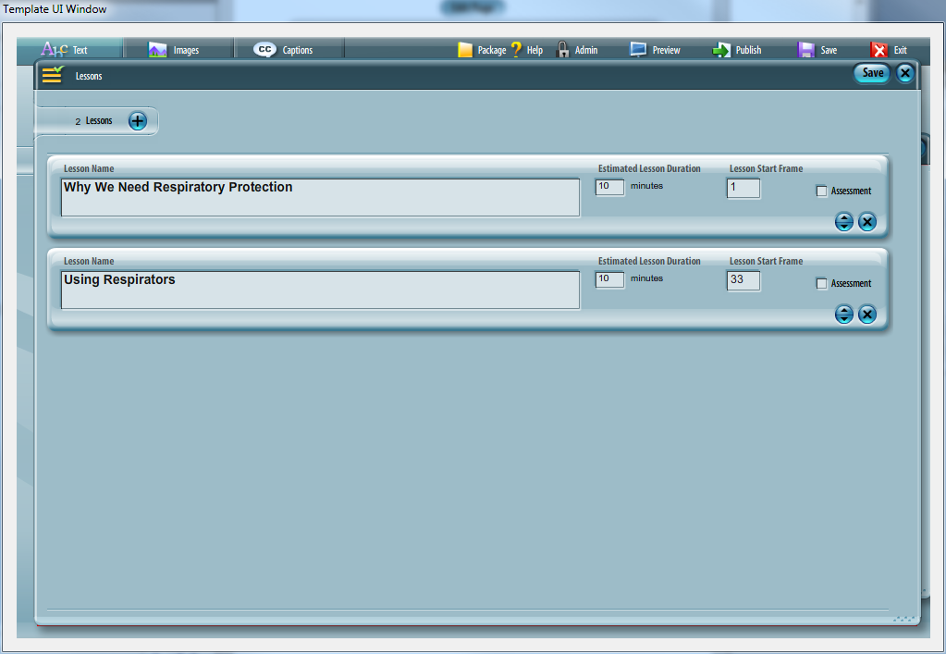

# Creating a Final Assessment

Final Assessments must always be built in the following order:

* Final Assessment Introduction Template
* Quiz Templates
* Final Assessment Submit
* Final Assessment Results
* Course Conclusion

The “Assessment” check box must be set for the lesson in the course lesson window of the Template UI. Selecting the assessment box indicates the lesson and its content should be treated as an assessment.

# Suggested Project Workflow

Generally, the best place to start a project is at the beginning:

**Identify and define the business need** for the training program

**Designate your project team**

Make sure you know up front who will be responsible for what project-related tasks. This may include Subject Matter Experts, (SMEs), content reviewers, graphics and audio personnel, writers, and so on.

Make sure you know who the key stakeholders in the project are. These are folks who will provide final sign off for the project or those with a vested interest in the project's outcome. For example, individuals in IT who will be responsible for implementing the solution.

**Identify the target audience**

**Identify and track down the content**

**Create a course outline**

Once you’ve got the basics established, create a course outline. Define content parameters for each lesson and write down specific learning objectives.

**Start Scripting/storyboarding**

Now you’re ready to start scripting. InVision Learning has provided Microsoft Word Scripting Templates that mimic the form of the Flash Learning Templates. If you write your course using these Script Templates, you’ll have an easy time organizing your content, keeping track of content gaps, and sending it out for initial team review and edits. And then you can simply cut and paste your content text right into the Flash Learning Templates.

Here is **one possible scripting/development workflow** that we have found works well, especially if a number of people will be involved in the creation and review of a course:

1. The Instructional Designer/Writer begins creating the script – this includes writing text, audio narration, and identifying graphics.

2. When a first draft is ready, share it with the designated project team and have them make edits directly to the Microsoft Word document.

3. Consolidate all comments, update the course script, and prepare to do a first draft using the Flash Learning Templates.

4. Create the Course and Lesson folder structure where all lesson assets will reside.

5. If a graphic artist will be gathering and creating artwork for the course, send him or her a copy of the script. Graphic images can be saved directly to the appropriate lesson folders. For easy identification, you may want to name graphics using the Screen ID # used in the Script Template.

6. Use the Learning Templates to begin creating lesson pages. For the first working draft, you may only be entering text and placeholder graphics.

7. Once the bulk of the content text is in place, you have an alpha version of your course. Have your project team do an online review and send you all comments and edits.

8. Update the course files using Flash Templates and make any appropriate changes to your script. Important: make sure that text edits are reflected in any audio transcripts.

9. Continue the update and review process until you feel confident that the on-screen content is solid.

10. Finalize your audio script and have the audio narration recorded. A good naming convention to use for saving audio files is the Screen ID# entered in the Script Templates.

11. Add the audio files to the course lesson pages using the Flash Templates. At this point, you can also time the text bullets to the audio, and create and time the closed captioning.

12. You now have a beta version of the course.

13. Send it around for a “final” review and make any last changes.

14. When you feel confident that the course is ready to go live, send an updated Course Launch page and the final course folders and files over to IT to be uploaded onto the web server.

This is just one way of creating a course. You may find a process that works better for you and your team.

# Using Audio, Video & Text

Using Text  
As much as possible, avoid lengthy text explanations and long paragraphs on a page. Users typically scan computer screens for information.

* Keep information to small digestible chunks of information.
* Use short text bullets for ease of scanning — 1 or 2 sentences per bullet max.
* If you're using audio, avoid narrating the on-screen text word for word. In fact, some research argues that including both text bullets and audio narration of those text bullets is overwhelming to a learner's working memory. Instead, use effective graphics and audio.

Graphics

**Graphics**The use of graphic images – photographs, illustrations, diagrams – can help your content come alive and allow learners to connect with the material.

Keep the following standards in mind when creating and saving your graphic images for a course:

* Always use non-progressive jpg files or PNG files.
* When saving jpg files, you always want to compress them as much as possible while maintaining the visual integrity of the image. There is no one right answer for this. When you start to see that an image has become pixilated, colors change, or the general quality of the image has degraded, then you know you’ve compressed it too far.
* The Templates give you some width & height size guidelines for images.
* Experiment with file image sizes to come up with an internal best practice.
* We recommend using Adobe Photoshop or Fireworks to manipulate images.

Audio  
Incorporating audio narration is a powerful way to make the content more accessible. Remember, there are a number of different learning styles out there – some of us learn best by hearing, some by seeing, and some by doing. A course that incorporates multiple approaches will have the best chance of meeting the needs of the most people.

More importantly, providing multiple representations of content creates opportunity for repetition, and effective tool for reinforcing information and ensuring an effective transfer of knowledge.

Recent studies have shown that it is best to NOT have audio simply narrate on-screen text, if there are also animations and other graphics to view on the screen. This can create an overload of the learner's working memory and is perhaps counter to older models of instructional design. Read [Ruth Clark's E-Learning and the Science of Instruction](http://www.amazon.com/e-Learning-Science-Instruction-Guidelines-Multimedia/dp/0787986836/ref=sr_1_1/002-7175010-9400050?ie=UTF8&s=books&qid=1190130103&sr=8-1) for more information on this topic.

Keep the following in mind when creating audio for a course:

* Only one audio file is allowed per page.
* Audio files must be converted to .mp3 format. Templates only support mp3 audio.
* Compression quality can change – the smaller the file size, the poorer the sound quality.
* Instruct Audio Recording crew/editors to save audio files in .mp3 format at 44,100 Hz. Lower sample rates will not play properly in Flash.

Video

**Video**If using video, keep the following in mind:

* Videos must be saved in an .flv or MP4 format (this is the Flash video format).
* Any other video formats (e.g., QuickTime or AVIs) can be saved as an .flv using the Flash video encoder that is provided with Adobe Flash.
* Be aware of the video size (width & height) and bandwidth.

Closed Captioning  
ClosedInVision Templates support the use of Closed Captioning in all of our courses. This enables learners to read an exact transcript of the audio file — useful when a learner’s computer does not have an audio card, or for learners with hearing difficulties.

# Admin Template UI

The Admin Template UI window allows developers to modify the global attributes of the course. These global values are used over more than one page in the course and typically appear in the navigation window.

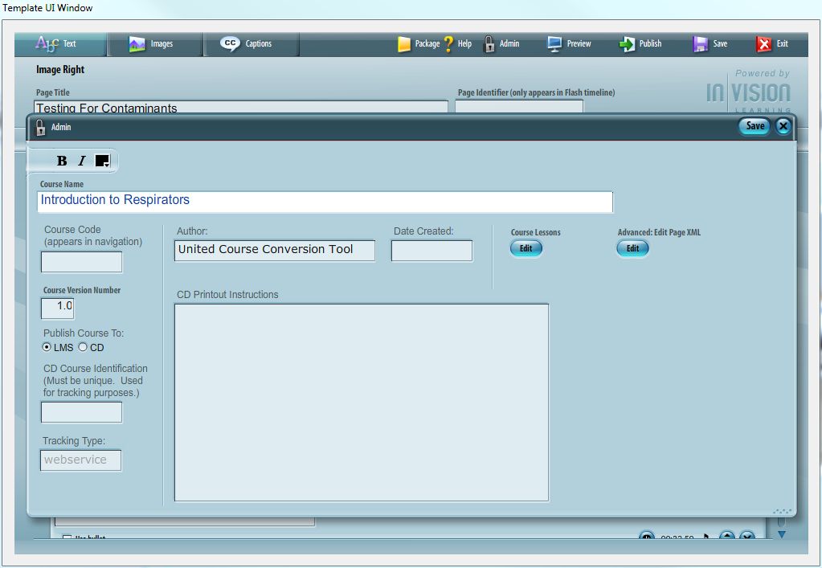

# Template Types

# Course Introduction

Overview

The Course Introduction Template is used at the beginning of a course to display course title, Course Version, Course Date and a help window prompt.

* This is a default screen and text cannot be modified by the TemplateUI.
* Version is automatically populated by the value from the Admin UI.
* Date is automatically populated by the value from the Admin UI.

This page should be one of the first pages the learner sees upon launching a course.   
Example   
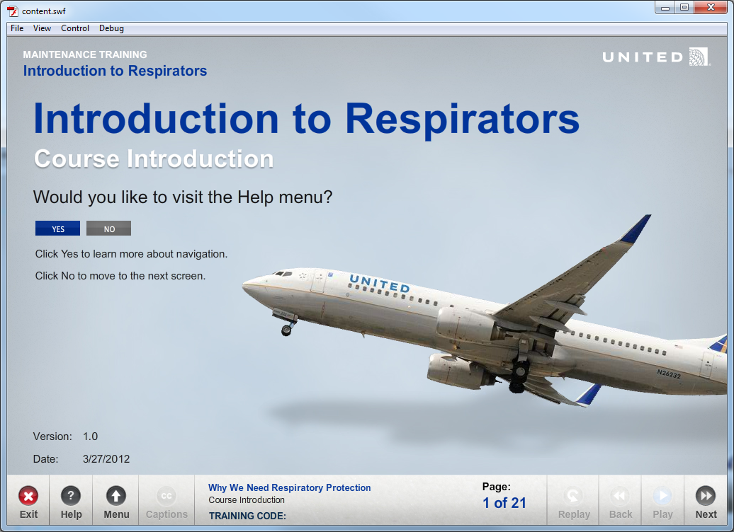

Using the Course Introduction Template  
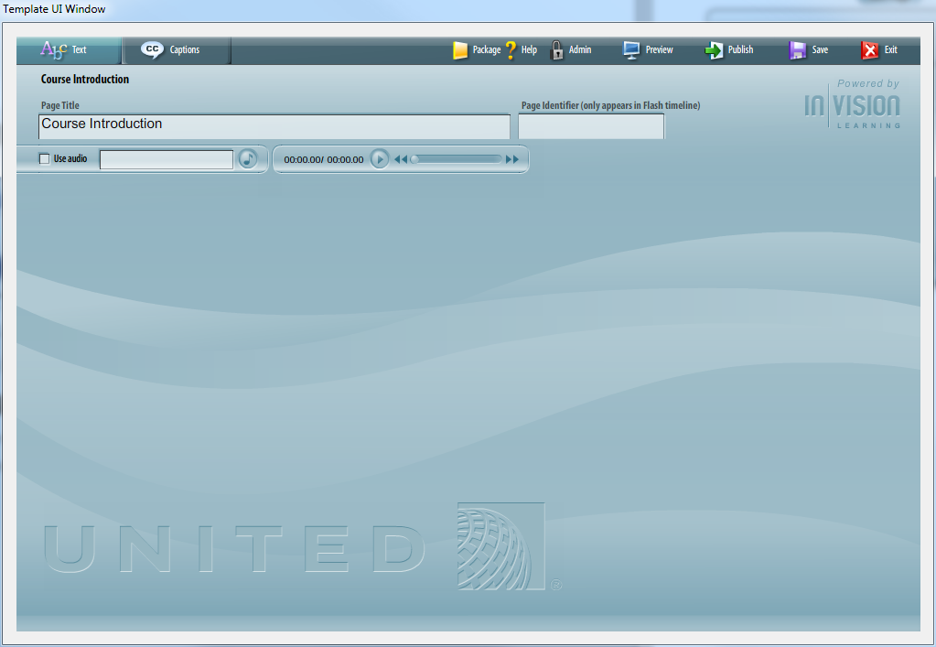

|  |  |
| --- | --- |
|  | Enter Page Name |
|  | Add Audio |
|  | Version – Value set in the Admin UI. |
|  | Date – Value set in the Admin UI. |

# Administrative Text

Overview

The Administrative Text Template is used at the beginning of a course to display copyright and disclaimer information.

This page should be one of the first pages the learner sees upon launching a course.

Example  
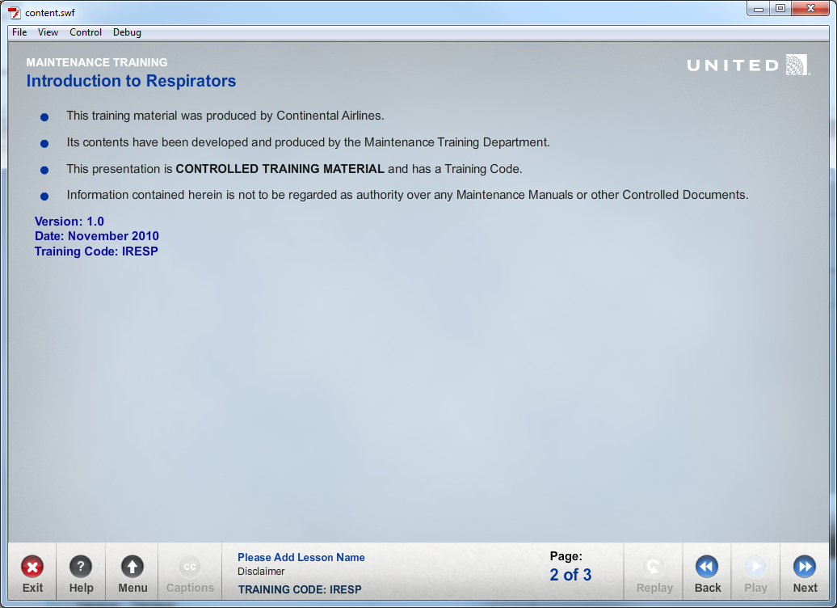

Sample Admin Text Content

The following text example has been standard in many of United's Maintenance Training Courses. We include it here as a reference.

* This training material was produced by United.
* Its contents have been developed and produced by the Maintenance Training Department.
* This presentation is **CONTROLLED TRAINING MATERIAL** and has a Training Code.
* Information contained herein is not to be regarded as authority over any Maintenance Manuals or other Controlled Documents.

Using the Administrative Text Template  
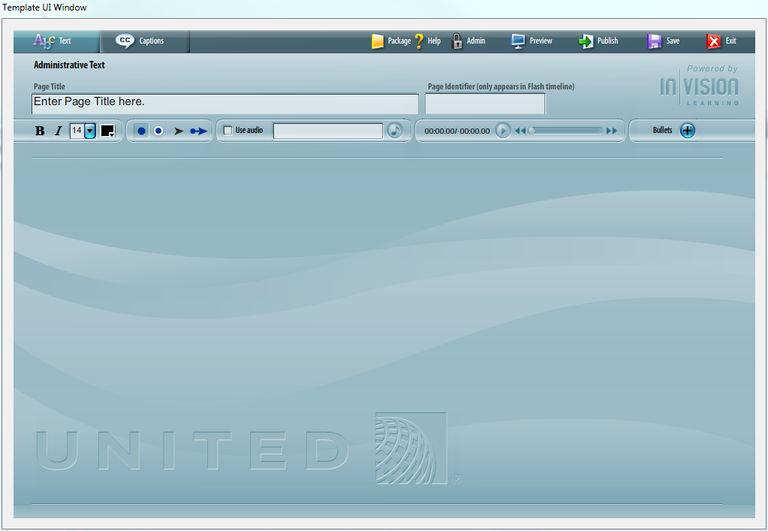

|  |  |
| --- | --- |
|  | Enter Page Name |
|  | Enter & Edit Bulleted Text |
|  | Add Audio |
|  | Time Text Bullets to Audio |

Code Snippet  


**Important** Remember to always addeventlistener “removed_from_stage” to all custom classes. The event is called when the movie clip is removed from the stage. This event is triggered when the next or back button changes the play head of the timeline or when code is executed to removeChild. The purpose of including this event is to clean up any children or event listeners from the class.

If the class is not “cleaned up” when the displayObject is removed from the stage, the objects remain in memory and can cause errors if the object is loaded again. Clearing everything from memory prevents errors later in the course.

# Lesson Overview

Overview

The Lesson Overview Template can be used at the beginning of each lesson to provide a general description of the lesson.

The page layout includes text and the image-half-circle on the first side of the screen.

You cannot add highlights or callouts to images in this Template.

Example  
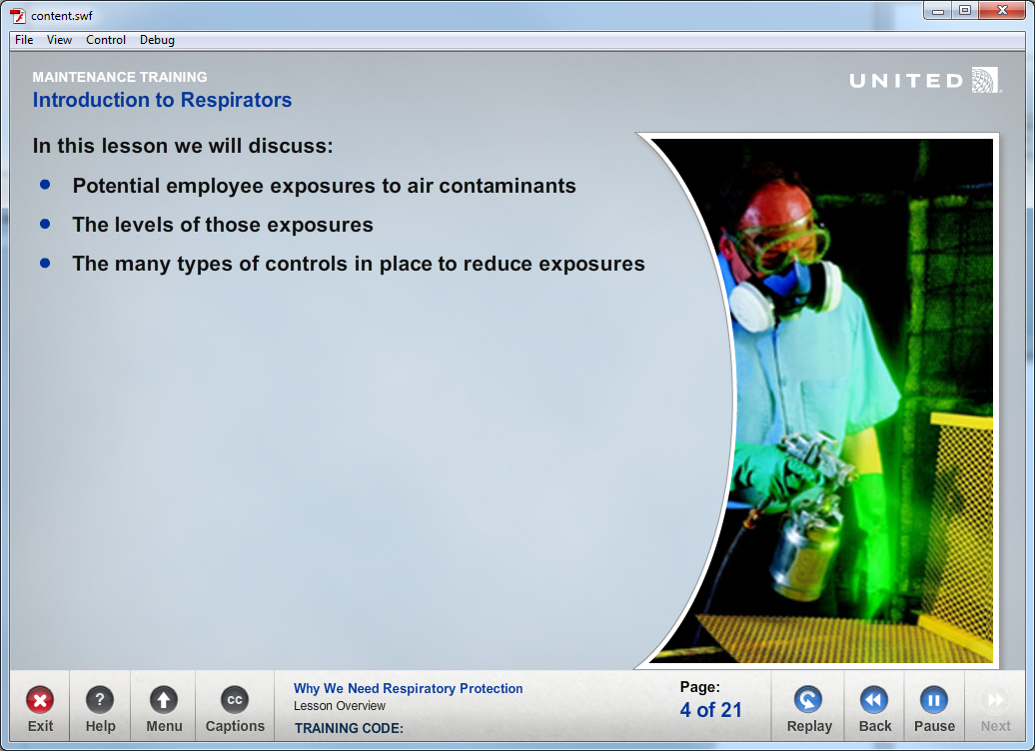

Using the Lesson Overview Template  
**Complete the Text Tab**  
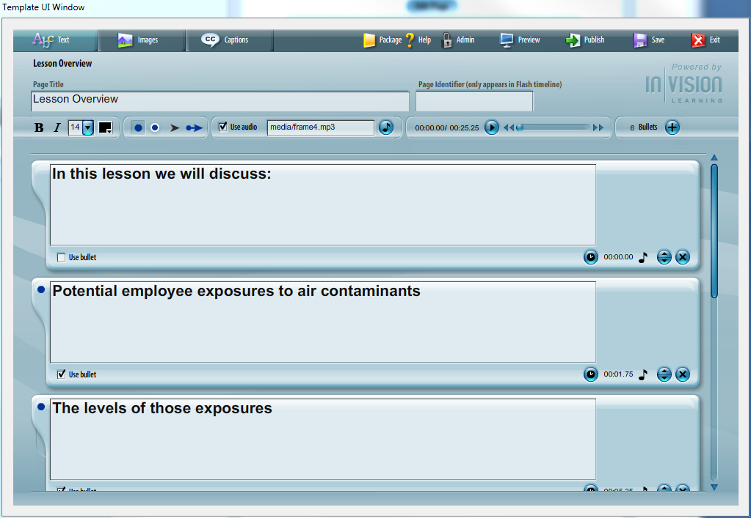

* Enter Page Name
* Enter & Edit Bulleted Text
* Add Audio
* Time Text Bullets to Audio

**Complete the Images Tab**  
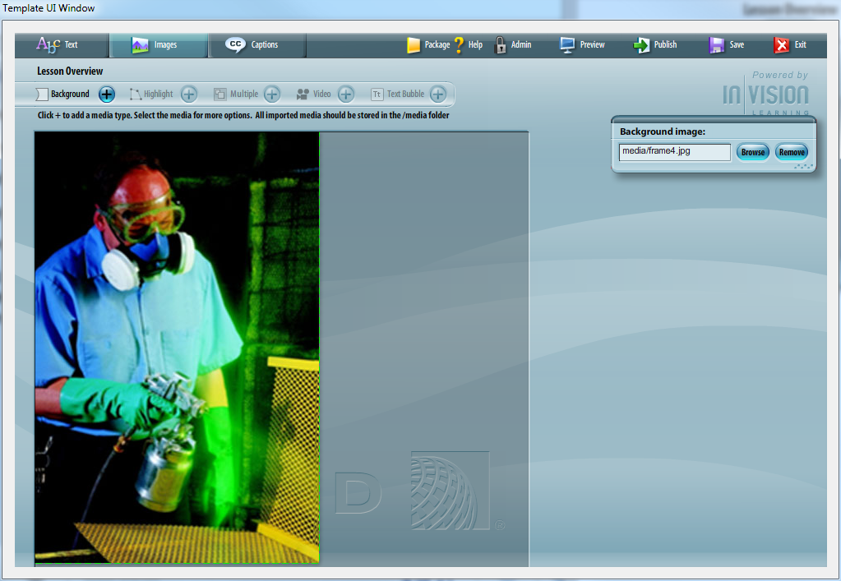

The Lesson Overview Templates uses the Image Half-Circle page layout. You only enter one background image for this template. Highlights, Multiple Images, Video and Text Bubble are disabled.

* Insert a background image

# Lesson Objective

Overview

The Lesson Objectives Template should be used at the beginning of each lesson to describe the learning objectives for this lesson.

The page layout includes text and the image-half-circle on the first side of the screen.

You cannot add highlights or callouts to images in this Template.

Example  
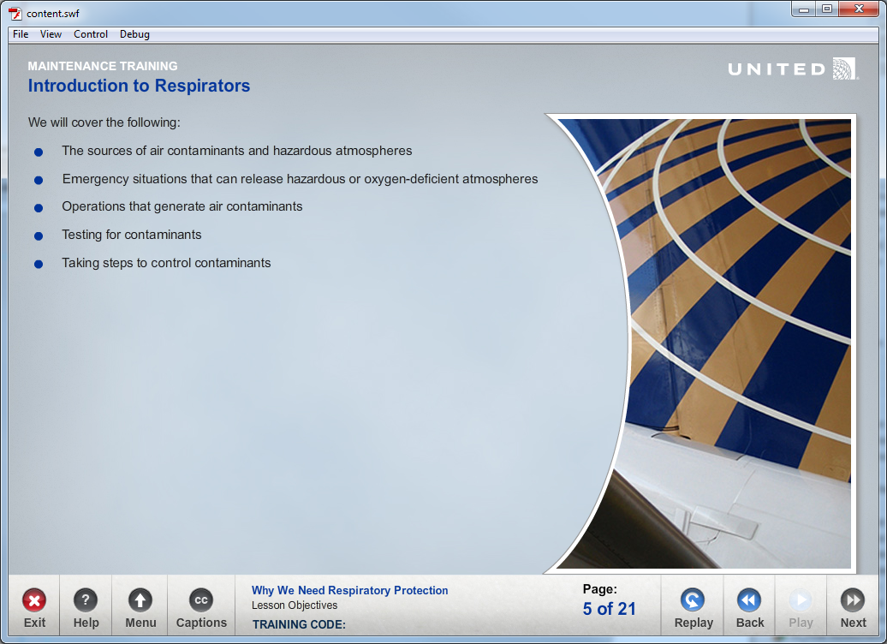

Using the Lesson Objectives Template  
**Complete the Text Tab**  
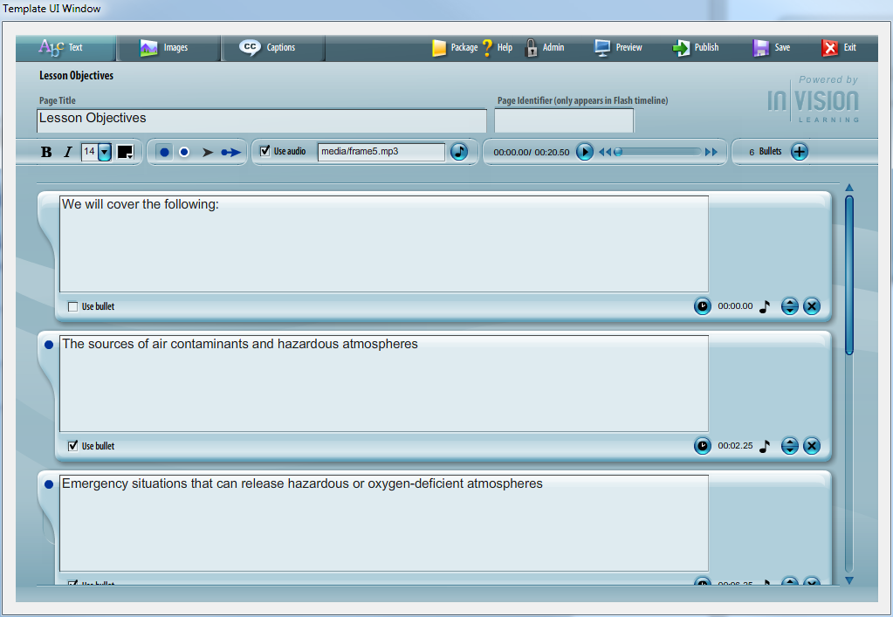

* Enter Page Name
* Enter & Edit Bulleted Text
* Add Audio
* Time Text Bullets to Audio

**Complete the Images Tab**  


The Lesson Objective Templates uses the Image Half-Circle page layout. You only enter one background image for this template. Highlights, Multiple Images, Video and Text Bubble are disabled.

* Insert a background image

# Image Half Circle

Overview

The Image Half-Circle Template can be used as a content page anywhere in a lesson.

The page layout includes text and the image-half-circle on the first side of the screen. To fill the entire image area, use an image that is 346 x 525 pixels.

You cannot add highlights or callouts to images in this Template.

Example  
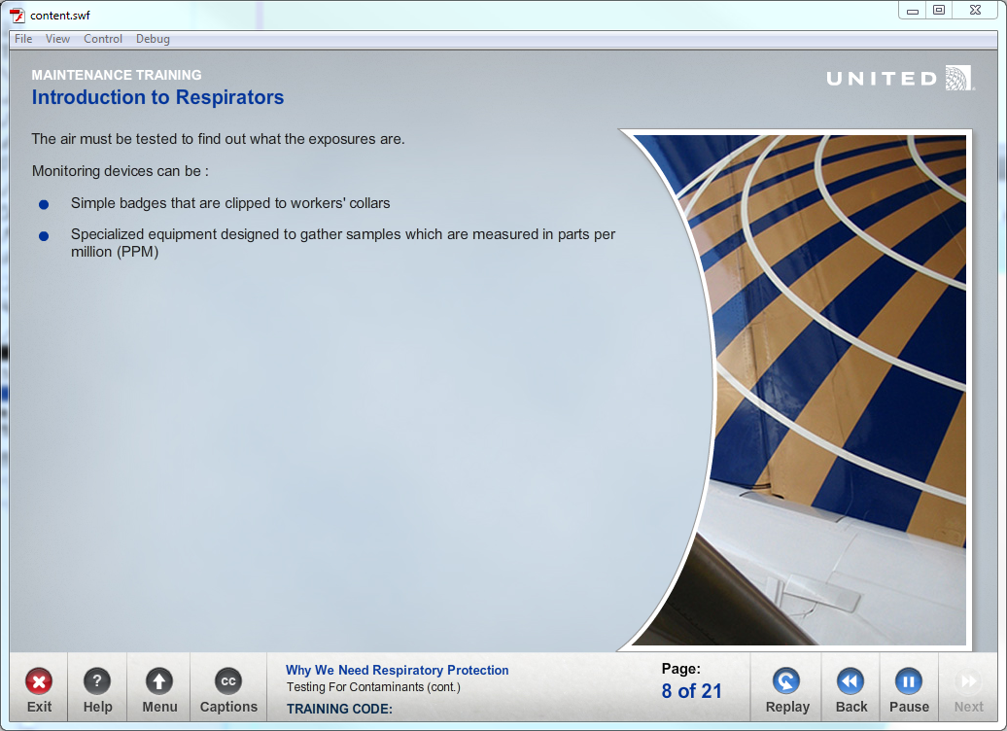

Using the Image Half-Circle Template  
**Complete the Text Tab**  
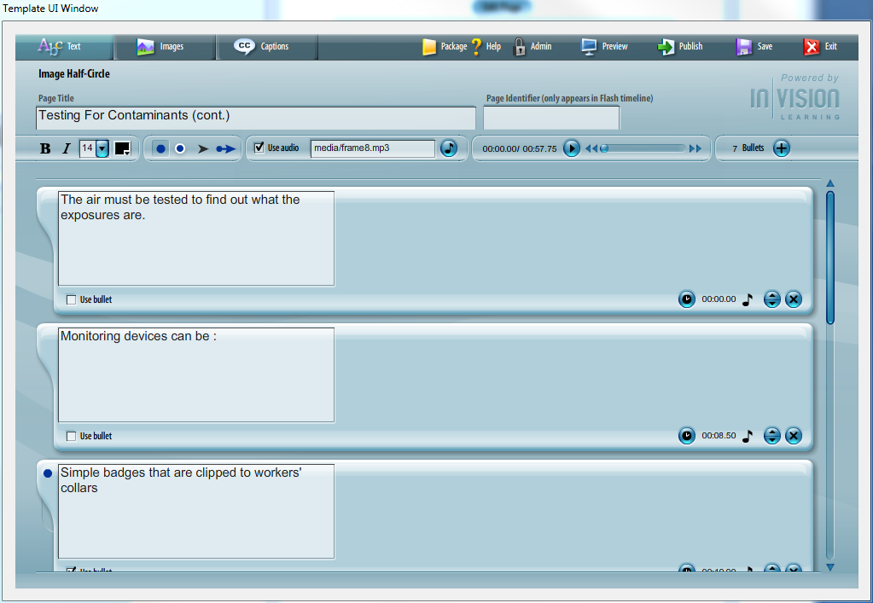

* Enter Page Name
* Enter & Edit Bulleted Text
* Add Audio
* Time Text Bullets to Audio

**Complete the Images Tab**  
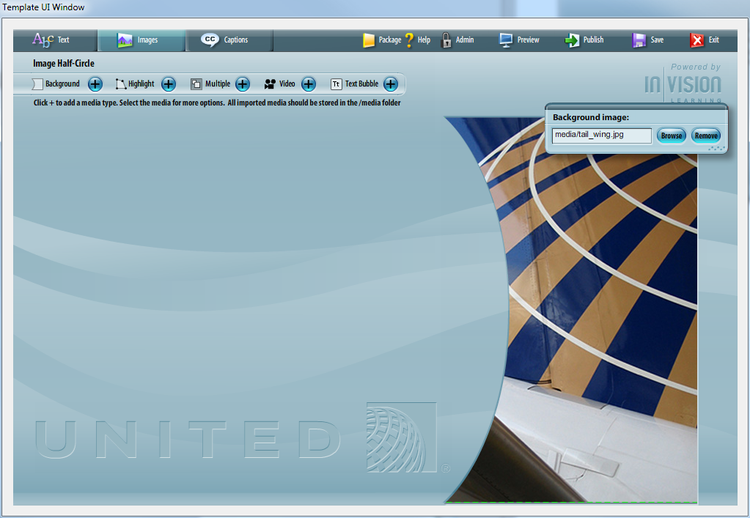

The Image Half-Circle page layout allows you to enter background images, highlights, multiple images, video, text bubble.

To fill the entire half-circle area, use an image that is 346 x 525 pixels.

# Image Top

Overview

The Image Top Template can be used as a content page anywhere in a lesson.

You can add highlights or callouts to images in this Template.

Example  
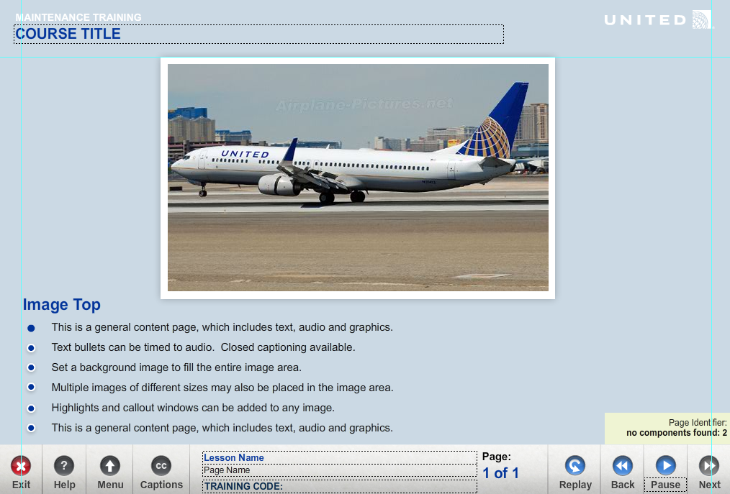

Using the Image Top Template  
**Complete the Text Tab**  
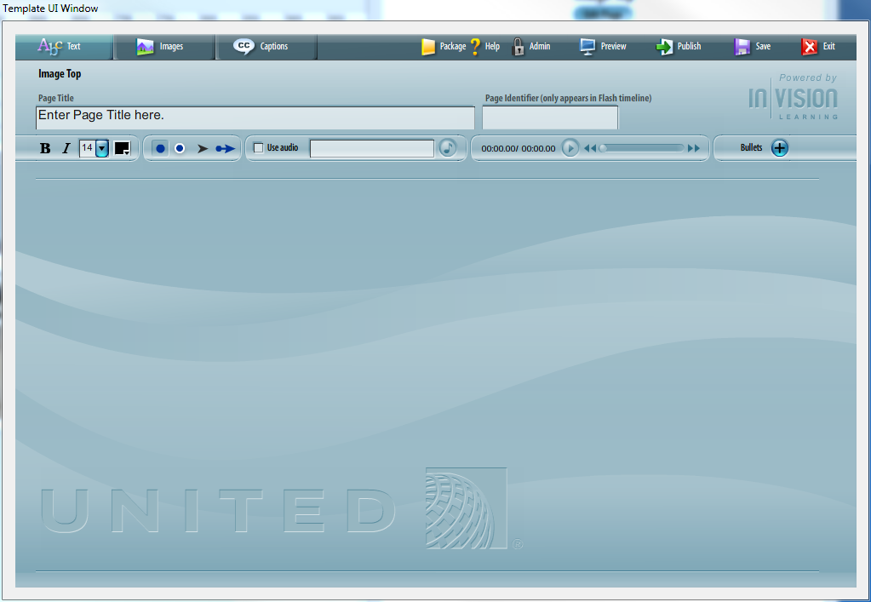

* Enter Page Name
* Enter & Edit Bulleted Text
* Add Audio
* Time Text Bullets to Audio

**Complete the Images Tab**  
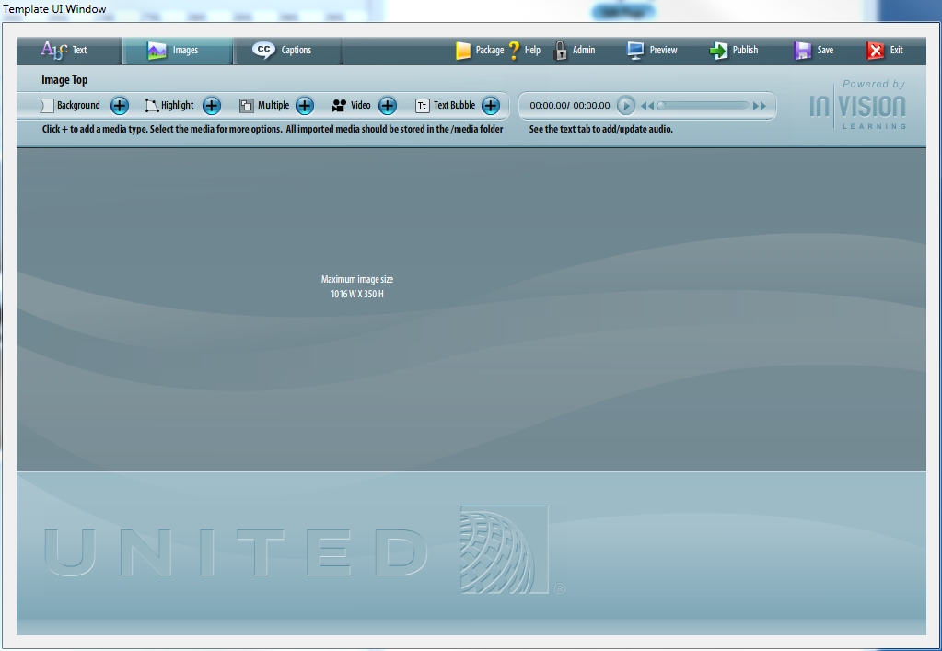

The Image Top page layout allows you to enter an optional background image. To fill the entire background area, use an image that is 1016 x 350 pixels.

You can multiple images to the screen to create a collage.

Highlights can be added to images. Highlights can be timed to the audio file and will open a callout box with a more detailed view.

Video can be added to the stage. Video controls can be turned on or off.

Text bubble windows can be added to the stage.

# Image Bottom

Overview

The Image Bottom Template can be used as a content page anywhere in a lesson.

You can add highlights or callouts to images in this Template.

Example  
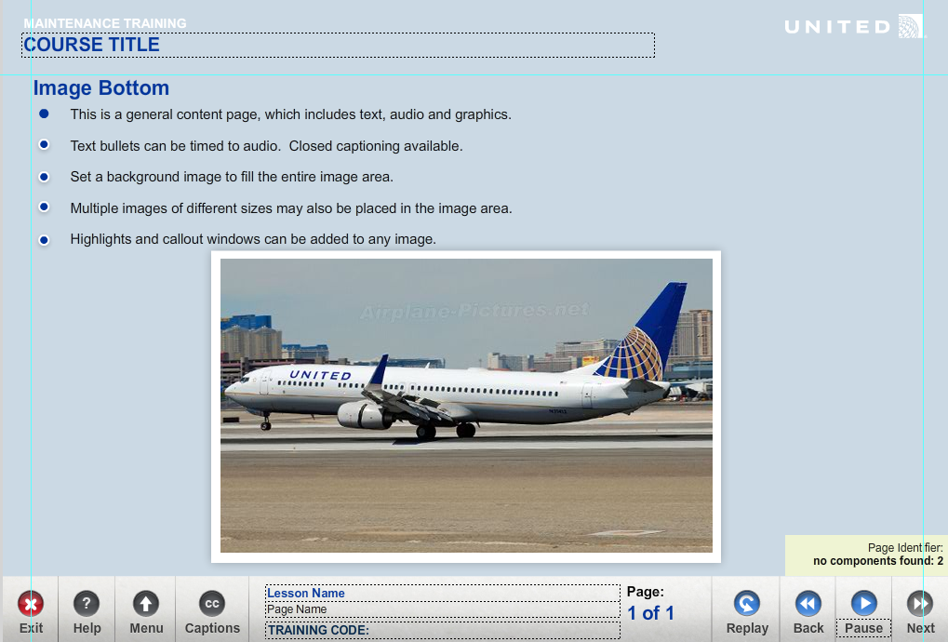

Using the Image Top Template  
**Complete the Text Tab**  
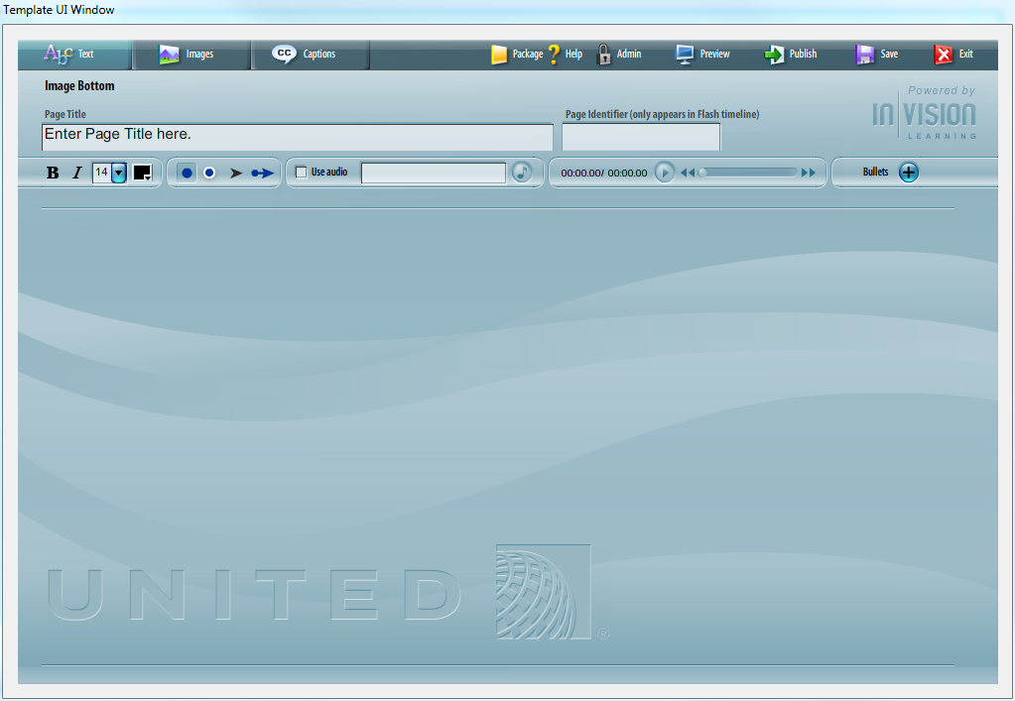

* Enter Page Name
* Enter & Edit Bulleted Text
* Add Audio
* Time Text Bullets to Audio

**Complete the Images Tab**  
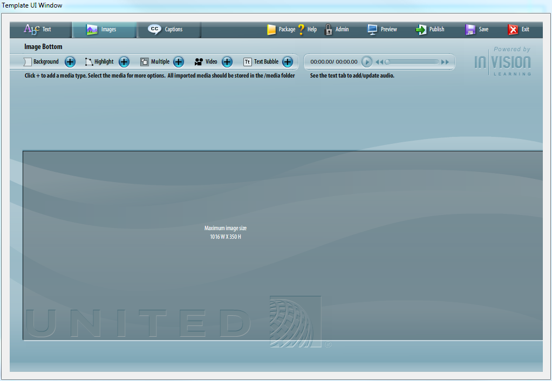

The Image Bottom page layout allows you to enter an optional background image. To fill the entire background area, use an image that is 1016 x 350 pixels.

You can multiple images to the screen to create a collage.

Highlights can be added to images. Highlights can be timed to the audio file and will open a callout box with a more detailed view.

Video can be added to the stage. Video controls can be turned on or off.

Text bubble windows can be added to the stage.

# Image Left

Overview

The Image Left Template can be used as a content page anywhere in a lesson.

You can add highlights or callouts to images in this Template.

Example  
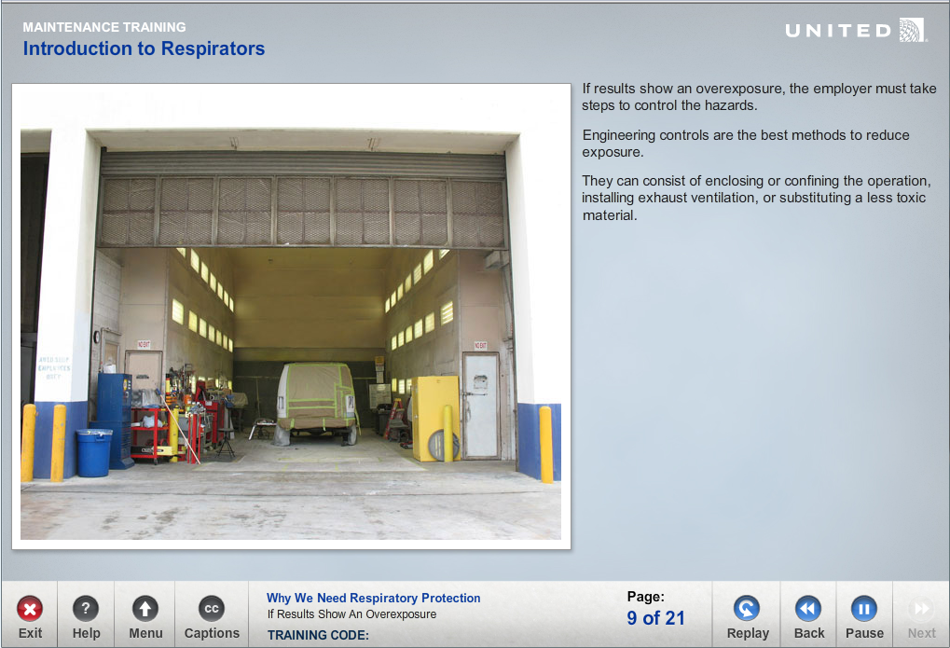

Using the Image Left Template  
**Complete the Text Tab**  
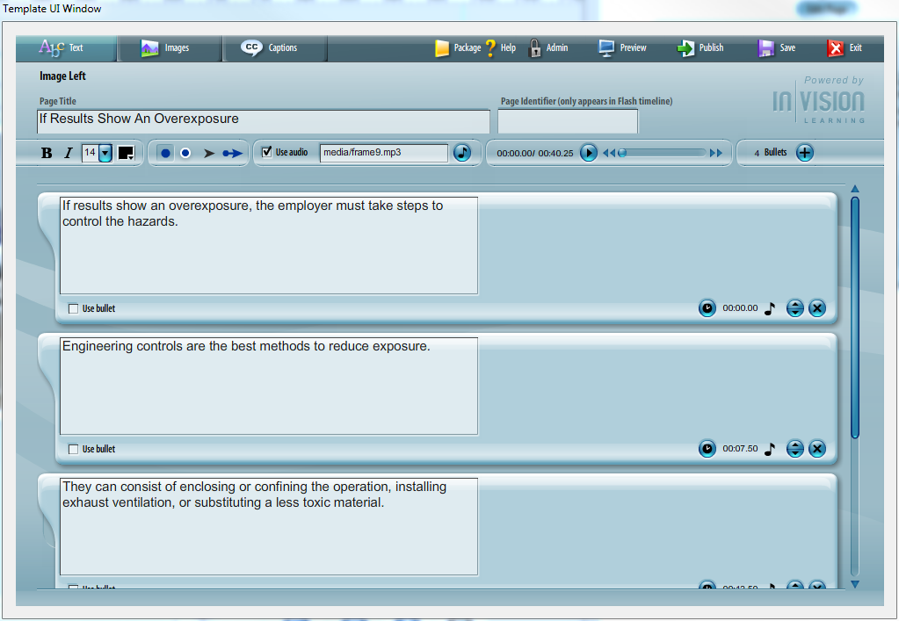

* Enter Page Name
* Enter & Edit Bulleted Text
* Add Audio
* Time Text Bullets to Audio

**Complete the Images Tab**  
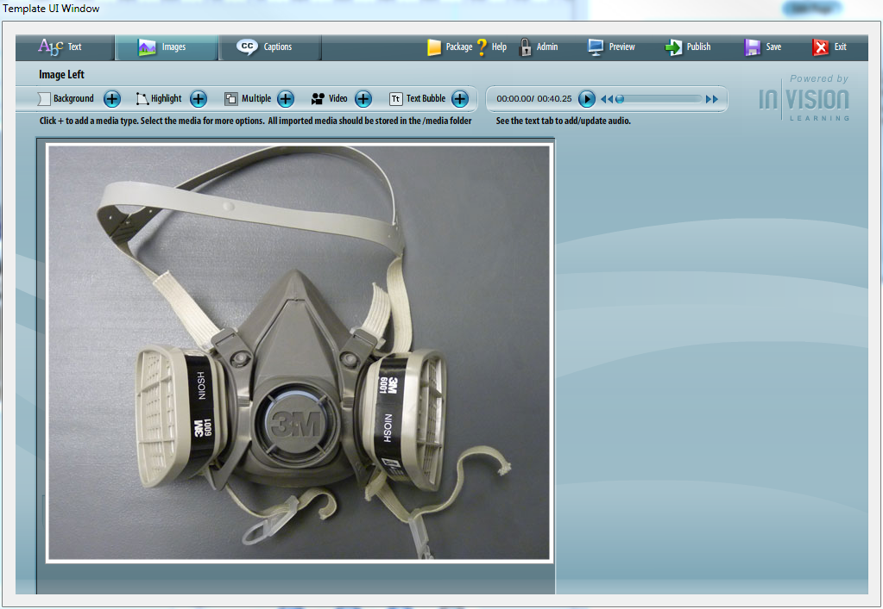

The Image Left page layout allows you to enter an optional background image. To fill the entire background area, use an image that is 600 x 538 pixels.

You can multiple images to the screen to create a collage.

Highlights can be added to images. Highlights can be timed to the audio file and will open a callout box with a more detailed view.

Video can be added to the stage. Video controls can be turned on or off.

Text bubble windows can be added to the stage.

# Image Right

Overview

The Image Right Template can be used as a content page anywhere in a lesson.

You can add highlights and callouts to images in this Template.

Example  
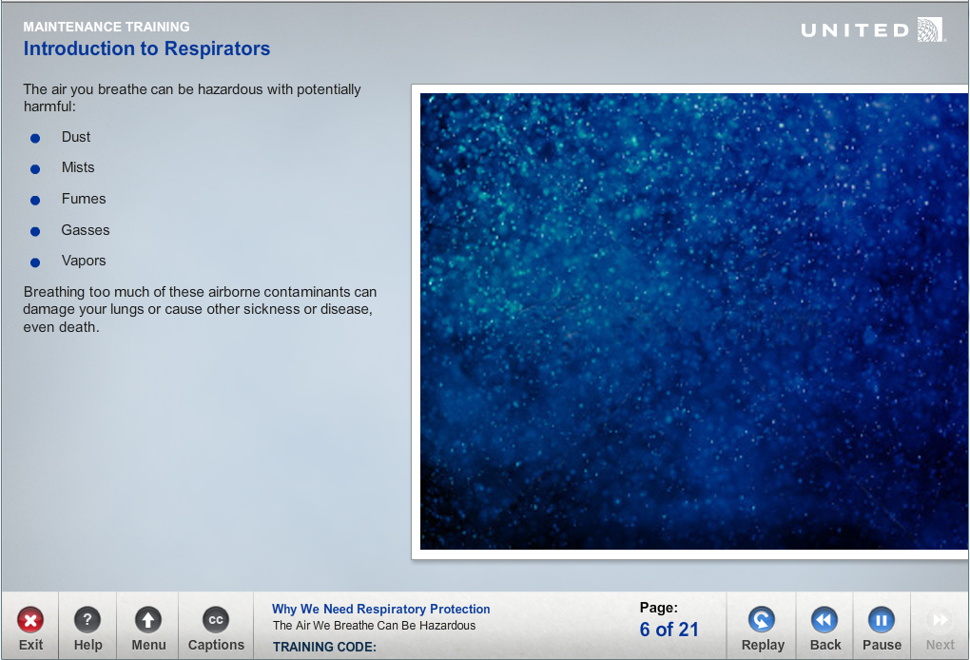

Using the Image Right Template  
**Complete the Text Tab**  
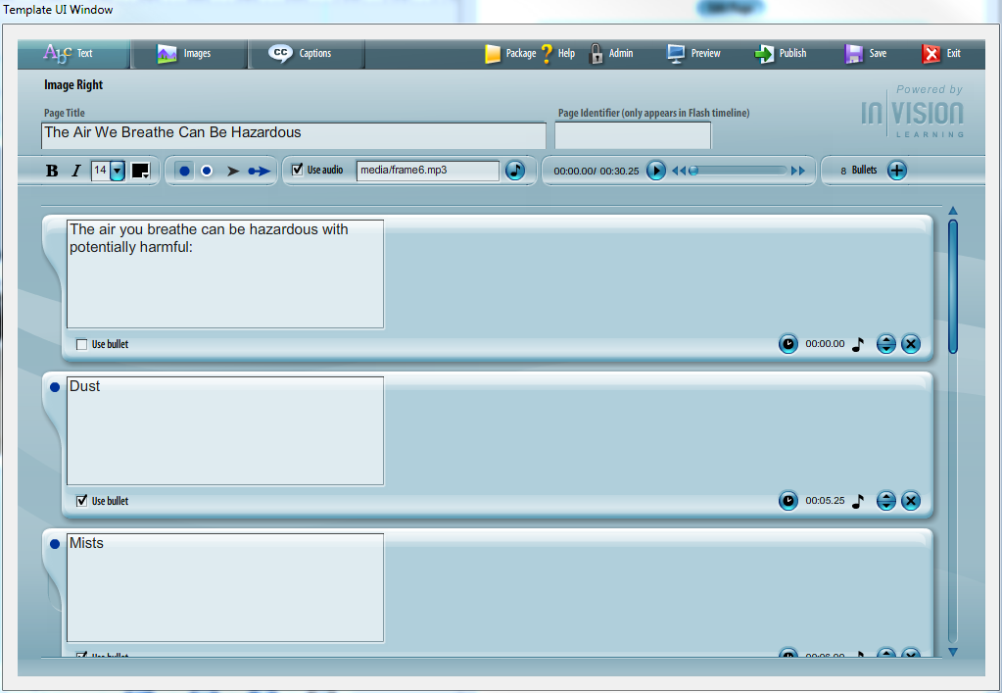

* Enter Page Name
* Enter & Edit Bulleted Text
* Add Audio
* Time Text Bullets to Audio

**Complete the Images Tab**  
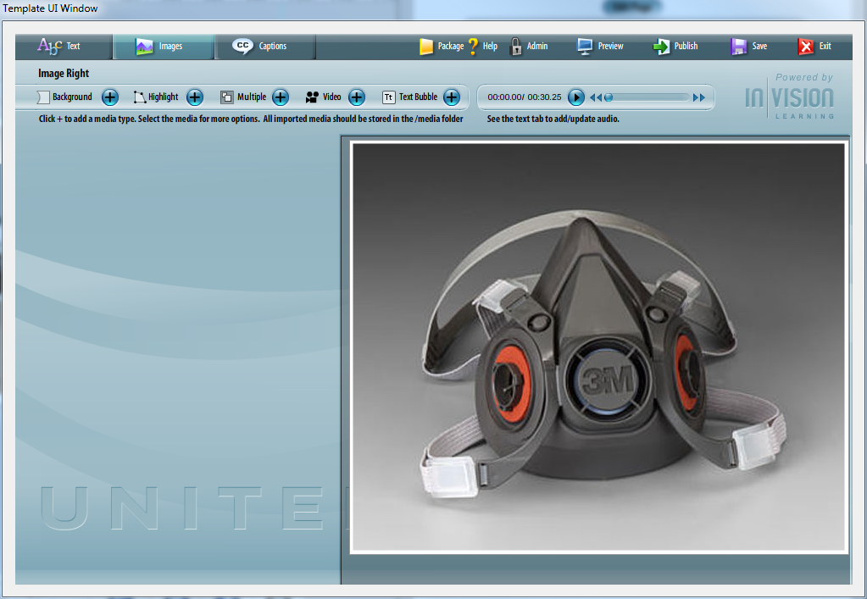

The Image Right page layout allows you to enter an optional background image. To fill the entire backbround area, use an image that is 600 x 538 pixels.

You can multiple images to the screen to create a collage.

Highlights can be added to images. Highlights can be timed to the audio file and will open a callout box with a more detailed view.

Video can be added to the stage. Video controls can be turned on or off.

Text bubble windows can be added to the stage.

# Image Full Screen

Overview

The Image Full Screen Template can be used as a content page anywhere in a lesson.

This template is used to display a full screen image or to create a full screen collage of images. There is only one short line of text. This page is optimal for displaying detailed animations with a lot of graphics, or for inserting a full page animated .swf file that was created external to templates.

You can add highlights and callouts to images in this Template.

Example  
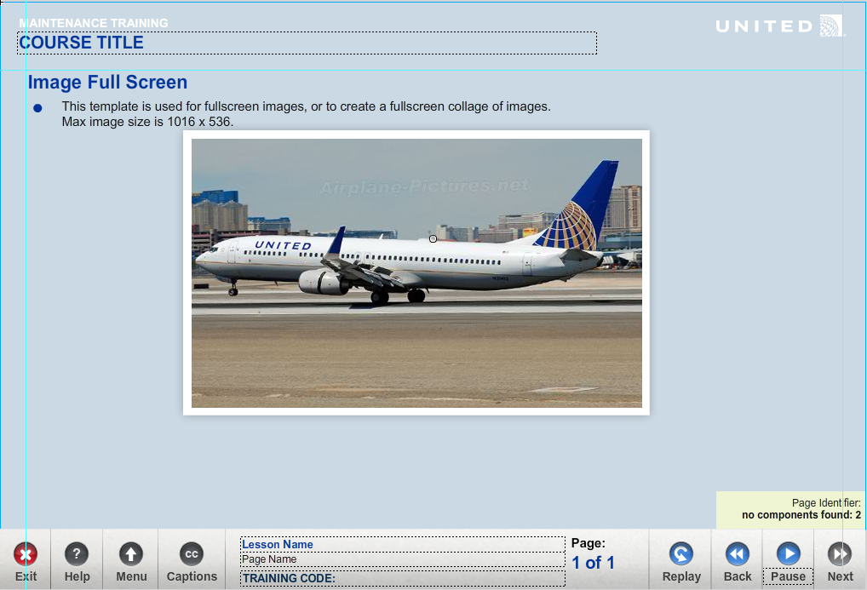

Using the Image Right Template  
**Complete the Text Tab**  
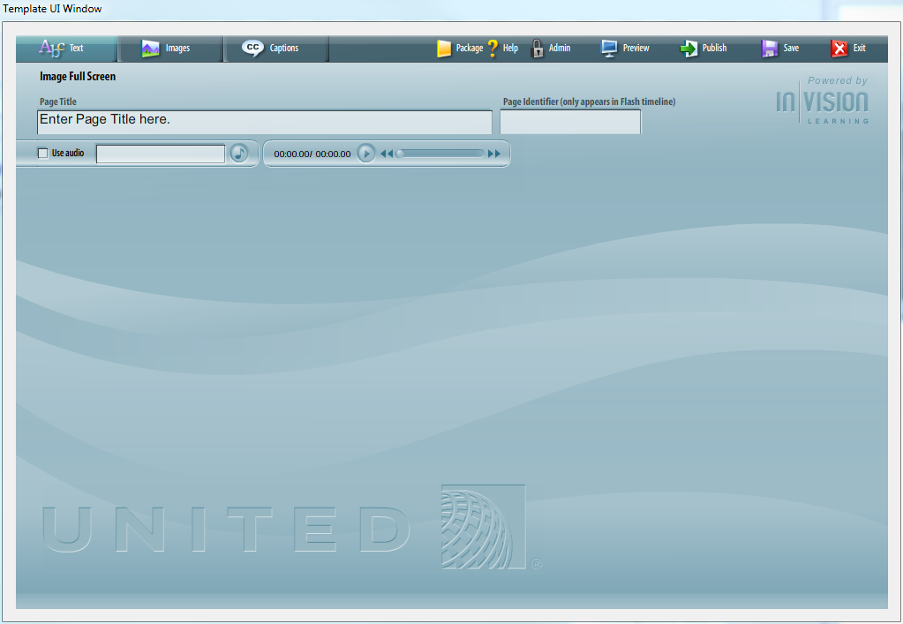

* Enter Page Name
* Enter & Edit Bulleted Text
* Add Audio

**Complete the Images Tab**  
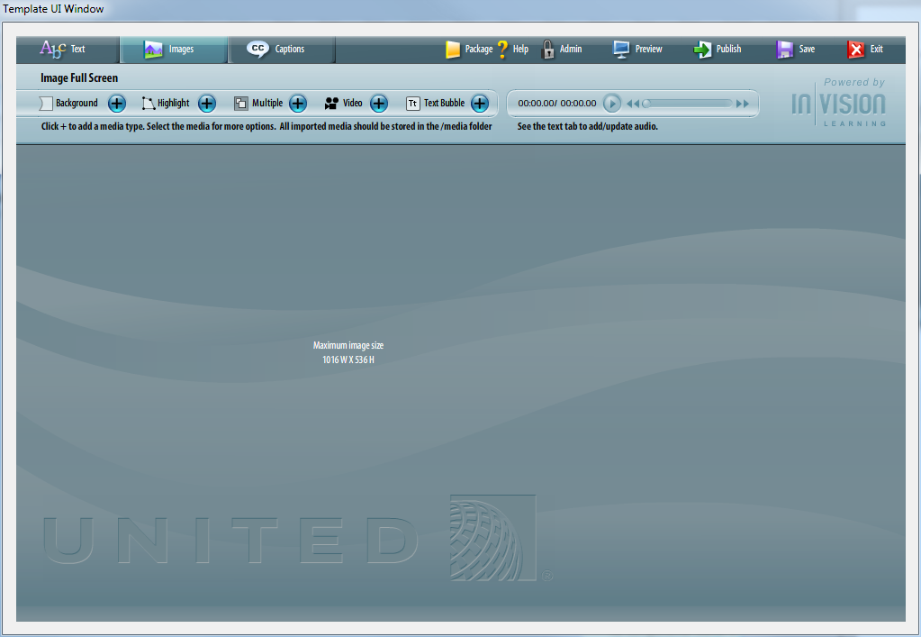

The Image Full Screen page layout allows you to enter an optional background image. To fill the entire backbround area, use an image that is 1016 x 536 pixels.

You can multiple images to the screen to create a collage.

Highlights can be added to images. Highlights can be timed to the audio file and will open a callout box with a more detailed view.

Video can be added to the stage. Video controls can be turned on or off.

Text bubble windows can be added to the stage.

# Video

Overview

The Video Template can be used as a content page anywhere in a lesson.

It includes text and a video file. The video control will resize dynamically based on the size of the video. There is no limits on the size of the video.

All video files must be saved in a .flv or .mp4 format. This is a Flash video file. Video files can be converted to a .flv or .mp4 format using the Flash Video Encoder, or any other third-party video encoding software.

The video slider is locked by default. This prevents learners from jumping to the next end of the video. Learners must watch the entire video to enable the next button.

Example  
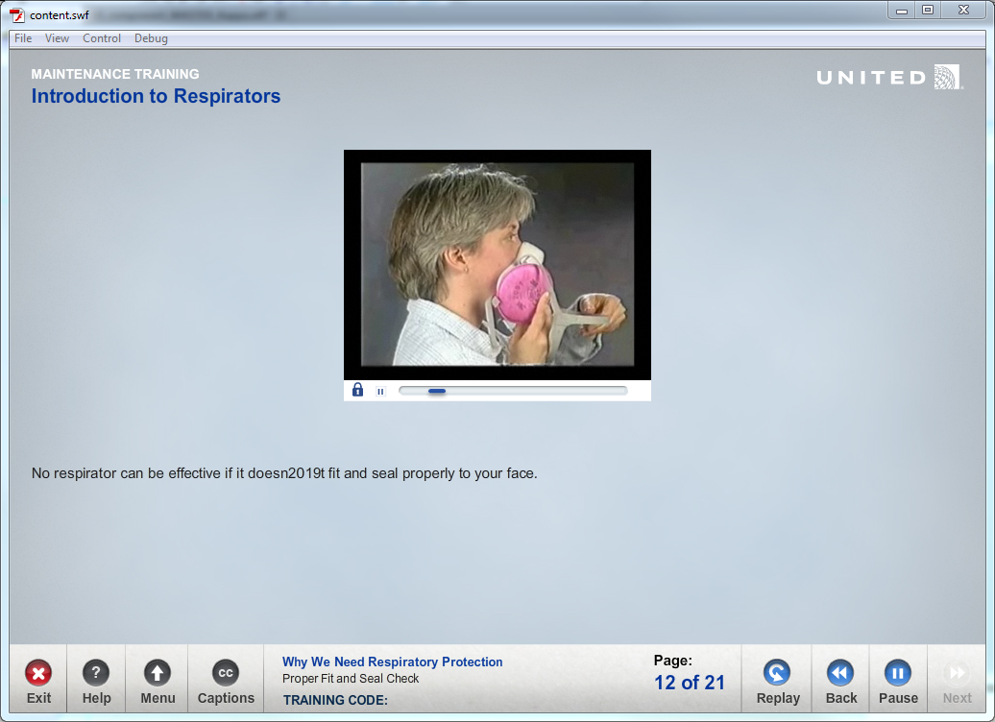

Using the Video Template  
**Complete the Text Tab**  
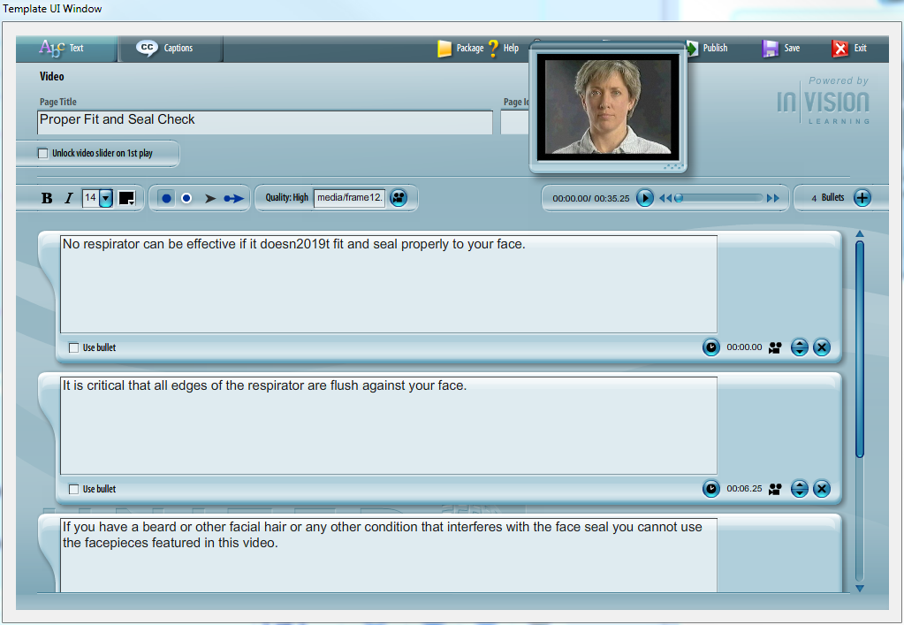

* Enter Page Name
* Enter & Edit Bulleted Text

As soon as a video has been added to the page, a Video Preview window will pop open. Note: this preview window is not in the actual size.

Once a file is selected, the filename will appear as well as the length of the file. You can play the video by clicking on the play button, or moving the scrubber bar along the timeline.

Timed bulleted text is timed to the video file.

# Click to Learn

Overview

The Click to Learn Template can be used as a content page anywhere in a lesson.

This template is used to display additional information about the content on the screen. When highlights are clicked on the stage, a pop-up window with text and graphics appears on the stage.

You can add highlights and callouts to images in this Template.

Example  
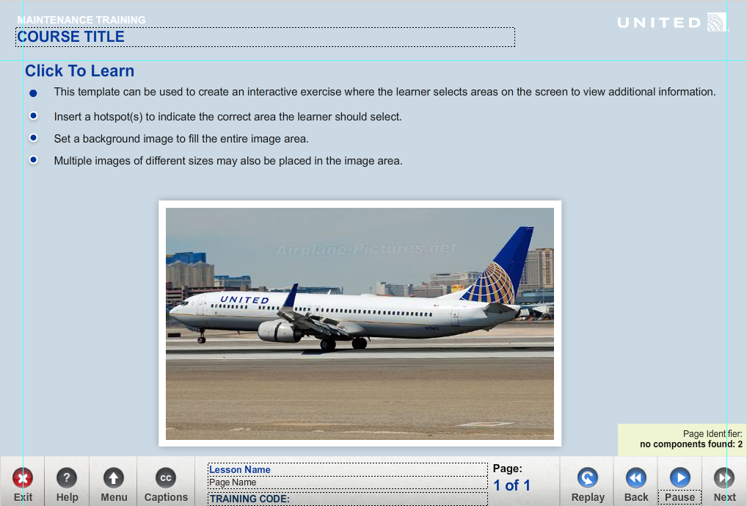

Using the Click to Learn Template  
**Complete the Text Tab**  
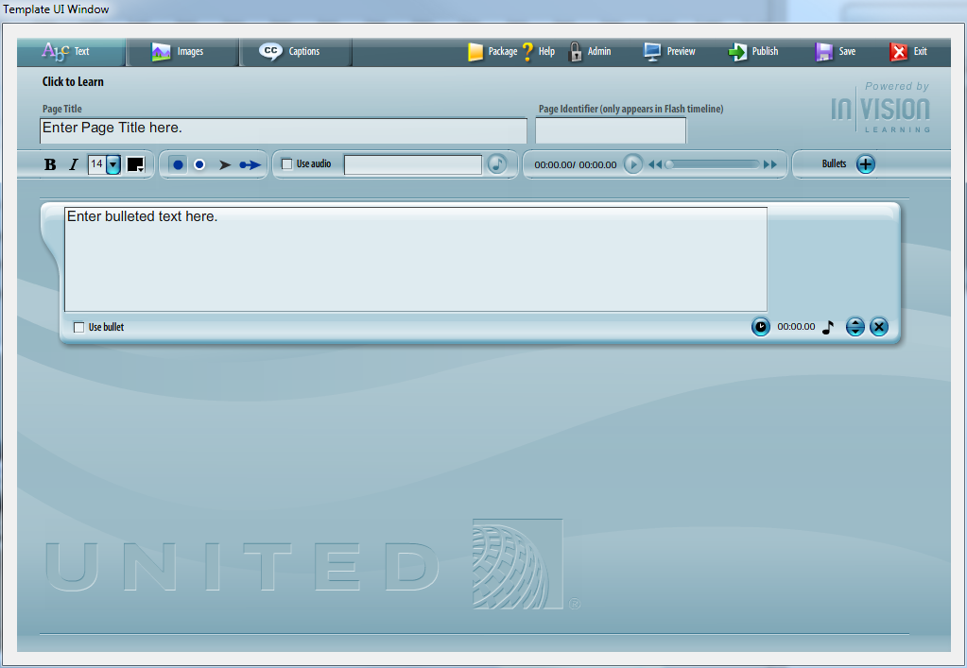

* Enter Page Name
* Enter & Edit Bulleted Text
* Add Audio

**Complete the Images Tab**  
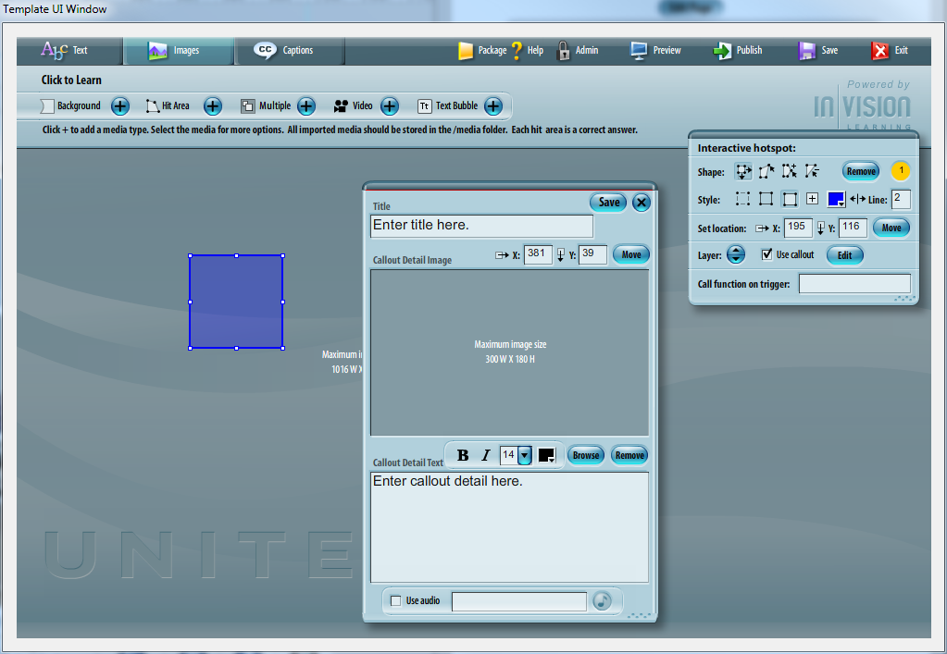

The Image Full Screen page layout allows you to enter an optional background image. To fill the entire backbround area, use an image that is 1016 x 536 pixels.

You can multiple images to the screen to create a collage.

Hit areas can be added to the stage. Learners click the hit area to show the callout information window.

Video can be added to the stage. Video controls can be turned on or off.

Text bubble windows can be added to the stage.

# Reflective

Overview

The Reflective Template can be used as a content page anywhere in a lesson.

This template is used to create a pause in the course content to allow the learner a moment to think about his or her own experiences and how they might apply the concepts being learned to their own jobs.

When the user starts typing a check answer button is displayed. When the learner clicks the button, feedback text is shown. The feedback text is used to help evaluate their response against best practices, etc.

Images and graphics can not be added to this screen using the Template UI.

Example  
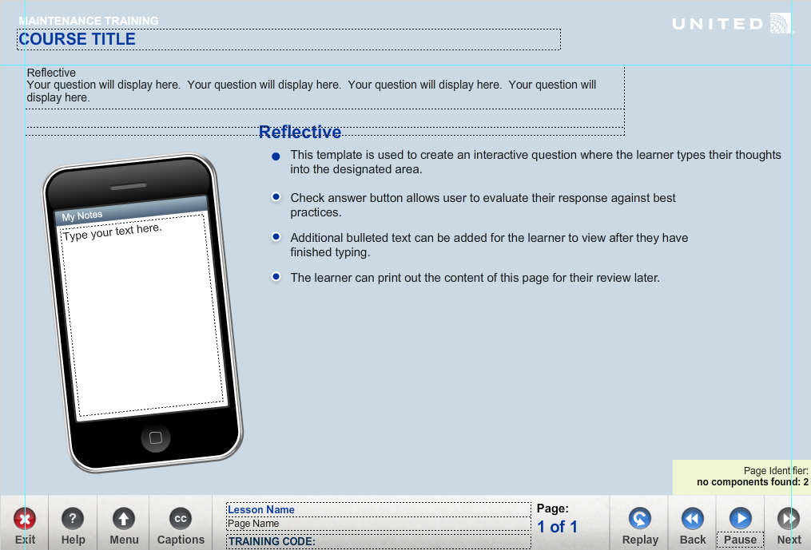

Using the Reflective Template  
**Complete the Question Tab**  
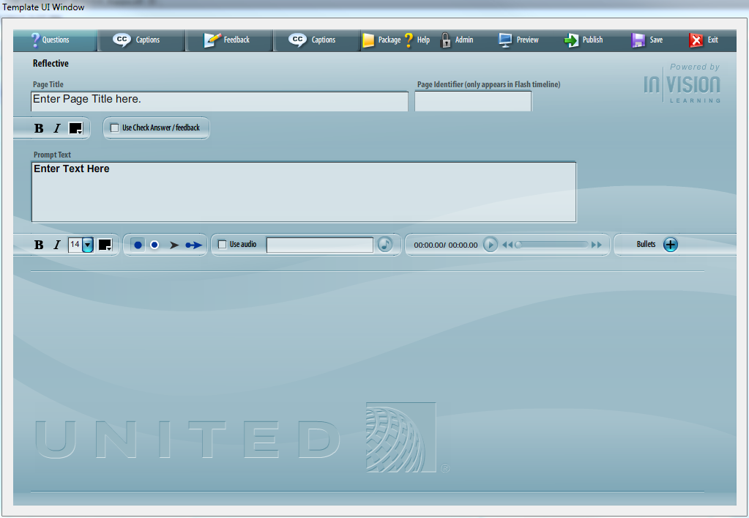

* Enter Page Name
* Add Question Prompt Text
* Enter & Edit Bulleted Text for Question
* Add Audio
* Add Feedback Prompt Text
* Enter & Edit Bulleted Text for Feedback

**Complete the Feedback Tab**  
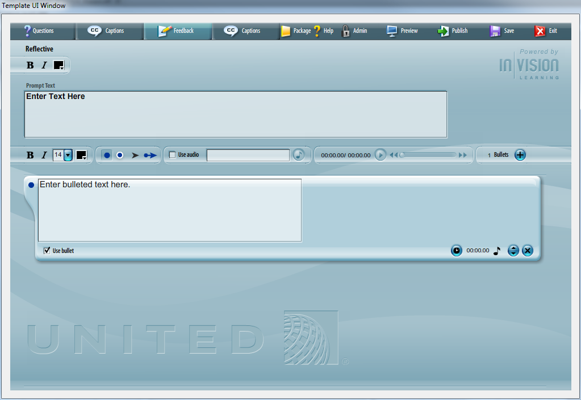

Question text appears first. This text can be used to explain what the user needs to do, and how they can interact this this page. Question text disappears when the learner clicks the “Check Answer” button.

Feedback text appears when the user clicks the “Check Answer” button.

# Resource Links

Overview

The Click to Learn Template can be used as a content page anywhere in a lesson.

This template is used to display links to external files. Clicking on the link opens the file in a new browser window. It is up to the operating system and browser to handle the file.

Links to files can be local to the course or user a web address.

Example  
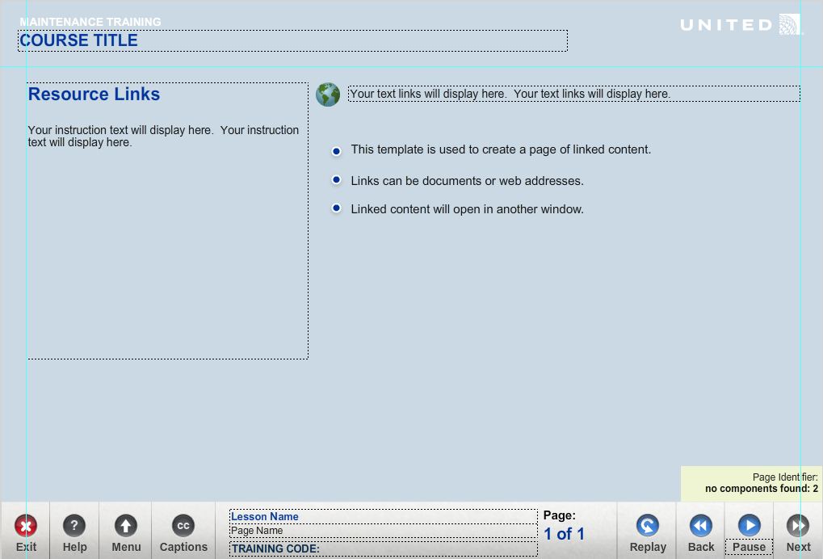

Using the Resource Links Template  
**Complete the Text Tab**  
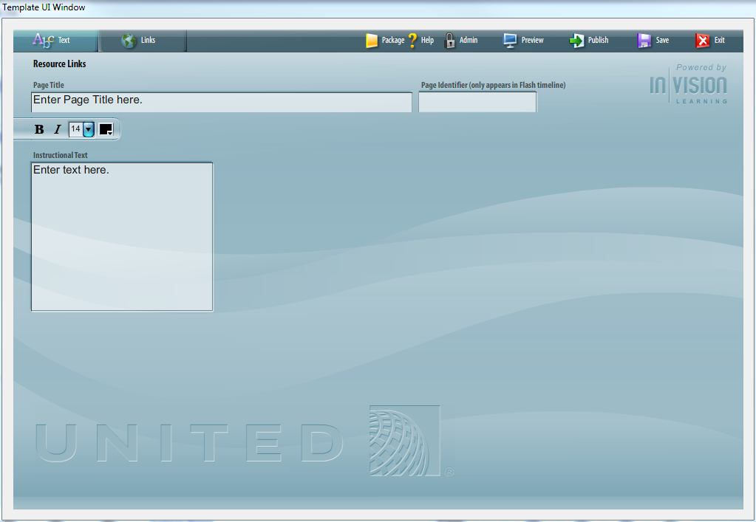

* Enter Page Name
* Enter Instruction Text

**Complete the Links Tab**  
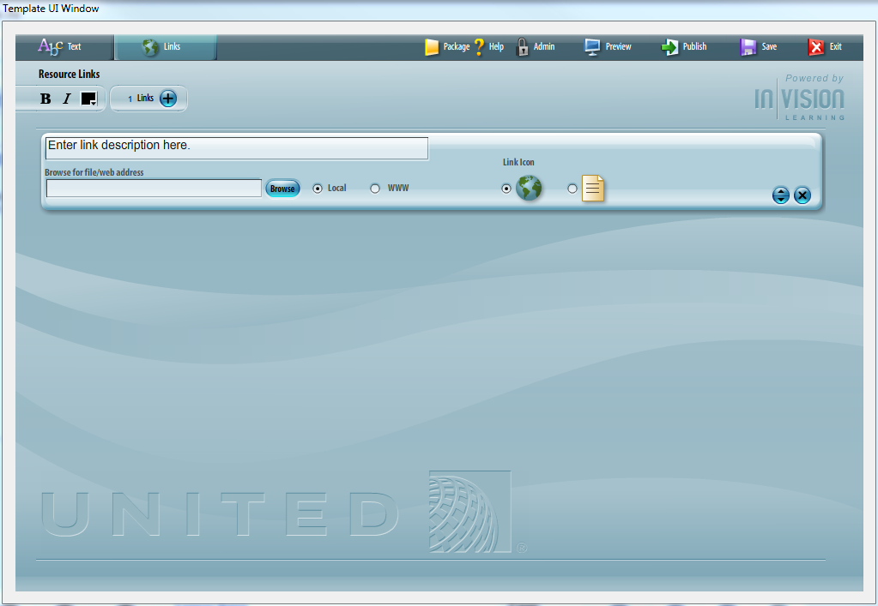

The Image Full Screen page layout allows you to enter a description of the link, browse for files, and set the icon for the link.

The page completion is set automatically to complete when the learner enters the page. Clicking the resource link is not mandatory.

# Quiz Introduction

Overview

The Quiz: Introduction Template can be used at the beginning of a chapter quiz as a way to introduce the quiz and set the user expectation. You may also want to use it as a brief summary of the lesson, providing a review of key learning points.

The page layout includes text and the image-half-circle on the first side of the screen.

You cannot add highlights or callouts to images in this Template.

Example  
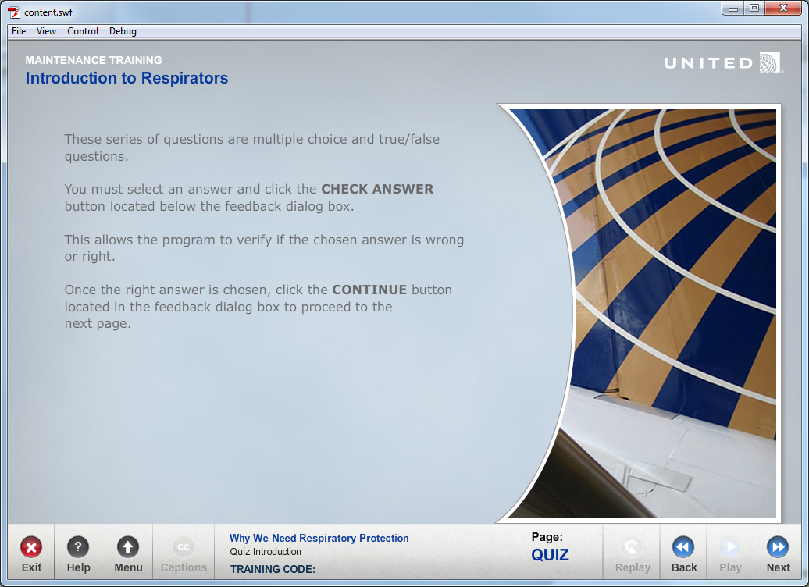

Using the Click to Learn Template  
**Complete the Text Tab**  
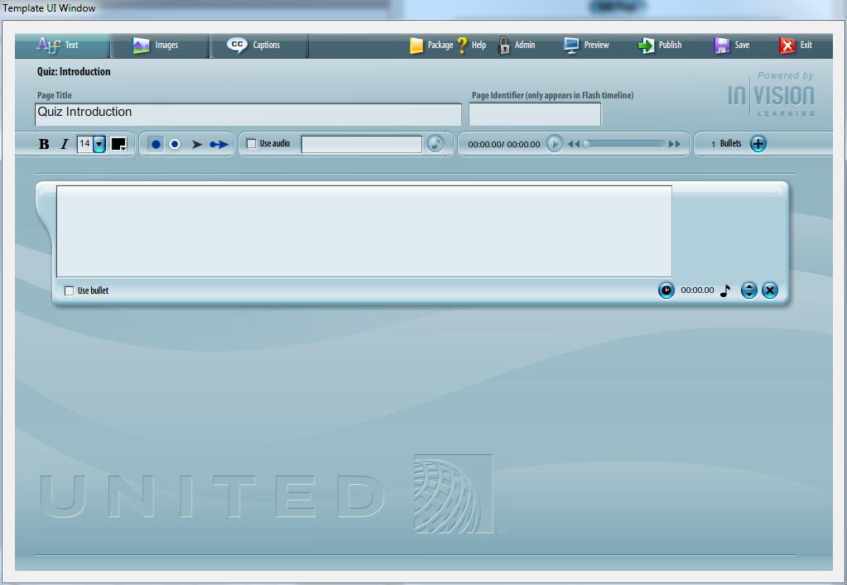

* Enter Page Name
* Enter & Edit Bulleted Text
* Add Audio

**Complete the Images Tab**  
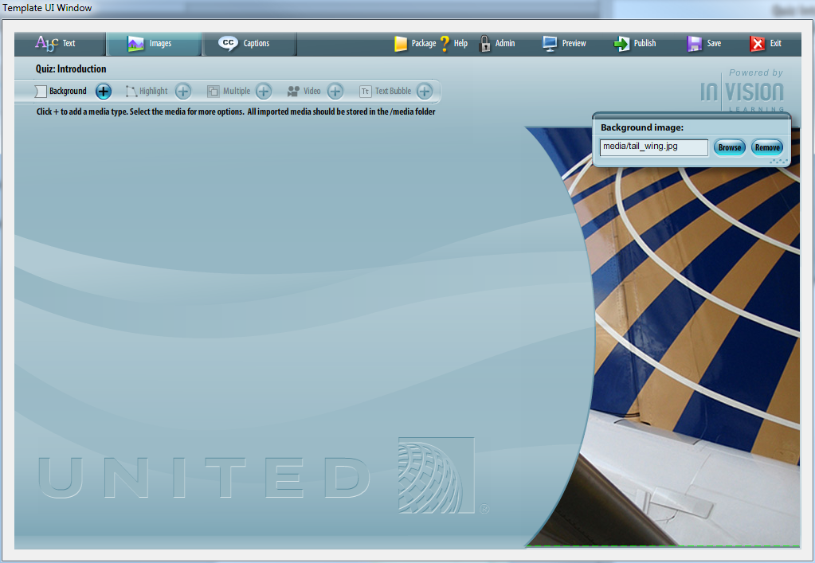

The Image Half-Circle page layout allows you to enter background images.

To fill the entire half-circle area, use an image that is 346 x 525 pixels.

# Quiz: Multiple Choice

Overview

The Quiz: Multiple Choice Template allows a course developer to create a multiple-choice question. A multiple choice question may include up to six possible answers.

Example  
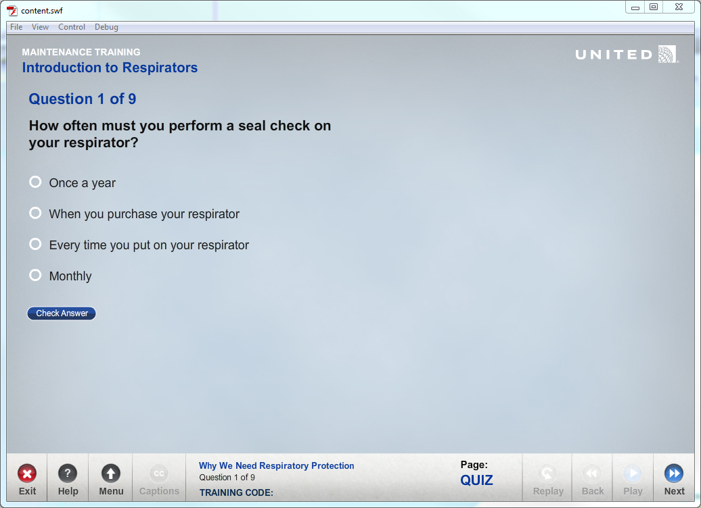

Using the Quiz: Multiple Choice Template  
**Complete the Text Tab**  
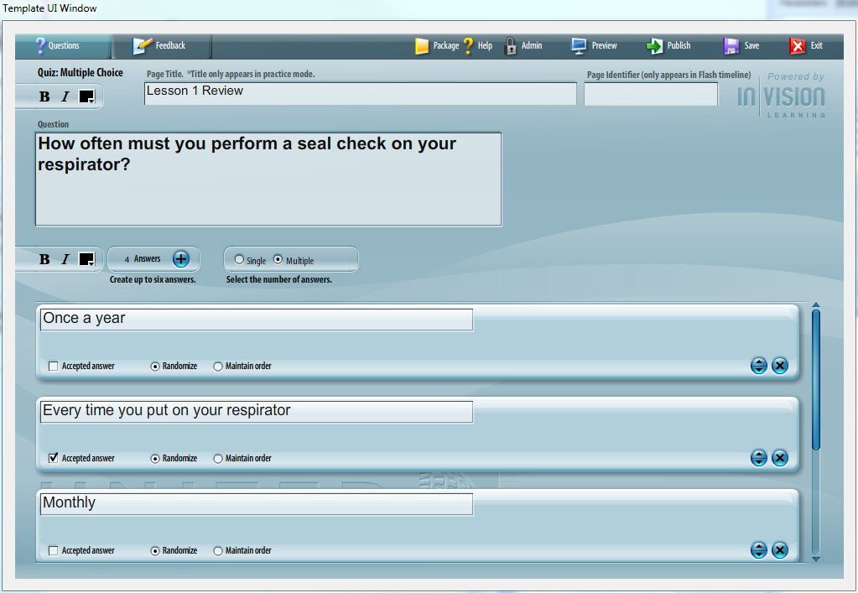

* Enter Page Name
* Enter & Edit Question Text
* Enter & Edit Answer Text

**Complete the Feedback Tab**  
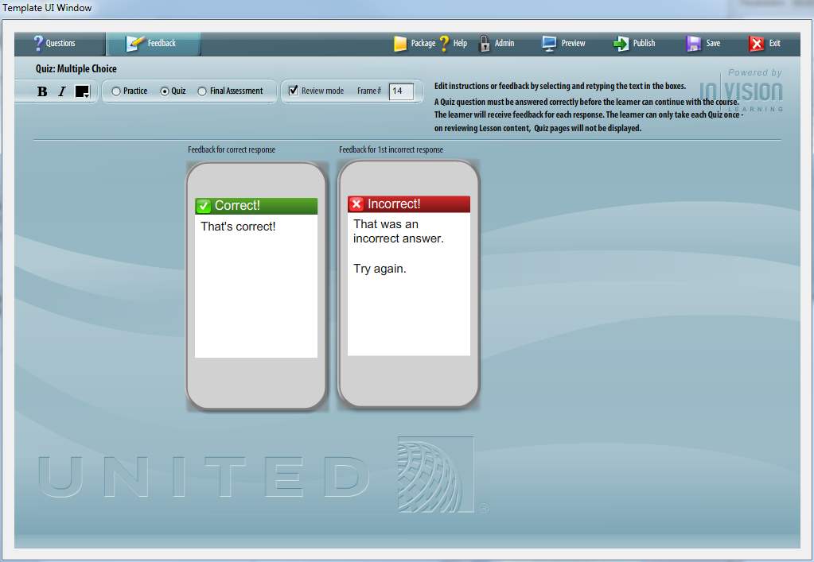

**Enter Question Text**

Type or cut/paste the question text into the question text area.

[[edit](http://continentaltemplatewiki.invisionlearning.com/wiki/index.php?title=Quiz:_Multiple_Choice&action=edit&section=7)] **Enter Possible Answers**

You can create up to six possible answers for a multiple choice question.

Type or cut/paste the answer text into the text area.

To add additional answers, click on the plus sign icon. The total number of answers will display.

[[edit](http://continentaltemplatewiki.invisionlearning.com/wiki/index.php?title=Quiz:_Multiple_Choice&action=edit&section=8)] **Choose the Accepted Answer**

Designate an option as the Accepted Answer by clicking the Accepted Answer Checkbox.

[[edit](http://continentaltemplatewiki.invisionlearning.com/wiki/index.php?title=Quiz:_Multiple_Choice&action=edit&section=9)] **Randomize or Maintain Answer Order**

To have an answer or answers appear in a random order on the screen, select Randomize.

To have an answer stick to its exact spot in a list, select Maintain Order.

*Example:*

You create a question with the following answers:

Blue

Green

Purple

All of the Above

You would like the first three items to appear in a random order in the list, so you choose Randomize for each of these answers.

"All of the Above" should always appear last in the list, so you select Maintain Order for this answer only.

**Quiz Types**

**Practice**  
A Practice question must be answered correctly before the learner can continue with the course. The learner will receive feedback for each response.

**Quiz**  
A Quiz question must be answered correctly before the learner can continue with the course. The learner will receive feedback for each response. The learner can only take each Quiz once - on reviewing Lesson content, Quiz pages will not be displayed.

**Final Assessment**  
In a Final Assessment, the learner will be scored on their answers. The learner will not receive feedback during the Assessment, but can flag questions for review before submitting their final answers.

**Review Mode**

Review mode takes the user back to a specific frame in the course when the user has incorrectly answered a question. This applies only applies to question type “Quiz”.

# Quiz: Multiple Choice Image

Overview

The Quiz: Multiple Choice Template allows a course developer to create a multiple-choice question. A multiple choice question may include up to six possible answers. This version allows developers to add graphical elements to the stage.

Example  
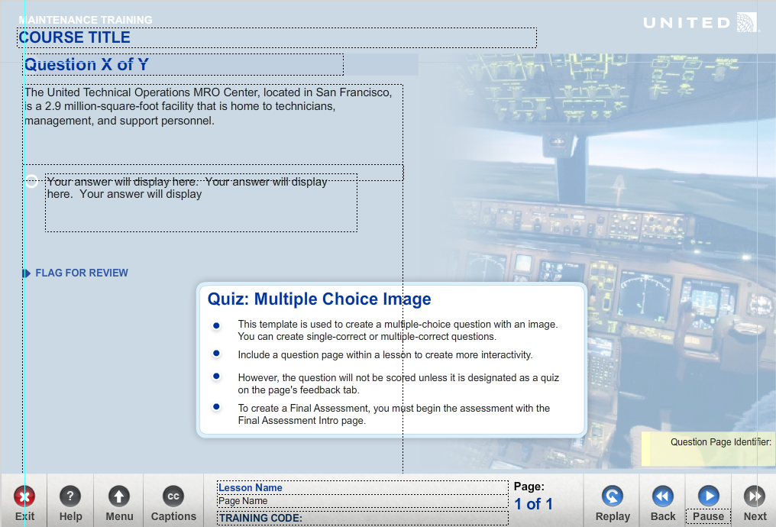

Using the Quiz: Multiple Choice Image Template  
**Complete the Text Tab**  
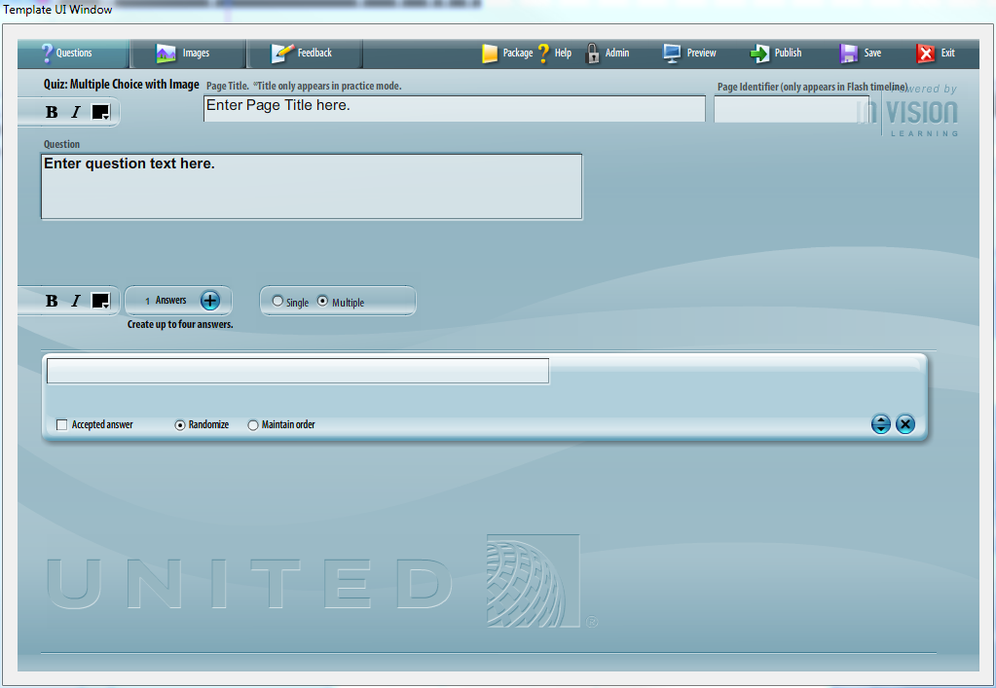

* Enter Page Name
* Enter & Edit Question Text
* Enter & Edit Answer Text

**Complete the Images Tab**  
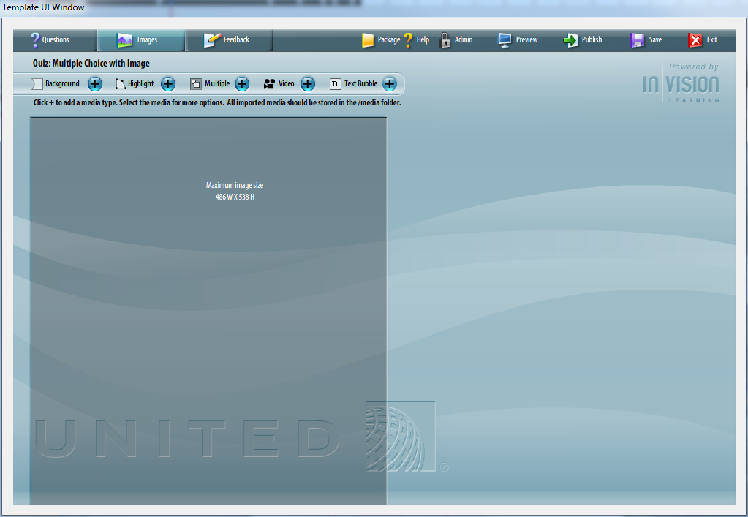

The Image Top page layout allows you to enter an optional background image.

You can multiple images to the screen to create a collage.

Highlights can be added to images. Highlights can be timed to the audio file and will open a callout box with a more detailed view.

Video can be added to the stage. Video controls can be turned on or off.

Text bubble windows can be added to the stage.

**Enter Question Text**

Type or cut/paste the question text into the question text area.

[[edit](http://continentaltemplatewiki.invisionlearning.com/wiki/index.php?title=Quiz:_Multiple_Choice&action=edit&section=7)] **Enter Possible Answers**

You can create up to six possible answers for a multiple choice question.

Type or cut/paste the answer text into the text area.

To add additional answers, click on the plus sign icon. The total number of answers will display.

[[edit](http://continentaltemplatewiki.invisionlearning.com/wiki/index.php?title=Quiz:_Multiple_Choice&action=edit&section=8)] **Choose the Accepted Answer**

Designate an option as the Accepted Answer by clicking the Accepted Answer Checkbox.

[[edit](http://continentaltemplatewiki.invisionlearning.com/wiki/index.php?title=Quiz:_Multiple_Choice&action=edit&section=9)] **Randomize or Maintain Answer Order**

To have an answer or answers appear in a random order on the screen, select Randomize.

To have an answer stick to its exact spot in a list, select Maintain Order.

*Example:*

You create a question with the following answers:

Blue

Green

Purple

All of the Above

You would like the first three items to appear in a random order in the list, so you choose Randomize for each of these answers.

"All of the Above" should always appear last in the list, so you select Maintain Order for this answer only.

**Quiz Types**

**Practice**  
A Practice question must be answered correctly before the learner can continue with the course. The learner will receive feedback for each response.

**Quiz**  
A Quiz question must be answered correctly before the learner can continue with the course. The learner will receive feedback for each response. The learner can only take each Quiz once - on reviewing Lesson content, Quiz pages will not be displayed.

**Final Assessment**  
In a Final Assessment, the learner will be scored on their answers. The learner will not receive feedback during the Assessment, but can flag questions for review before submitting their final answers.

**Review Mode**

Review mode takes the user back to a specific frame in the course when the user has incorrectly answered a question. This applies only applies to question type “Quiz”.

# Quiz: True False

Overview

The Quiz: True/False Template allows a course developer to create a true/false question.

Example  
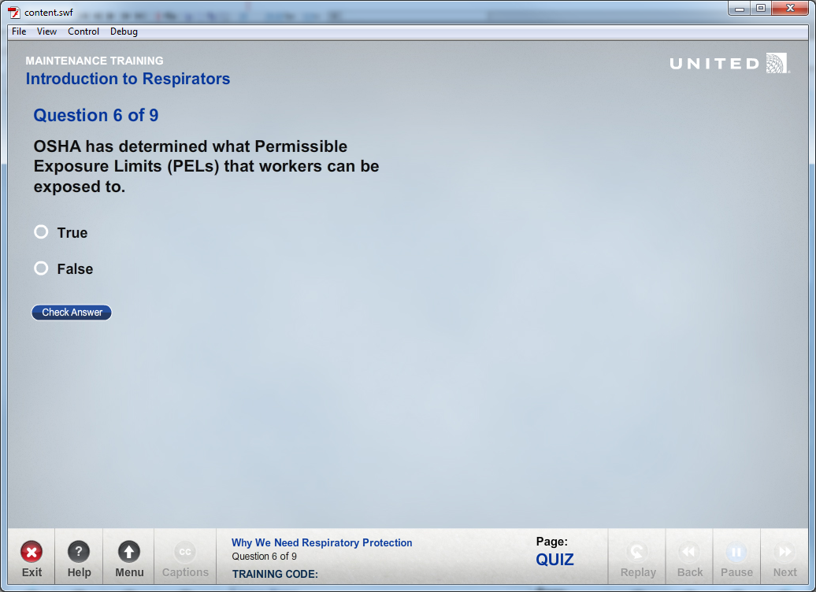

Using the Quiz: True False Template  
**Complete the Text Tab**  
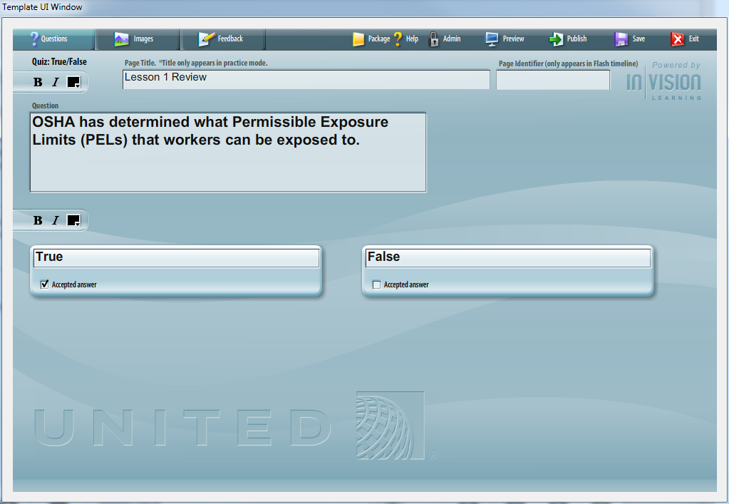

* Enter Page Name
* Enter & Edit Question Text
* Enter & Edit Answer Text

**Complete the Images Tab**  
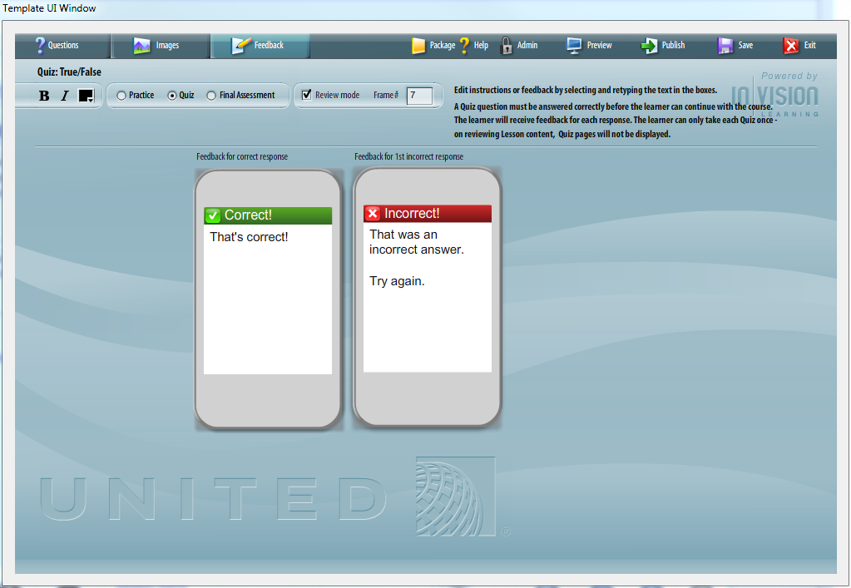

The Image Top page layout allows you to enter an optional background image.

You can multiple images to the screen to create a collage.

Highlights can be added to images. Highlights can be timed to the audio file and will open a callout box with a more detailed view.

Video can be added to the stage. Video controls can be turned on or off.

Text bubble windows can be added to the stage.

**Enter Question Text**

Type or cut/paste the question text into the question text area. [[edit](http://continentaltemplatewiki.invisionlearning.com/wiki/index.php?title=Quiz:_Multiple_Choice&action=edit&section=7)]

[[edit](http://continentaltemplatewiki.invisionlearning.com/wiki/index.php?title=Quiz:_Multiple_Choice&action=edit&section=8)] **Choose the Accepted Answer**

Designate an option as the Accepted Answer by clicking the Accepted Answer Checkbox.

**Quiz Types**

**Practice**  
A Practice question must be answered correctly before the learner can continue with the course. The learner will receive feedback for each response.

**Quiz**  
A Quiz question must be answered correctly before the learner can continue with the course. The learner will receive feedback for each response. The learner can only take each Quiz once - on reviewing Lesson content, Quiz pages will not be displayed.

**Final Assessment**  
In a Final Assessment, the learner will be scored on their answers. The learner will not receive feedback during the Assessment, but can flag questions for review before submitting their final answers.

**Review Mode**

Review mode takes the user back to a specific frame in the course when the user has incorrectly answered a question. This applies only applies to question type “Quiz”.

# Quiz: Fill in the Blank

Overview

The Quiz: Fill in the Blank Template allows a course developer to create a fill-in-the-blank question.

Example  
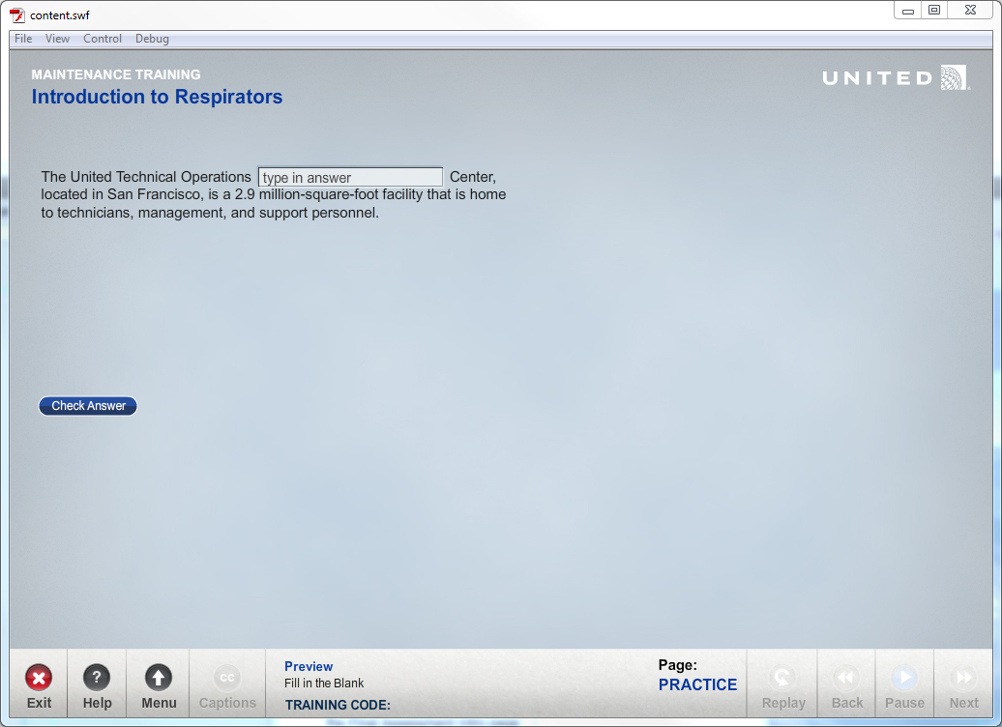

Using the Quiz: Fill in the Blank Template  
**Complete the Text Tab**  
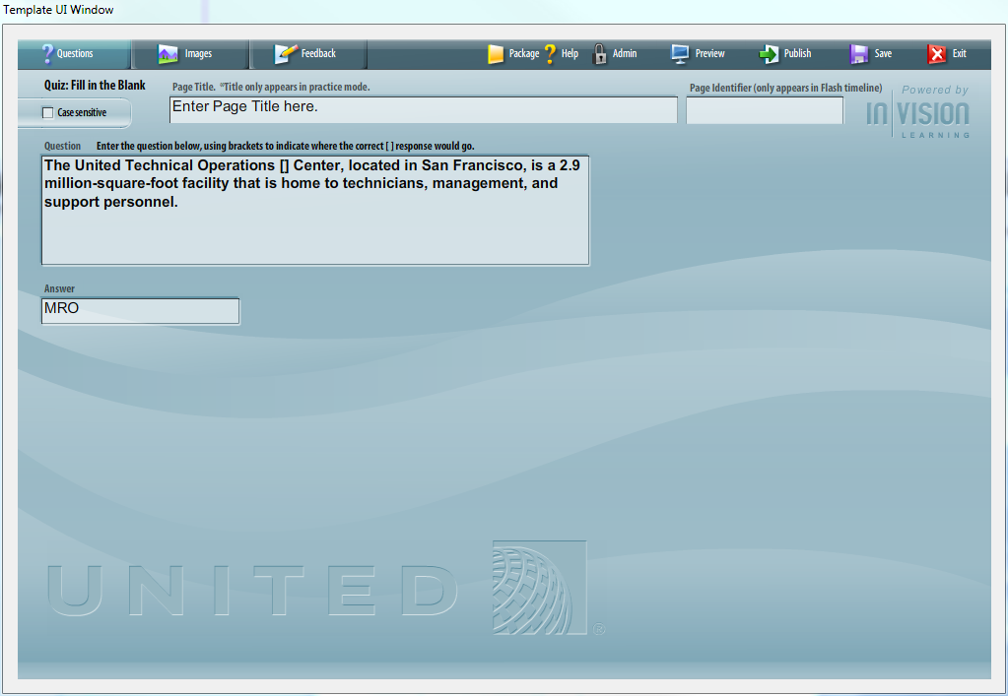

* Enter Page Name
* Enter & Edit Question Text
* Enter & Edit Answer Text

**Complete the Images Tab**  
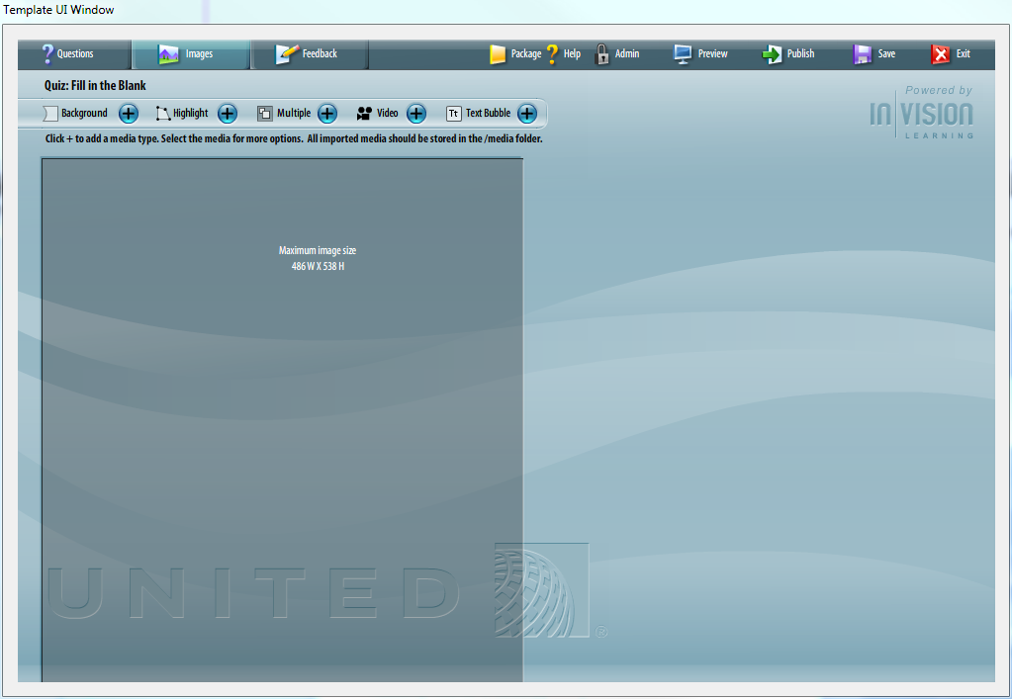

The Image Top page layout allows you to enter an optional background image.

You can multiple images to the screen to create a collage.

Highlights can be added to images. Highlights can be timed to the audio file and will open a callout box with a more detailed view.

Video can be added to the stage. Video controls can be turned on or off.

Text bubble windows can be added to the stage.

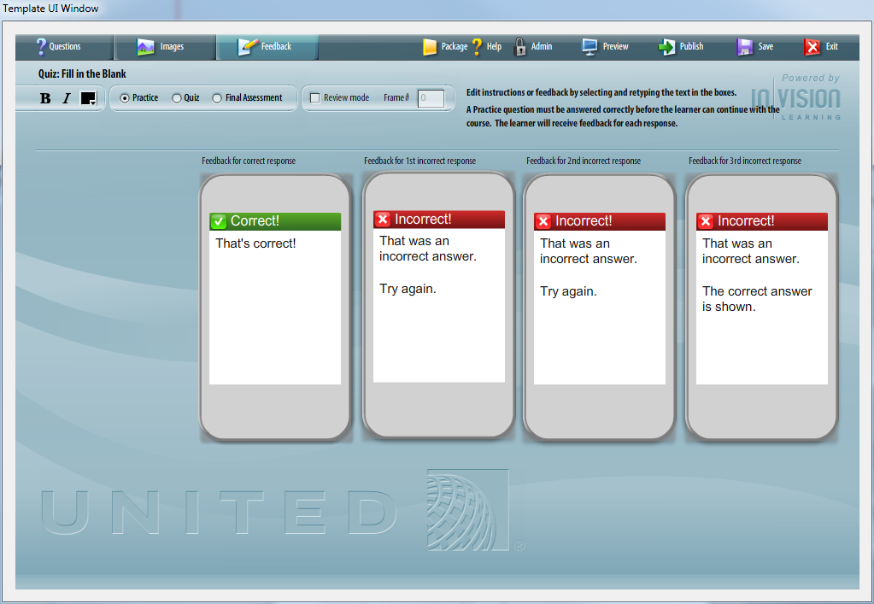

**Enter Question Text**

Type or cut/paste the question text into the question text area. Use closed brackets []to indicate where the correct response will go. The templates will automatically detect the brackets and set up the page appropriately.

*Example:* United [] has a fabulous Maintenance Crew.

[[edit](http://continentaltemplatewiki.invisionlearning.com/wiki/index.php?title=Quiz:_Multiple_Choice&action=edit&section=7)] **Enter Possible Answers**

Type or cut/paste the answer text into the text area.

**Quiz Types**

**Practice**  
A Practice question must be answered correctly before the learner can continue with the course. The learner will receive feedback for each response.

**Quiz**  
A Quiz question must be answered correctly before the learner can continue with the course. The learner will receive feedback for each response. The learner can only take each Quiz once - on reviewing Lesson content, Quiz pages will not be displayed.

**Final Assessment**  
In a Final Assessment, the learner will be scored on their answers. The learner will not receive feedback during the Assessment, but can flag questions for review before submitting their final answers.

**Review Mode**

Review mode takes the user back to a specific frame in the course when the user has incorrectly answered a question. This applies only applies to question type “Quiz”.

# Quiz: Explore

Overview

The Quiz: Explore Template allows a course developer to create a click-to-learn or explore question page. For example, you could create a question asking the user to identify where on the image they can find a specific circuit breaker. The user will have to click on the designated hotspot area to get the answer correct.

Example  
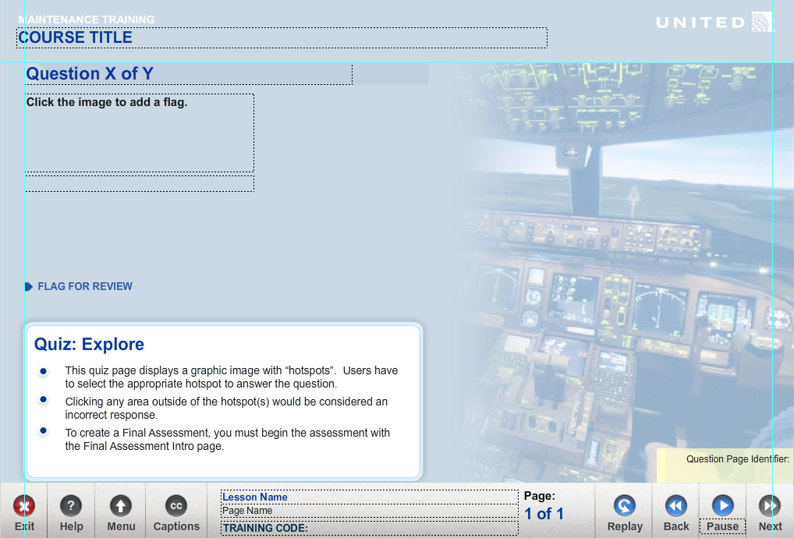

Using the Quiz: Explore Template  
**Complete the Text Tab**  
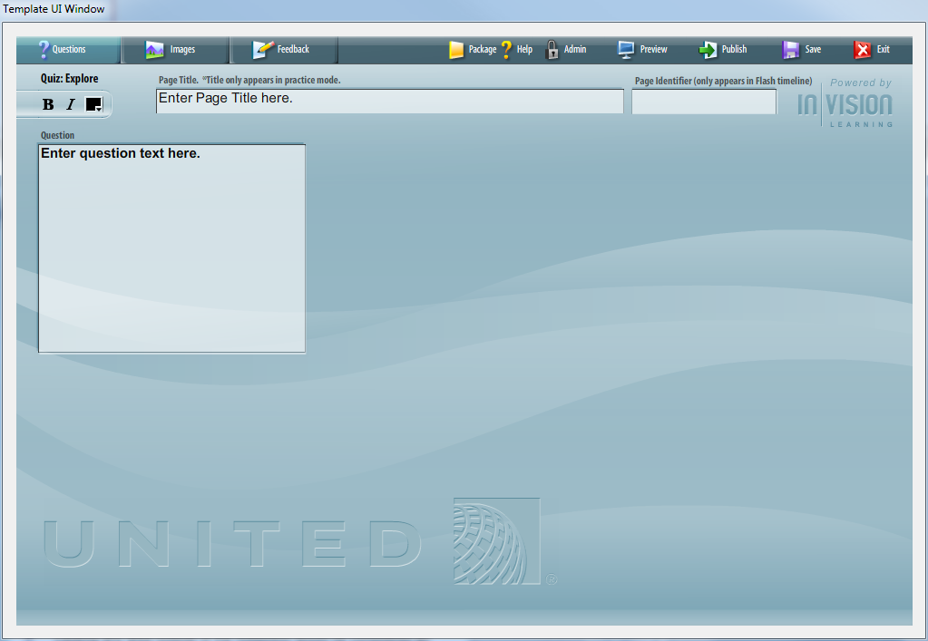

* Enter Page Name
* Enter & Edit Question Text
* Enter & Edit Answer Text

**Complete the Images Tab**  
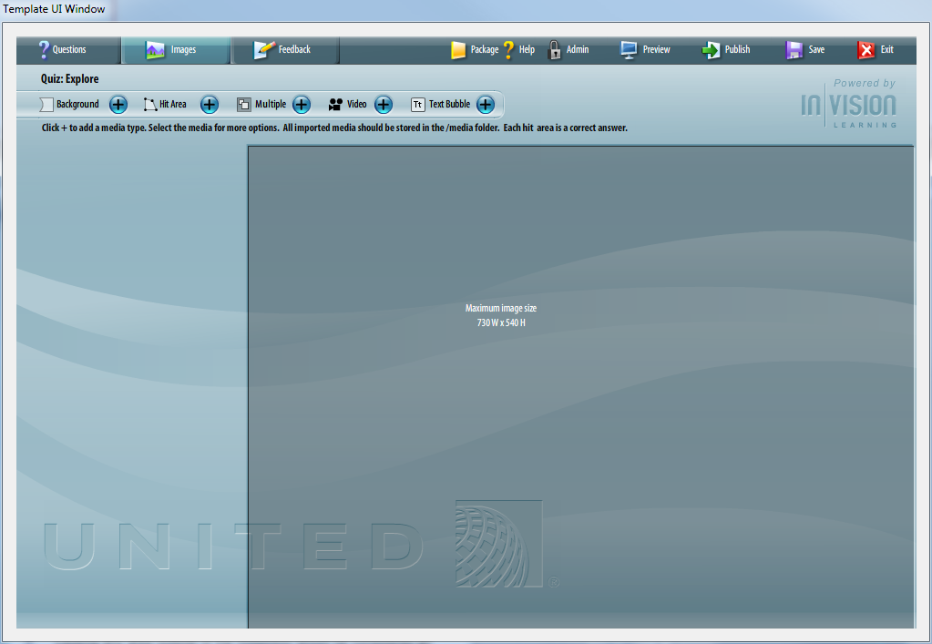

The Image Top page layout allows you to enter an optional background image.

You can multiple images to the screen to create a collage.

Highlights can be added to images. Highlights can be timed to the audio file and will open a callout box with a more detailed view.

Video can be added to the stage. Video controls can be turned on or off.

Text bubble windows can be added to the stage.

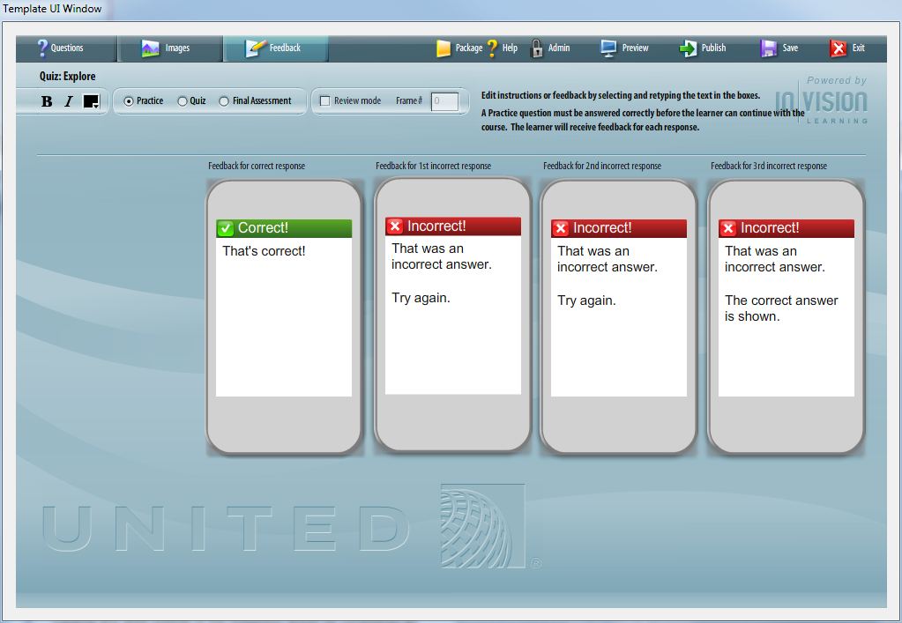

**Enter Question Text**

Type or cut/paste the question text into the question text area.

[[edit](http://continentaltemplatewiki.invisionlearning.com/wiki/index.php?title=Quiz:_Multiple_Choice&action=edit&section=7)] **Enter Possible Answers**

In the Images Tab, you will upload the appropriate image(s) and designated specific highlight/hotspot areas. Any area that is designated as a highlight will be considered a correct response.

**Quiz Types**

**Practice**  
A Practice question must be answered correctly before the learner can continue with the course. The learner will receive feedback for each response.

**Quiz**  
A Quiz question must be answered correctly before the learner can continue with the course. The learner will receive feedback for each response. The learner can only take each Quiz once - on reviewing Lesson content, Quiz pages will not be displayed.

**Final Assessment**  
In a Final Assessment, the learner will be scored on their answers. The learner will not receive feedback during the Assessment, but can flag questions for review before submitting their final answers.

**Review Mode**

Review mode takes the user back to a specific frame in the course when the user has incorrectly answered a question. This applies only applies to question type “Quiz”.

# Quiz: Drag & Drop

Overview

The Quiz: Drag & Drop Template allows a course developer to create drag & drop question. The user drags a text label (“object”) to a designated “target”. The target and dragger are pre-set graphic box.

Example  
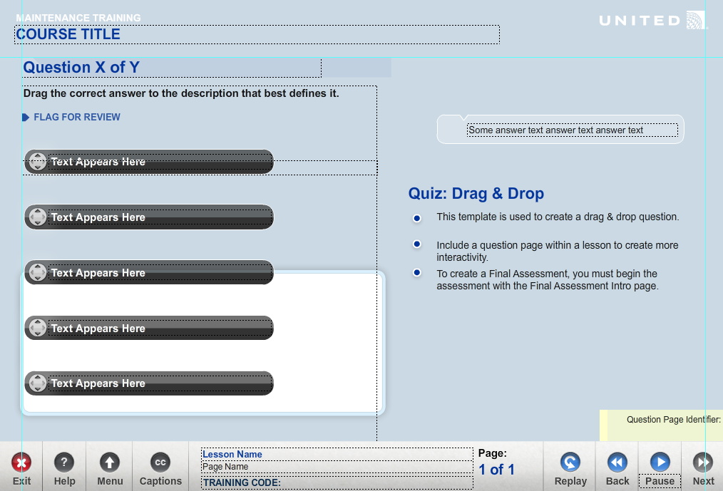

Using the Quiz: Drag & Drop Template  
**Complete the Text Tab**  
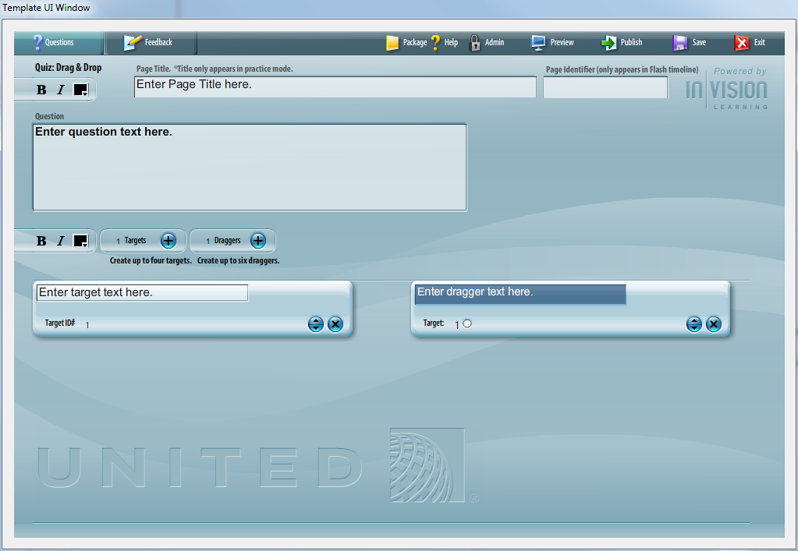

* Enter Page Name
* Enter & Edit Question Text
* Enter & Edit Answer Text

**Complete the Images Tab**  
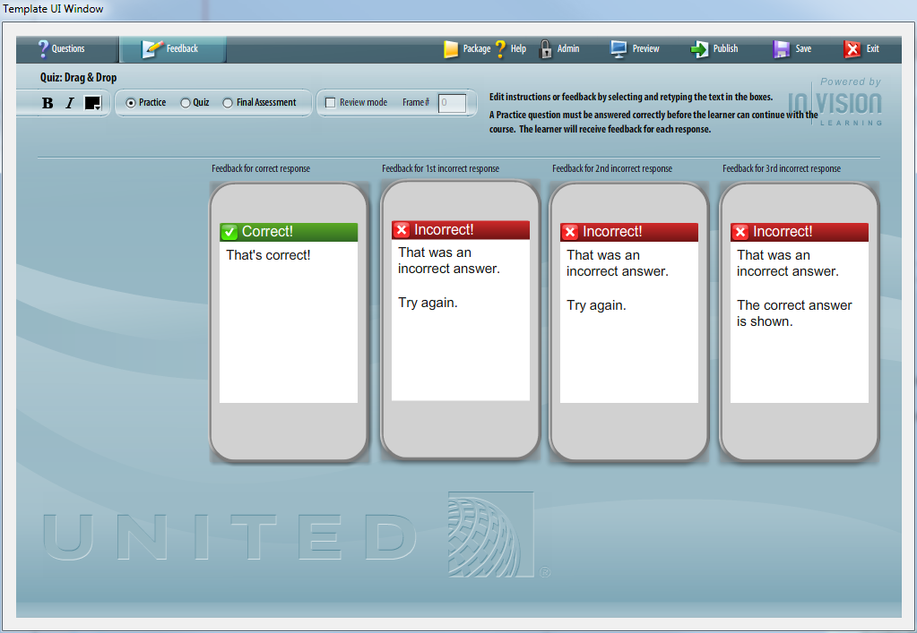

**Enter Question Text**

Type or cut/paste the question text into the question text area.

[[edit](http://continentaltemplatewiki.invisionlearning.com/wiki/index.php?title=Quiz:_Multiple_Choice&action=edit&section=7)] **Enter Possible Answers**

In the Text Tab, you will designate a specific dragger to target. Any dragger that is not dropped into a target will be considered an incorrect response.

**Quiz Types**

**Practice**  
A Practice question must be answered correctly before the learner can continue with the course. The learner will receive feedback for each response.

**Quiz**  
A Quiz question must be answered correctly before the learner can continue with the course. The learner will receive feedback for each response. The learner can only take each Quiz once - on reviewing Lesson content, Quiz pages will not be displayed.

**Final Assessment**  
In a Final Assessment, the learner will be scored on their answers. The learner will not receive feedback during the Assessment, but can flag questions for review before submitting their final answers.

**Review Mode**

Review mode takes the user back to a specific frame in the course when the user has incorrectly answered a question. This applies only applies to question type “Quiz”.

# Quiz: Drag & Drop Paragraph

Overview

The Quiz: Drag & Drop Paragraph Template allows a course developer to create drag & drop question. The user drags a text label (“object”) to a designated “target”. The target and dragger are pre-set graphic box.

This template differs from a Drag & Drop in its ability to add more text to the screen. The dragger icon is only moved. The text remains in place.

Example  
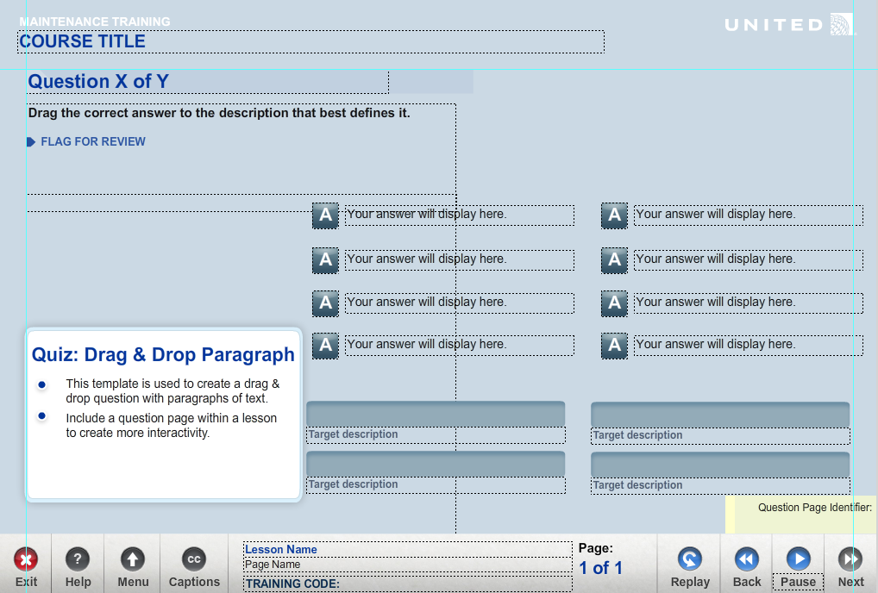

Using the Quiz: Drag & Drop Paragraph Template  
**Complete the Text Tab**  
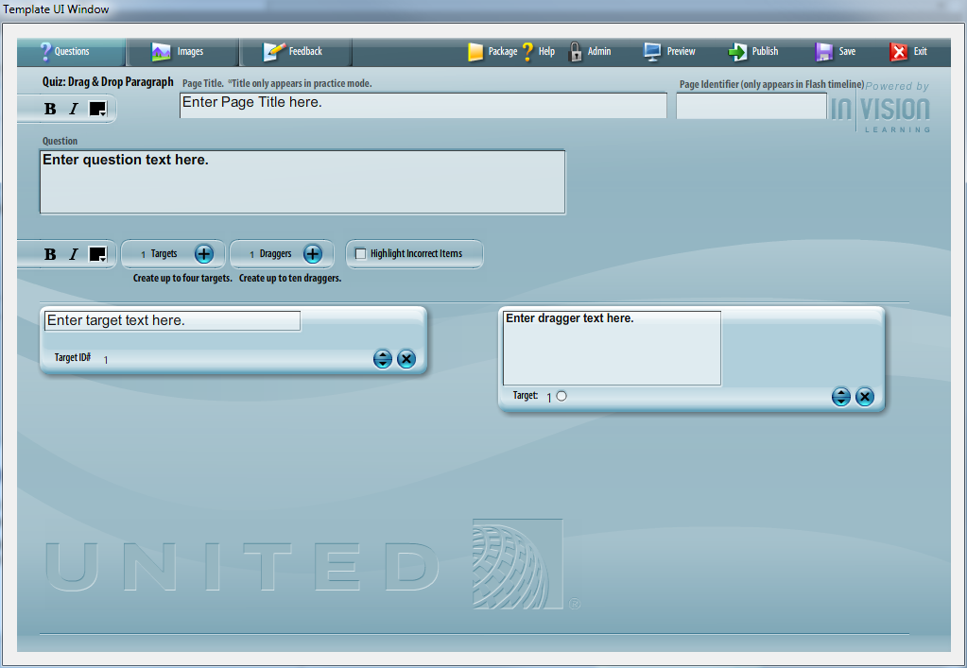

* Enter Page Name
* Enter & Edit Question Text
* Enter & Edit Answer Text

**Complete the Images Tab**  
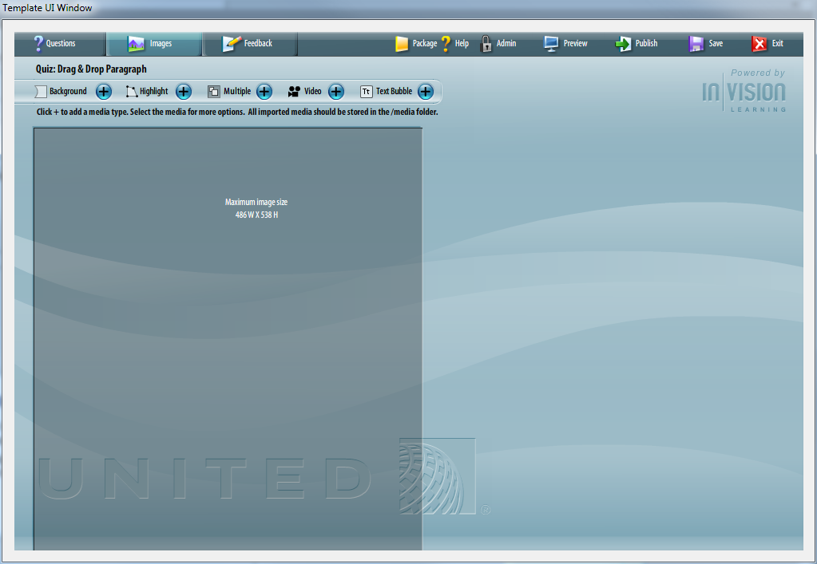

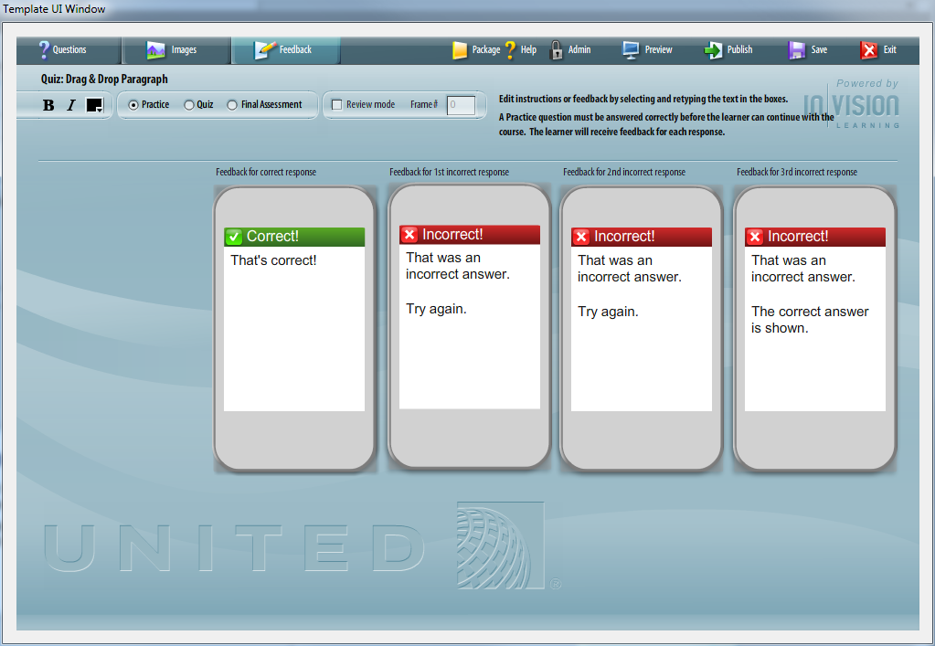

**Enter Question Text**

Type or cut/paste the question text into the question text area.

[[edit](http://continentaltemplatewiki.invisionlearning.com/wiki/index.php?title=Quiz:_Multiple_Choice&action=edit&section=7)] **Enter Possible Answers**

In the Text Tab, you will designate a specific dragger to target. Any dragger that is not dropped into a target will be considered an incorrect response.

**Quiz Types**

**Practice**  
A Practice question must be answered correctly before the learner can continue with the course. The learner will receive feedback for each response.

**Quiz**  
A Quiz question must be answered correctly before the learner can continue with the course. The learner will receive feedback for each response. The learner can only take each Quiz once - on reviewing Lesson content, Quiz pages will not be displayed.

**Final Assessment**  
In a Final Assessment, the learner will be scored on their answers. The learner will not receive feedback during the Assessment, but can flag questions for review before submitting their final answers.

**Review Mode**

Review mode takes the user back to a specific frame in the course when the user has incorrectly answered a question. This applies only applies to question type “Quiz”.

# Quiz: Rank & Order

Overview

The Quiz: Rank & Order Template allows a course developer to create rank & order question. The user numbers each text item in the proper order. A drop down provides a specific range of numbers.

This type of question can be useful for helping a user learn the specific steps of a sequence: *“Put the processing steps in the correct order.”*

Example  
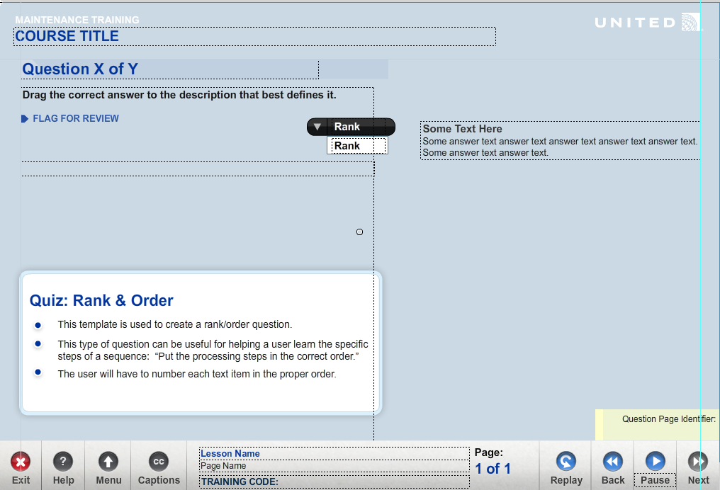

Using the Quiz: Rank & Order Template  
**Complete the Text Tab**  
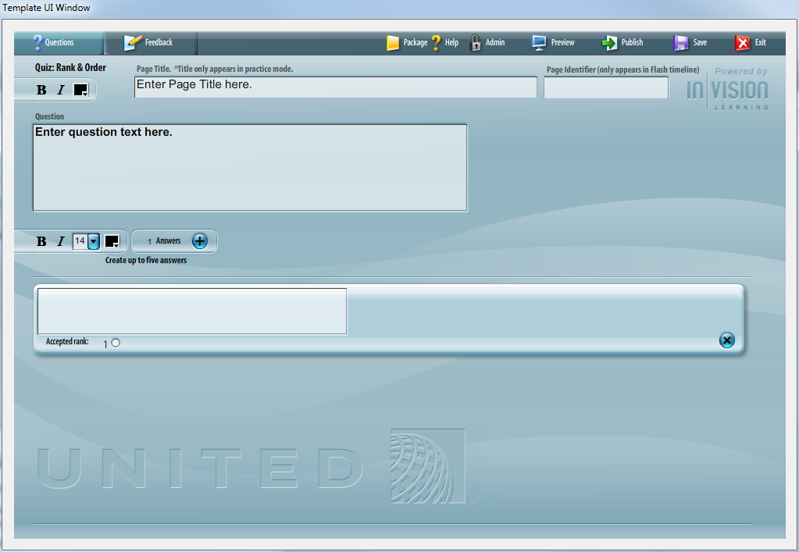

* Enter Page Name
* Enter & Edit Question Text
* Enter & Edit Answer Text

**Complete the Images Tab**  
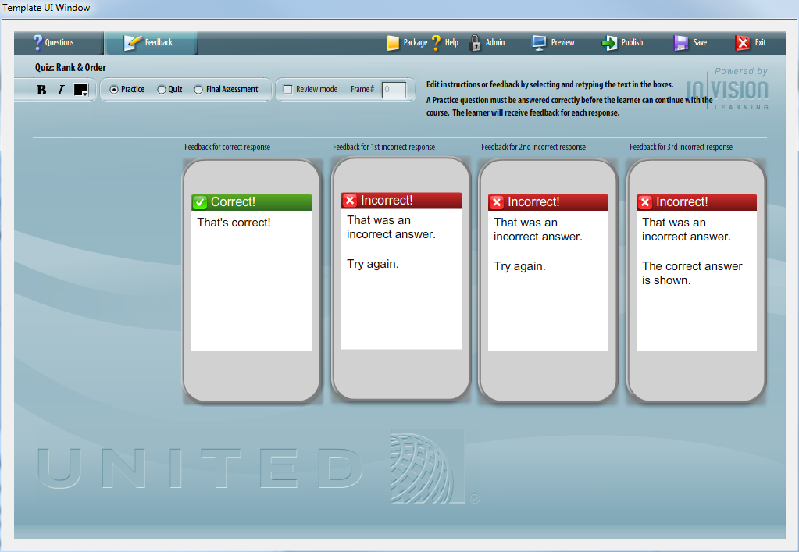

**Enter Question Text**

Type or cut/paste the question text into the question text area.

[[edit](http://continentaltemplatewiki.invisionlearning.com/wiki/index.php?title=Quiz:_Multiple_Choice&action=edit&section=7)] **Enter Possible Answers**

In the Text Tab, you designate a specific accepted rank for each of answers.

**Quiz Types**

**Practice**  
A Practice question must be answered correctly before the learner can continue with the course. The learner will receive feedback for each response.

**Quiz**  
A Quiz question must be answered correctly before the learner can continue with the course. The learner will receive feedback for each response. The learner can only take each Quiz once - on reviewing Lesson content, Quiz pages will not be displayed.

**Final Assessment**  
In a Final Assessment, the learner will be scored on their answers. The learner will not receive feedback during the Assessment, but can flag questions for review before submitting their final answers.

**Review Mode**

Review mode takes the user back to a specific frame in the course when the user has incorrectly answered a question. This applies only applies to question type “Quiz”.

# Quiz: Rank & Order Image

Overview

The Quiz: Rank & Order Image Template allows a course developer to create rank & order question. The user numbers each text item in the proper order. A drop down provides a specific range of numbers.  
  
This template differs from Rank & Order in that an image can be displayed.

This type of question can be useful for helping a user learn the specific steps of a sequence: *“Based on the image, put the processing steps in the correct order.”*

Example  
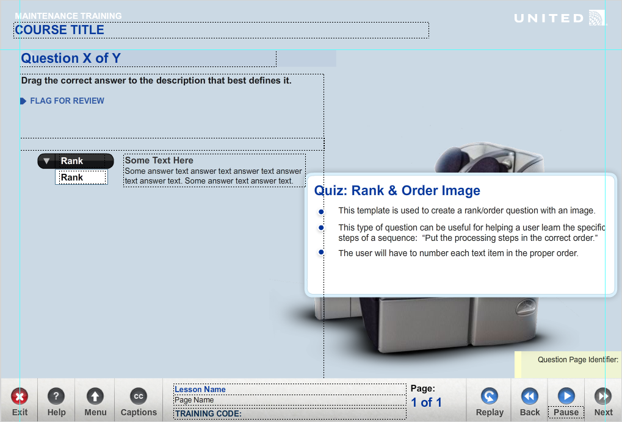

Using the Quiz: Rank & Order Image Template  
**Complete the Text Tab**  
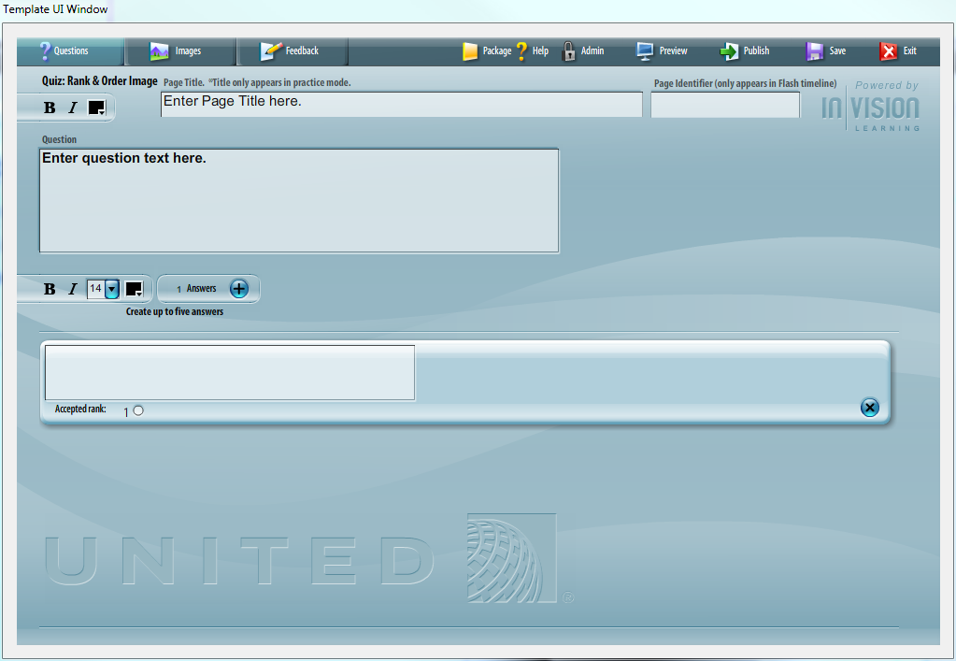

* Enter Page Name
* Enter & Edit Question Text
* Enter & Edit Answer Text

**Complete the Images Tab**  
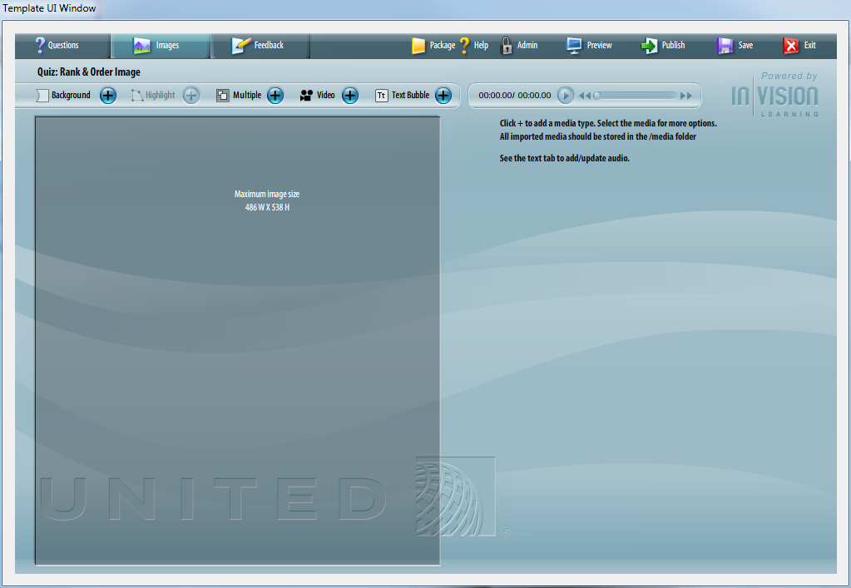

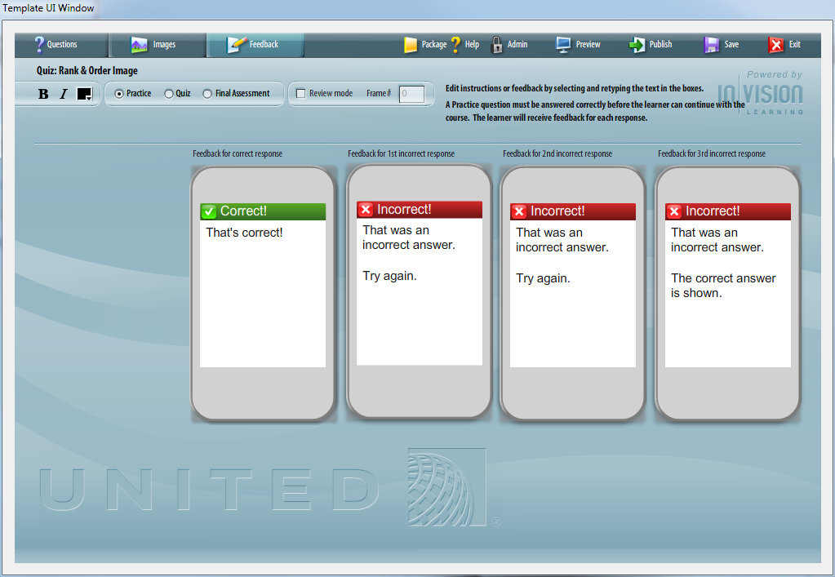

**Enter Question Text**

Type or cut/paste the question text into the question text area.

[[edit](http://continentaltemplatewiki.invisionlearning.com/wiki/index.php?title=Quiz:_Multiple_Choice&action=edit&section=7)] **Enter Possible Answers**

In the Text Tab, you designate a specific accepted rank for each of answers.

**Quiz Types**

**Practice**  
A Practice question must be answered correctly before the learner can continue with the course. The learner will receive feedback for each response.

**Quiz**  
A Quiz question must be answered correctly before the learner can continue with the course. The learner will receive feedback for each response. The learner can only take each Quiz once - on reviewing Lesson content, Quiz pages will not be displayed.

**Final Assessment**  
In a Final Assessment, the learner will be scored on their answers. The learner will not receive feedback during the Assessment, but can flag questions for review before submitting their final answers.

**Review Mode**

Review mode takes the user back to a specific frame in the course when the user has incorrectly answered a question. This applies only applies to question type “Quiz”.

# Lesson Summary

Overview

The Lesson Summary is a text page with audio that summarizes key learning points from the lesson. This page should go at the end of a lesson, before the Lesson Complete page. Text bullets can be timed to audio.

Example  
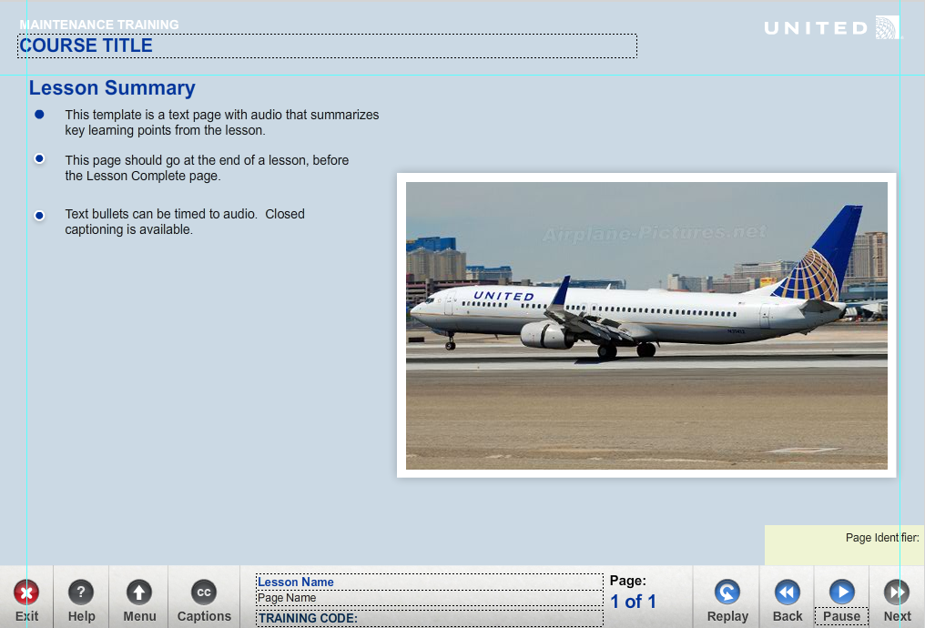

Using the Lesson Summary Template  
**Complete the Text Tab**  
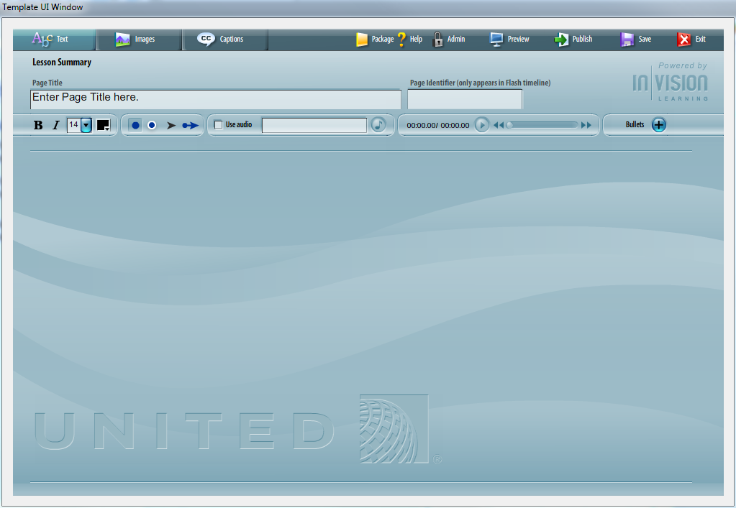

* Enter Page Name
* Enter & Edit Question Text
* Enter & Edit Answer Text

**Complete the Images Tab**  
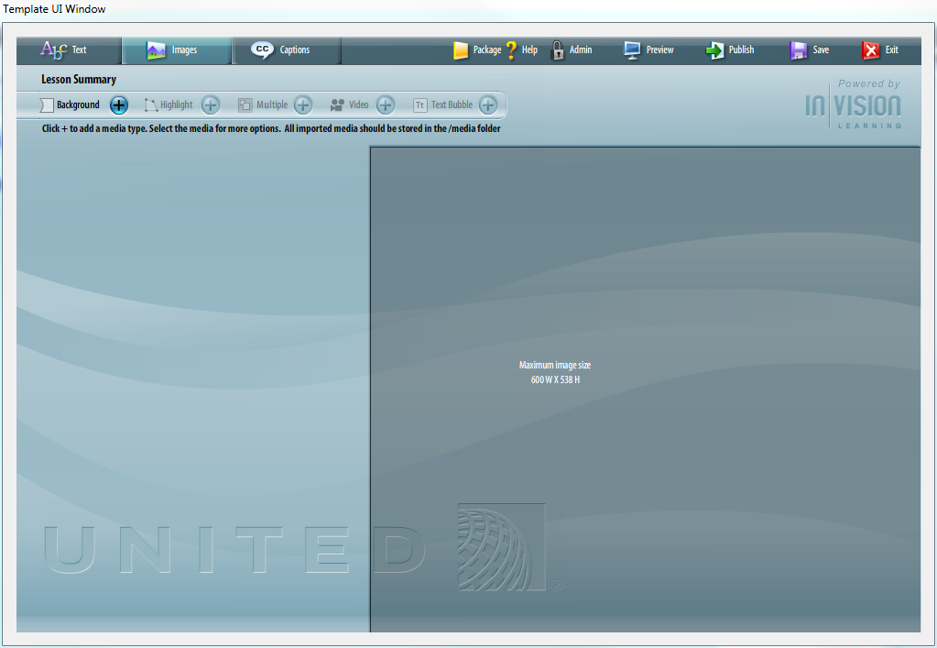

The Image Top page layout allows you to enter an optional background image.

You can multiple images to the screen to create a collage.

Highlights can be added to images. Highlights can be timed to the audio file and will open a callout box with a more detailed view.

Video can be added to the stage. Video controls can be turned on or off.

Text bubble windows can be added to the stage.

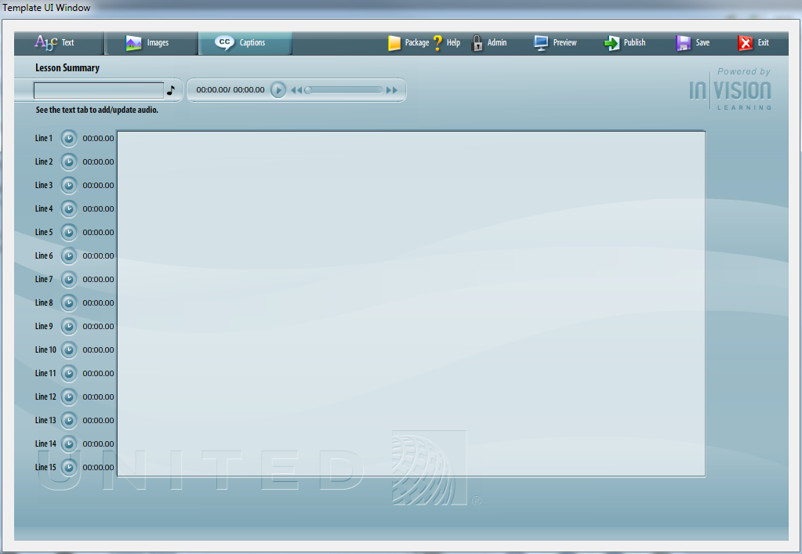

# Lesson Complete

Overview

The Lesson Complete is a text page with audio that is placed at the end of a lesson. It is not mandatory to have a lesson complete, but is a good best practice.

Example  
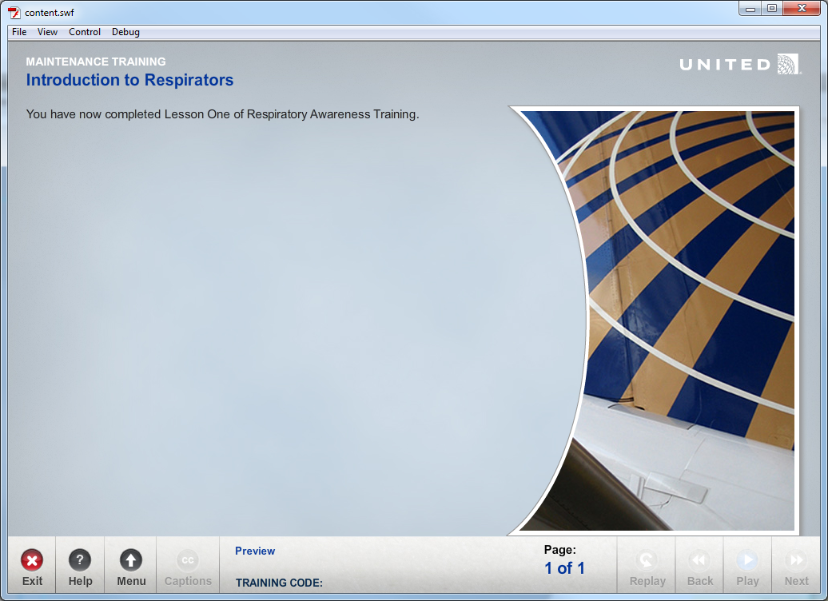

Using the Lesson Complete Template  
**Complete the Text Tab**  
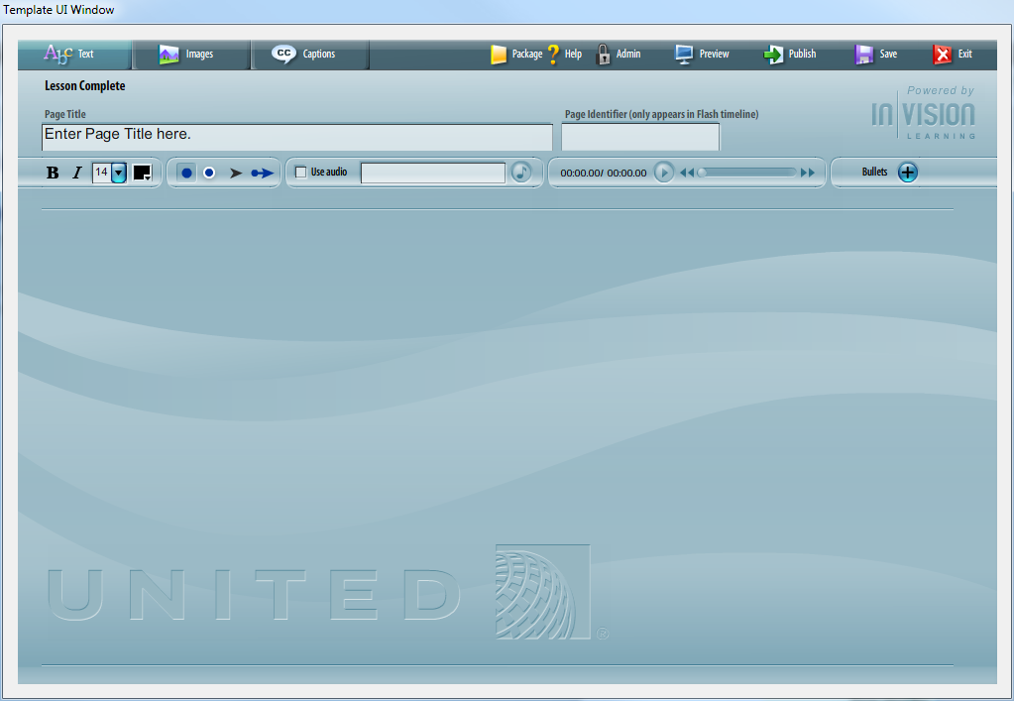

* Enter Page Name
* Enter & Edit Question Text
* Enter & Edit Answer Text

**Complete the Images Tab**  
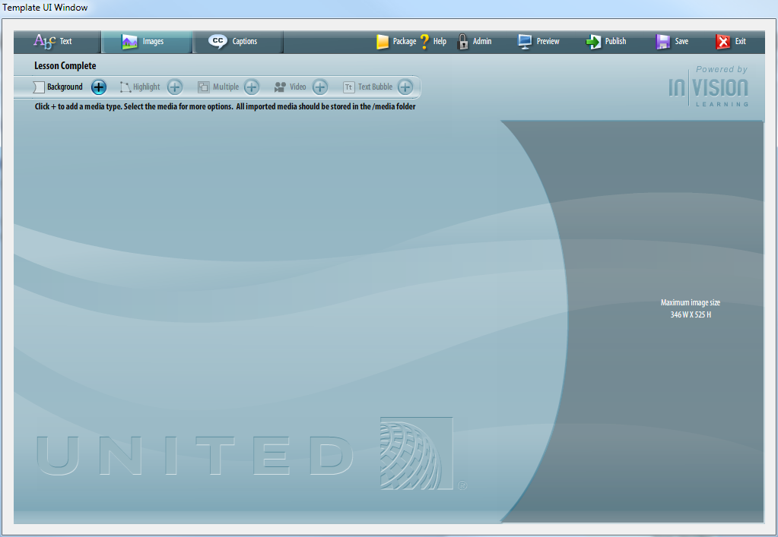

The Image Top page layout allows you to enter an optional background image.

You can multiple images to the screen to create a collage.

Highlights can be added to images. Highlights can be timed to the audio file and will open a callout box with a more detailed view.

Video can be added to the stage. Video controls can be turned on or off.

Text bubble windows can be added to the stage.

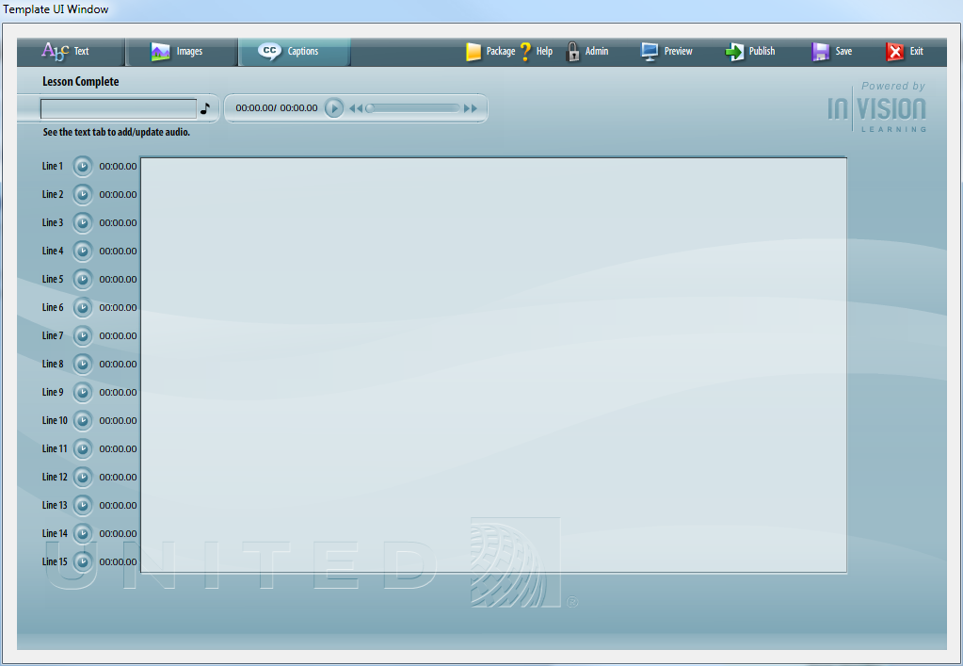

# Final Assessment Introduction

Overview

The Final Assessment Introduction is a text page with audio that is placed at the beginning of a final assessment lesson. The template is used introduce the Final Assessment and allows the learner to pause before attempting the final assessment.

Example  
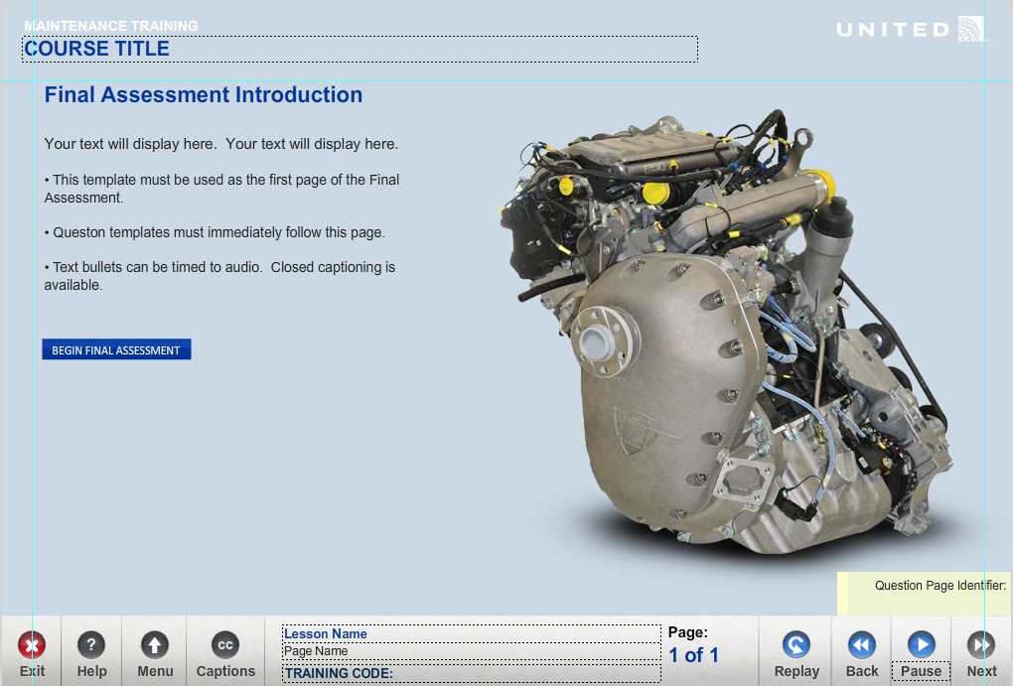

Using the Final Assessment Introduction Template  
**Complete the Text Tab**  
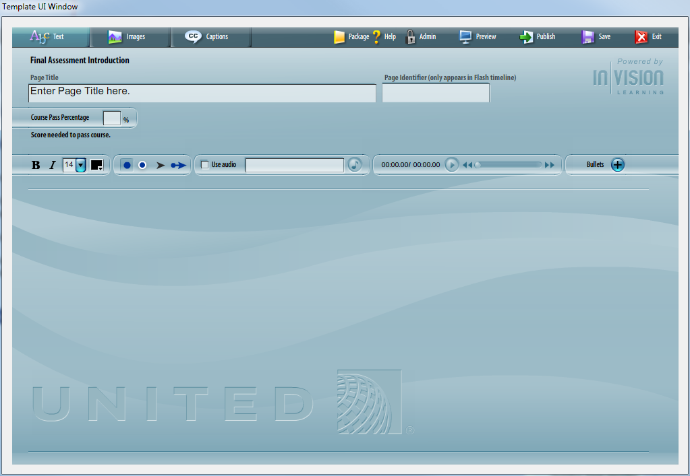

* Enter Page Name
* Enter & Edit Question Text
* Enter & Edit Answer Text

**Complete the Images Tab**  
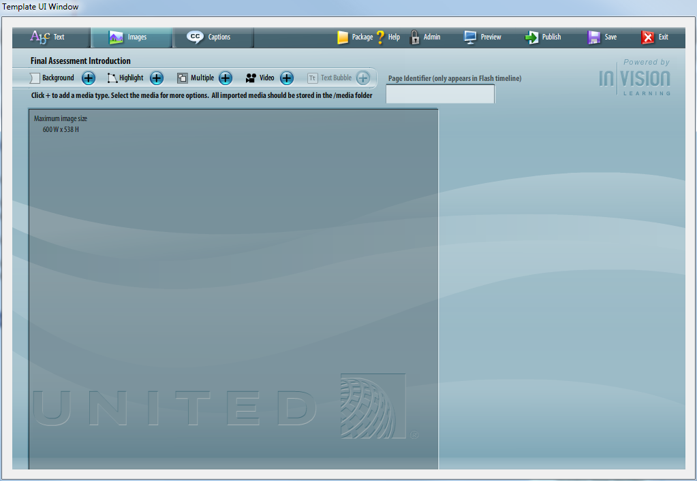

The Image Top page layout allows you to enter an optional background image.

You can multiple images to the screen to create a collage.

Highlights can be added to images. Highlights can be timed to the audio file and will open a callout box with a more detailed view.

Video can be added to the stage. Video controls can be turned on or off.

Text bubble windows can be added to the stage.

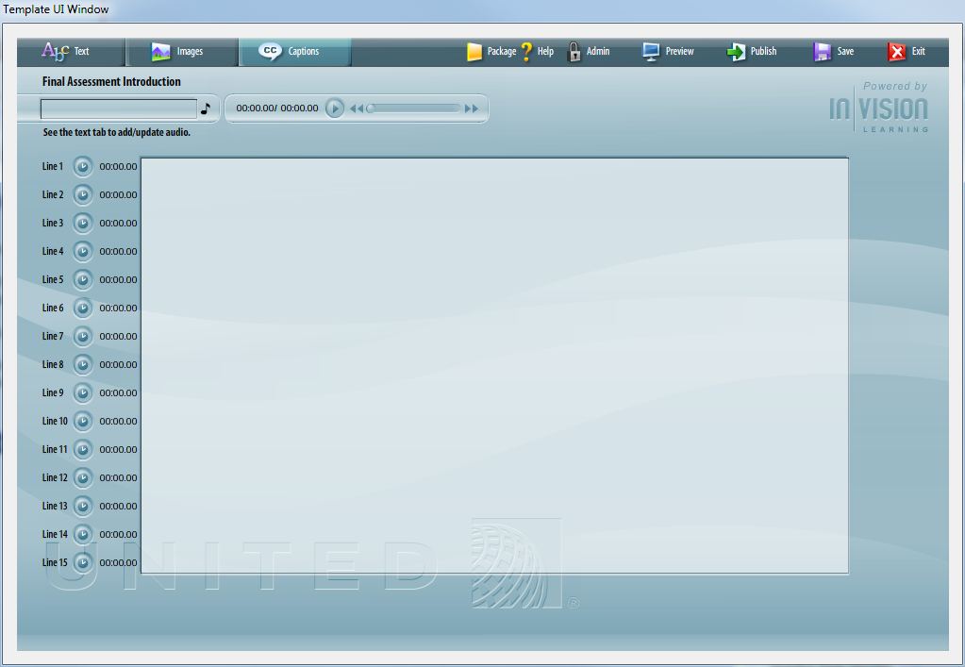

# Final Assessment Submit

Overview

The Final Assessment Submit is a text page with audio and graphics. This template is placed after the last question template in the timeline and before the Final Assessment Results Template. This template gives the learner the chance to review all questions/flagged questions and to submit for final evaluation/score.

Example  
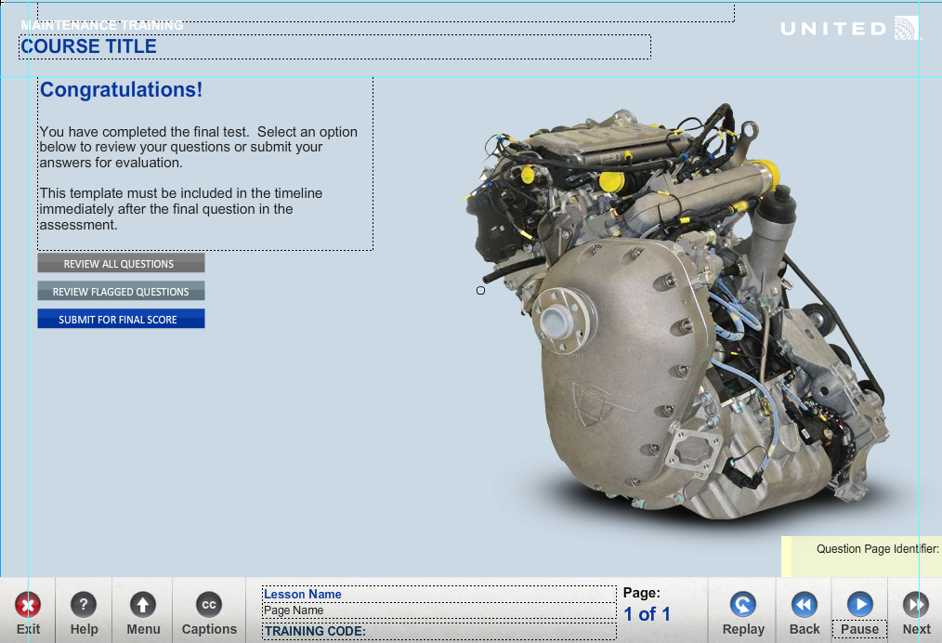

Using the Final Assessment Submit Template  
**Complete the Text Tab**  
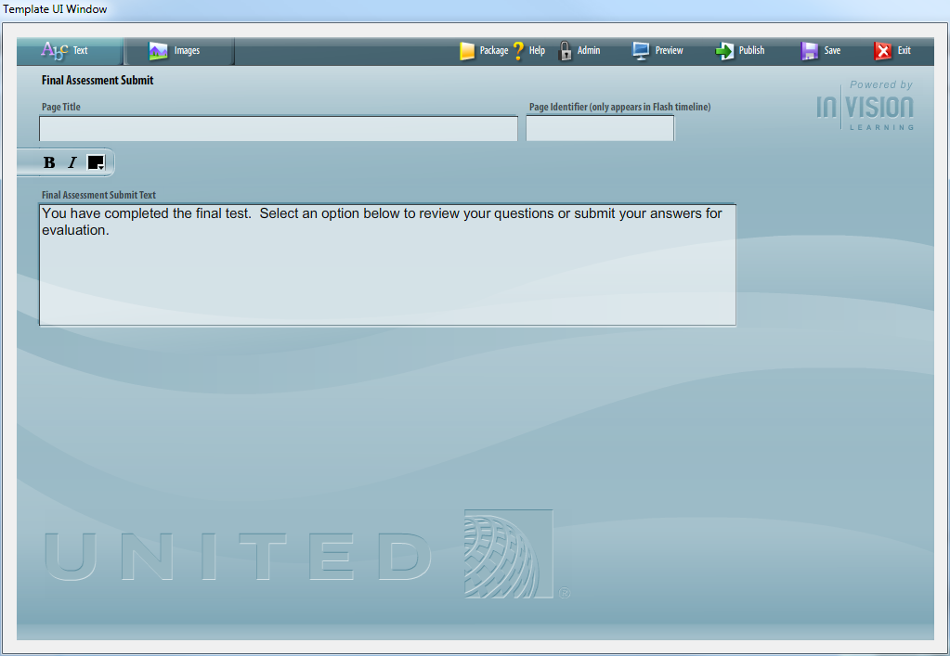

* Enter Page Name
* Enter & Edit Question Text
* Enter & Edit Answer Text

**Complete the Images Tab**  
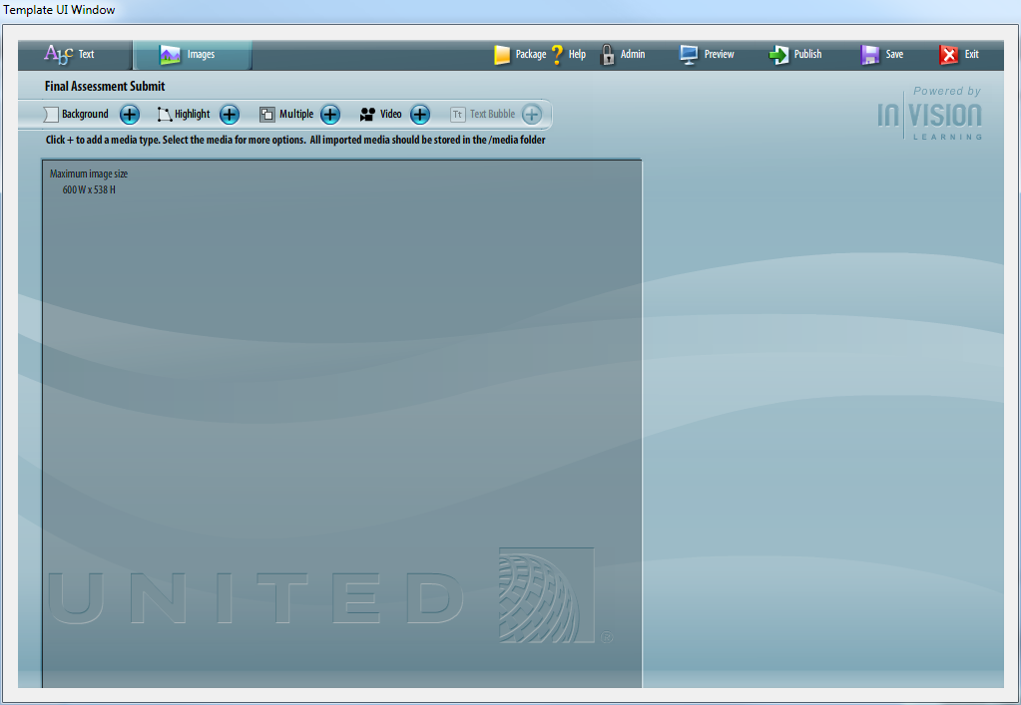

The Image Top page layout allows you to enter an optional background image.

You can multiple images to the screen to create a collage.

Highlights can be added to images. Highlights can be timed to the audio file and will open a callout box with a more detailed view.

Video can be added to the stage. Video controls can be turned on or off.

Text bubble windows can be added to the stage.

# Final Assessment Results

Overview

The Final Assessment Results template must be inserted after the Final Assessment Submit Template. It displays the user’s score and shows results for any questions that were answered incorrectly.

Example  
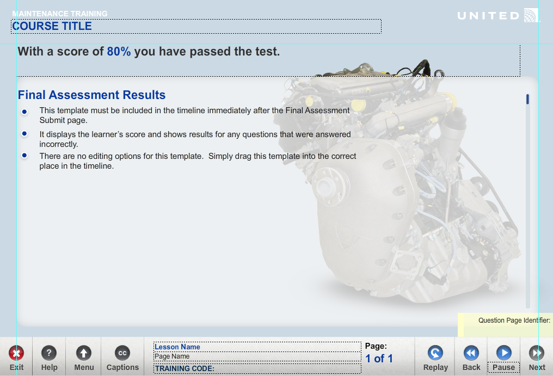

Using the Final Assessment Results Template  
**Complete the Images Tab**  
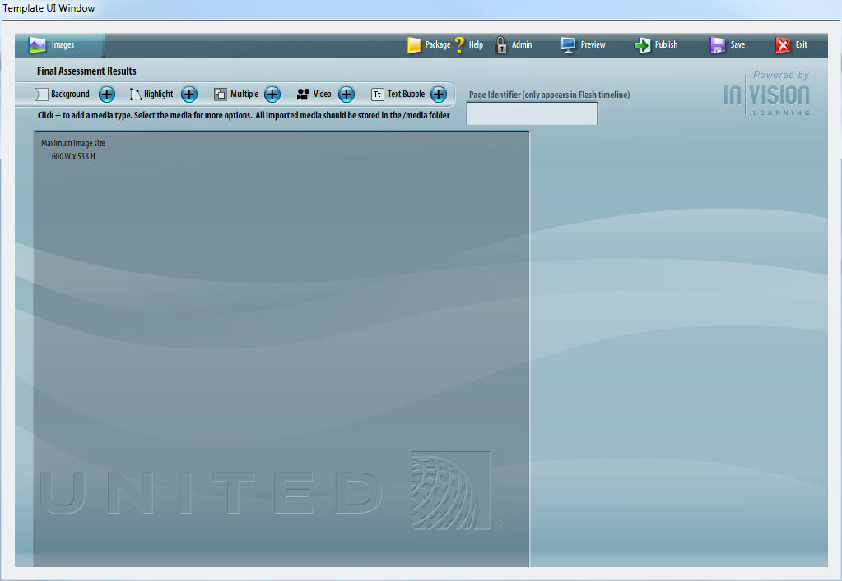

The Image Top page layout allows you to enter an optional background image.

You can multiple images to the screen to create a collage.

Highlights can be added to images. Highlights can be timed to the audio file and will open a callout box with a more detailed view.

Video can be added to the stage. Video controls can be turned on or off.

Text bubble windows can be added to the stage.

# Course Conclusion

Overview

The Course Conclusion template is placed at the end of the last lesson of a course or after the Final Assessment Results template. When a user successfully passes a course, congratulations text appears. You can edit the text the learner will see if they pass.

If the learner does not pass the course, they will see a Course Failed screen. You can edit the text the learner will see if they fail, directing them to retake the course.

Example  
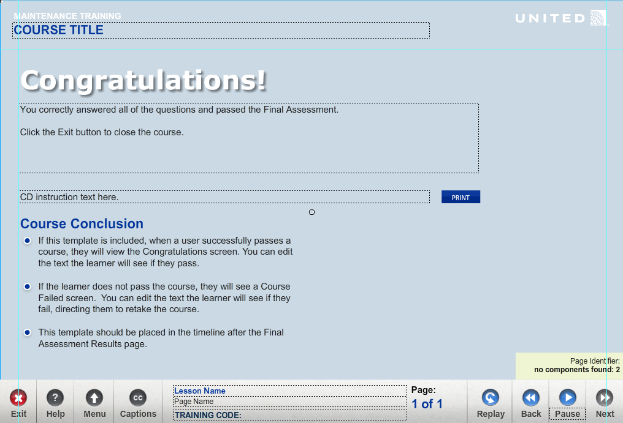

Using the Final Assessment Results Template  
**Complete the Images Tab**  
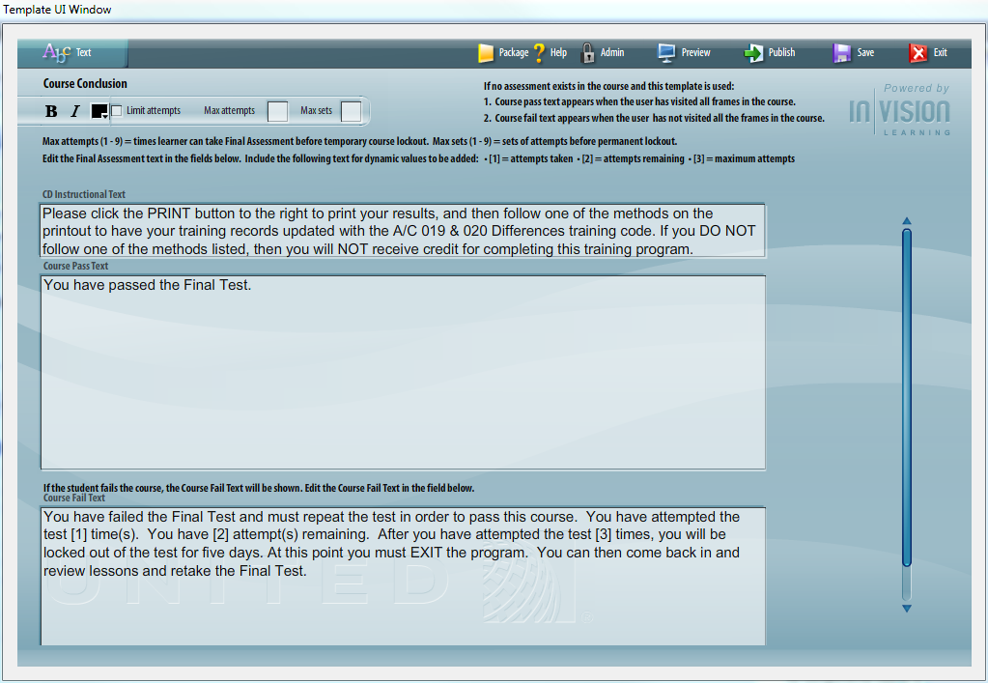

CD Instruction Text

This text appears when the course is in CD mode.

Course Pass Text

This text appears when the user score is equal to or greater than the course pass percent. Course pass percent is set in the Final Assessment Introduction page. If an assessment does not exist, the course pass text appears when all pages of the course have been completed.

Course Fail Text

This text appears when the users score is less than the course pass percent. If an assessment does not exist, the course fail text appears when the learner enters the page and all pages of the course have not been completed.

Failed Set Text

Text appears when the Max Attempts are hit. Max Attemts are set in the course conclusion.

Failed All Sets Text

Text appears when the Max Attempts and Max Sets are hit.

# Customizable

Overview

The customizable template provides a way to create custom content for a course. The template acts as a placeholder and tells the course custom content exists in the frame of the timeline. There is no limit to the type or amount of content created in a course. Use this template as you would any non-quiz or final assessment template.

It is recommended to place all custom content in the “custom content” layer on the main timeline.

Example  
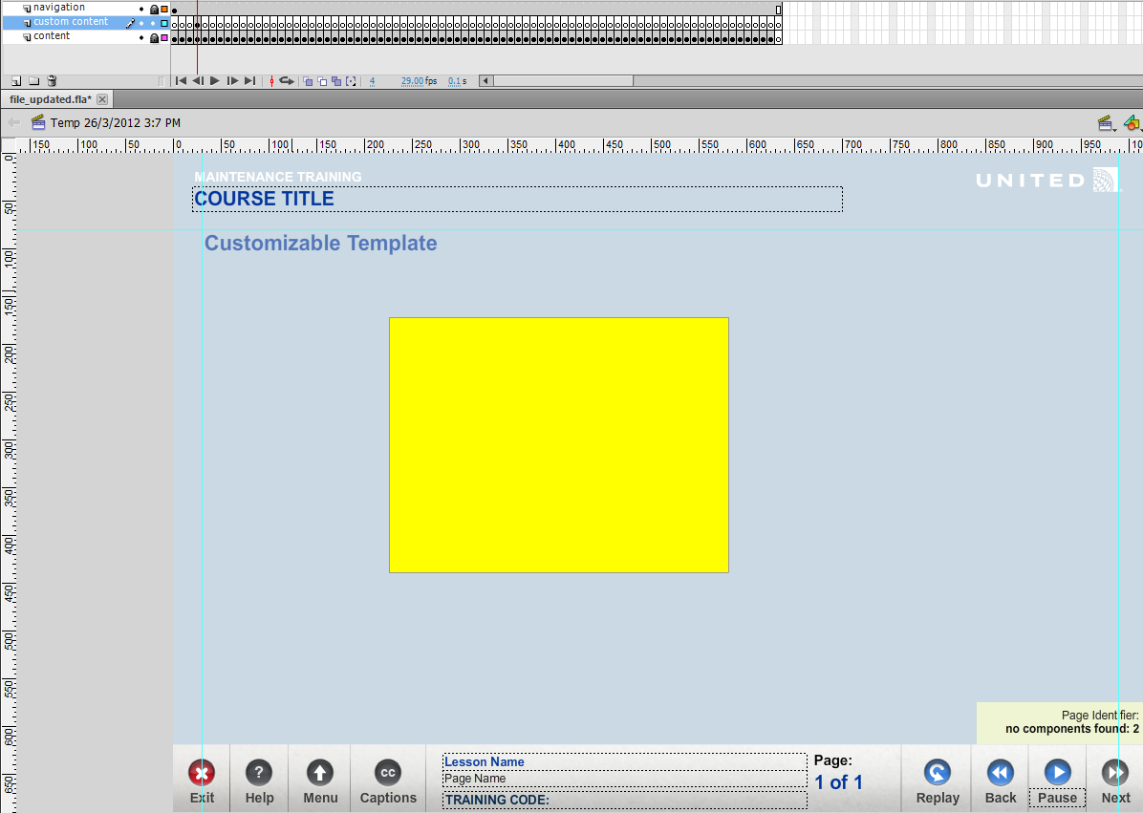

Using the Customizable Template  
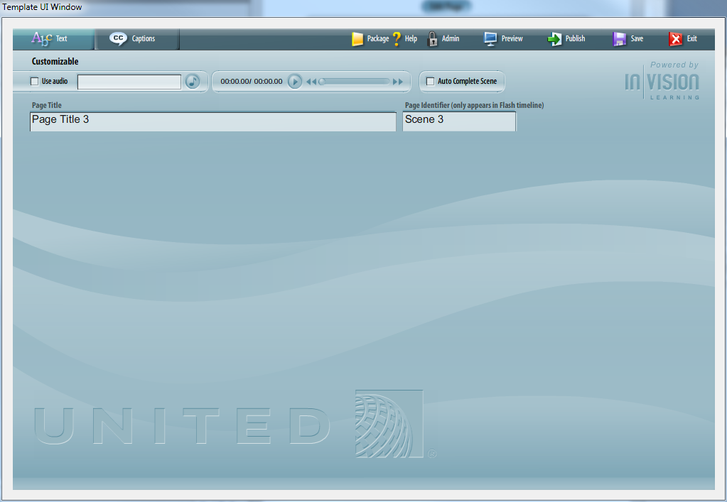

Enter Page Title

Page title appears in the navigation bar at the bottom of the screen.

Add Audio

Add an audio file to automatically play on entering the page.

Auto Complete Scene

Automatically marks the page as complete. If unchecked, the page waits for the audio to complete or custom code to trigger the completion.

Code Snippet  


**Please see “Custom Content.FLA” for examples of how to create custom content.**

**Important** Remember to always include addeventlistener “removed_from_stage” to all custom classes. The event is called when the movie clip is removed from the stage. This event is triggered when the next or back button changes the play head of the timeline or when code is executed to removeChild. The purpose of including this event is to clean up any children or event listeners from the class.

If the class is not “cleaned up” when the displayObject is removed from the stage, the objects remain in memory and can cause errors if the object is loaded again. Clearing everything from memory prevents errors later in the course.

# Customizable Question

Overview

The customizable Question template provides a way to create custom questions for a course. The template acts as a placeholder and tells the course custom question content exists in the frame of the timeline. There is no limit to the type or amount of content created in a course. Use this template as you would a Quiz template.

The Customizable Question template does rely on existing quiz elements for consistency and ease of use. The elements are in the Customizable Question template and should not be modified as they are necessary to the course. They are as follows:

* Flag For Review
* Submit Button
* Feedback window

Each of the elements can be controlled using classes.

It is recommended to place all custom content in the “custom content” layer on the main timeline.

Example  
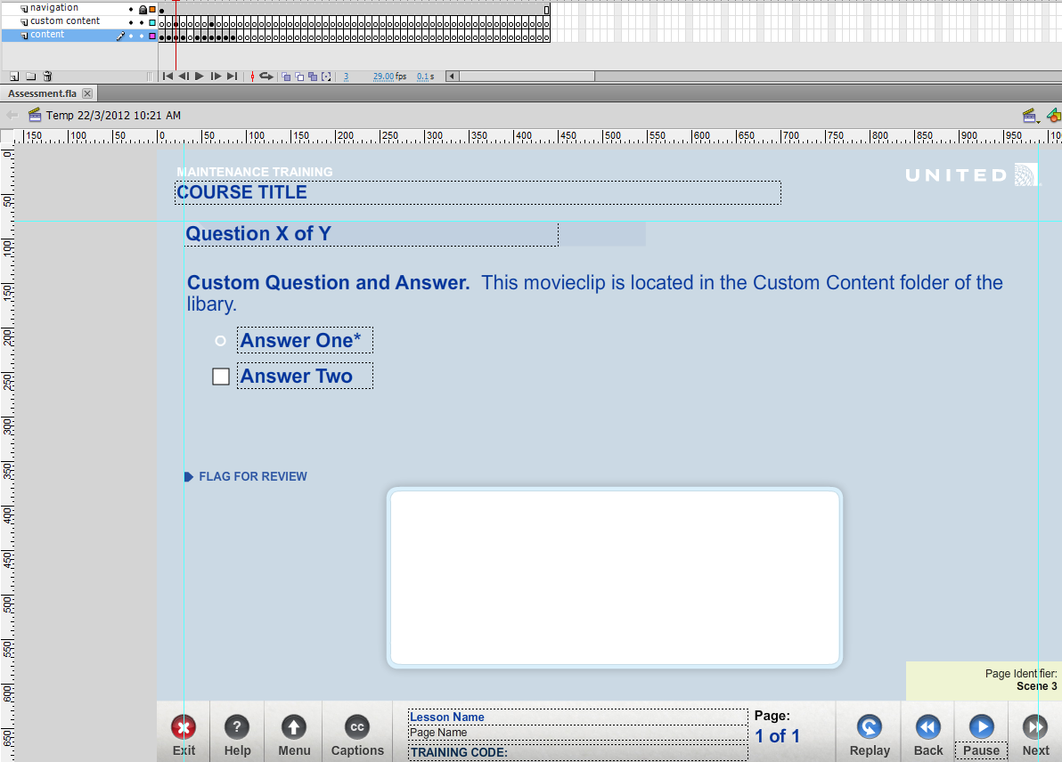

Using the Customizable Question Template  
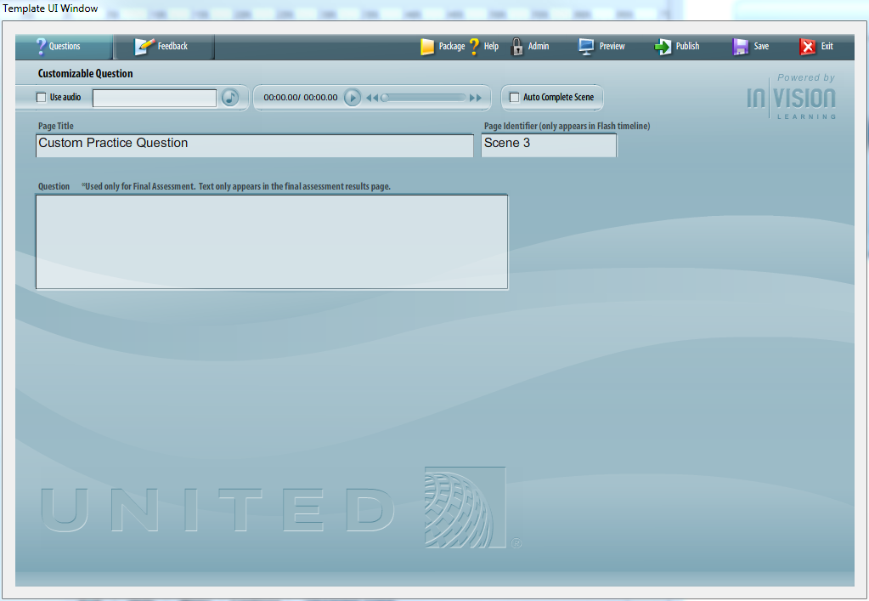

Enter Page Title

Page title appears in the navigation bar at the bottom of the screen.

Add Audio

Add an audio file to automatically play on entering the page.

Auto Complete Scene

Automatically marks the page as complete. If unchecked, the page waits for the audio to complete or custom code to trigger the completion.

Question Text

This field is used for the final assessment. When the final assessment displays the learner’s results, this text appears in the question answer fields.

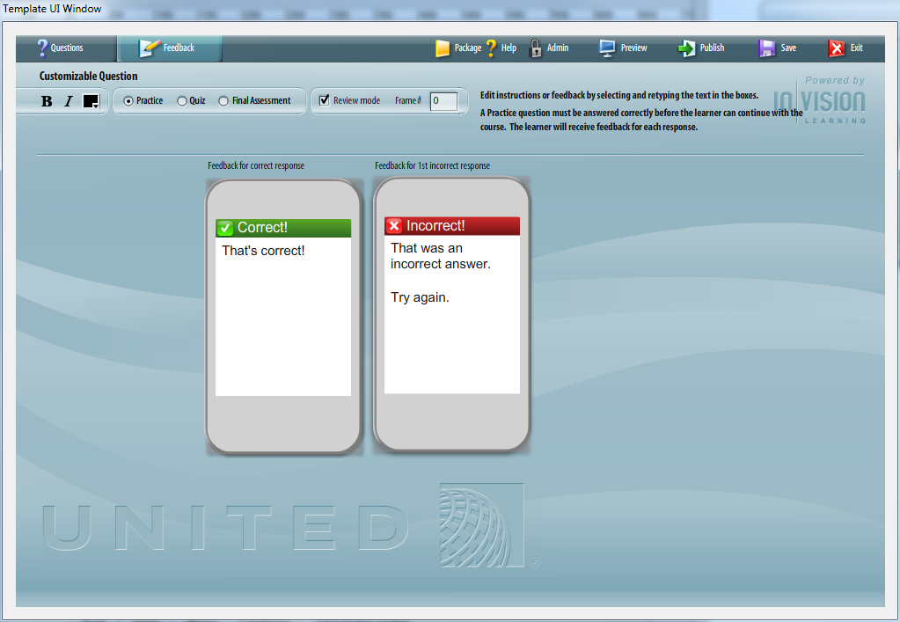

The Feedback tab works just like question templates. The feedback response text appears when the “Check Answer” button is selected.

**Quiz Types**

**Practice**  
A Practice question must be answered correctly before the learner can continue with the course. The learner will receive feedback for each response.

**Quiz**  
A Quiz question must be answered correctly before the learner can continue with the course. The learner will receive feedback for each response. The learner can only take each Quiz once - on reviewing Lesson content, Quiz pages will not be displayed.

**Final Assessment**  
In a Final Assessment, the learner will be scored on their answers. The learner will not receive feedback during the Assessment, but can flag questions for review before submitting their final answers.

**Review Mode**

Review mode takes the user back to a specific frame in the course when the user has incorrectly answered a question. This applies only applies to question type “Quiz”.

**Please see “Assessment.FLA” for examples of how to create custom question content.**

**Important** Remember to always include addeventlistener “removed_from_stage” to all custom classes. The event is called when the movie clip is removed from the stage. This event is triggered when the next or back button changes the play head of the timeline or when code is executed to removeChild. The purpose of including this event is to clean up any children or event listeners from the class.

If the class is not “cleaned up” when the displayObject is removed from the stage, the objects remain in memory and can cause errors if the object is loaded again. Clearing everything from memory prevents errors later in the course.

# Q & A

Question: Can the Course Intro be made to count as a Lesson Overview?

Answer: The course intro can be included in any lesson.  Unlike the previous templates, lessons can start with any type of template.  A lesson could start with a Course Introduction template.  Ideally, the course introduction would only be used once, but there is nothing preventing it to be used more than once.

Question: I figured, just as the Lesson Overview and Lesson Complete encapsulate a lesson, the Course Intro and Course Conclusion would work the same way to encapsulate the Course, meaning all content should be inside the course instead of inside a lesson.

Answer: Currently, the Template UI Admin > Course Lesson page defines where a lesson starts.  The logic for the lesson creation is as follows:  Retrieve lesson start frame, read all the template data from that start frame to (next lesson frame || end of course).  
  
Lesson Overview and Lesson Complete are not used to identify the lesson.  Because of that, lessons can start with virtually any template type.

Here’s an example of how a course sequence looks in the previous templates.  Note.  Lesson Overview was required to indicate where the lesson would start.  Both examples were pulled from content.xml in a course.

    <sequence id="sequence1" type="menu">

                <scene id="scene1" />

                <scene id="scene2" />

                <scene id="scene3" />

    </sequence>

    <sequence id="sequence2" type="lesson">

                <scene id="scene4" />

<scene id="scene5" />

    </sequence>

Here’s the new course sequencing.  Note.  The new course sequencing is set in the Template UI > Admin > Course Lessons.  Lessons and Assessment are defined there.

    <step frame="1" time="10" desc="sequence" id="sequence1" type="lesson" name="Why We Need Respiratory Protection">

                 <step desc="scene" id="scene1"/>

                 <step desc="scene" id="scene2"/>

                <step desc="scene" id="scene3"/>

    </step>

Question: Does this mean that there would have to be a Lesson Complete after the Course Conclusion, as technically the Final Assessment Intro, Final Assessment Submit, Final Assessment Results and the Conclusion would technically not be within the lesson?

Answer: No, a lesson does not need a lesson complete.  Since the lessons are defined by the Template UI > Admin > Course Lessons there is no need to use a lesson complete to identify the end of a lesson.  It is a best practice, but not required to have a lesson complete.

The last lesson would be defined as a final assessment in the Template UI > Admin > Course Lessons.  Just like the previous version of an assessment template, Final Assessment Intro, Final Assessment Submit, Final Assessment Results and the Conclusion were mandatory in a final assessment lesson.